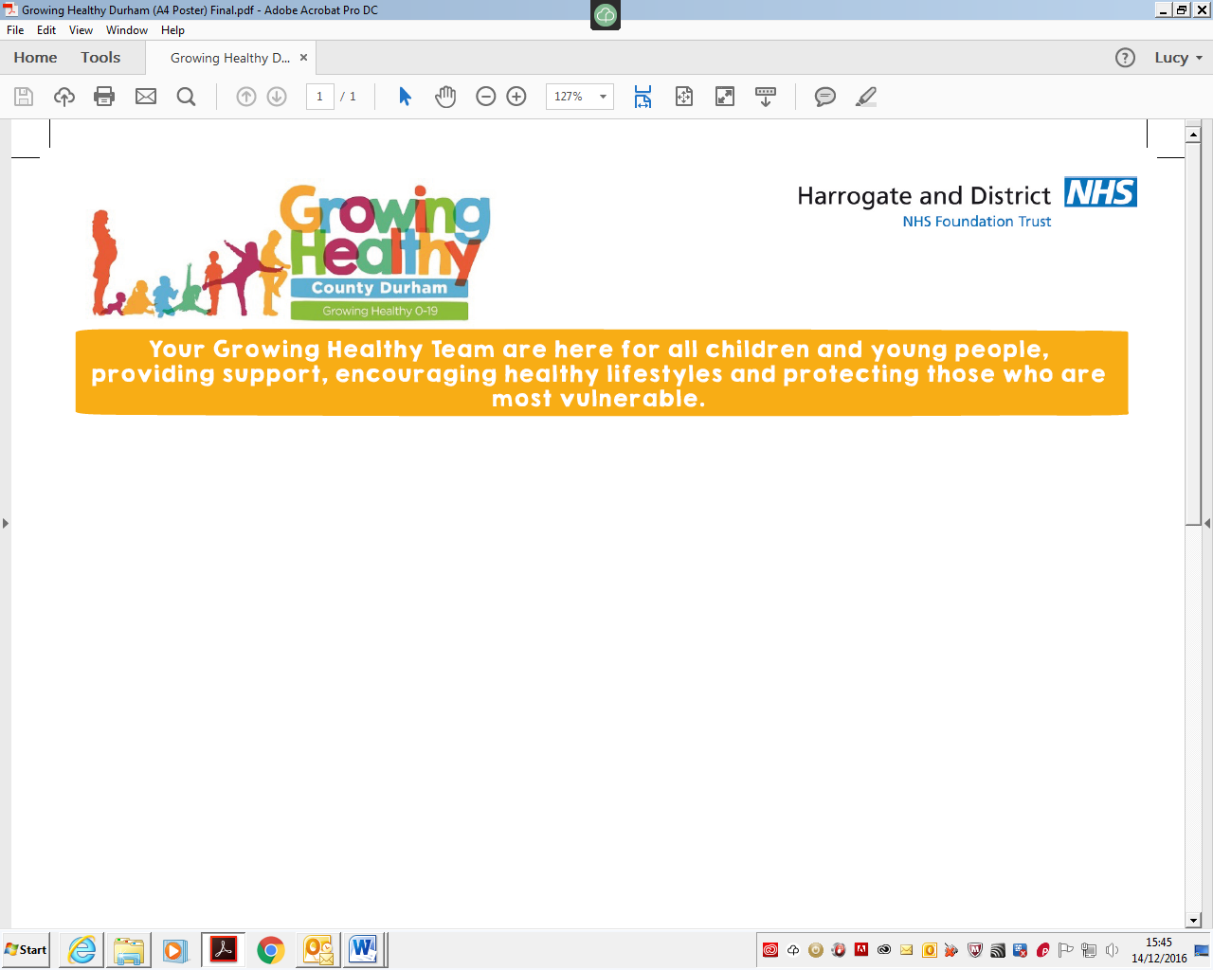
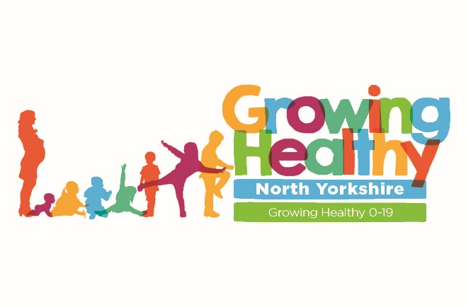
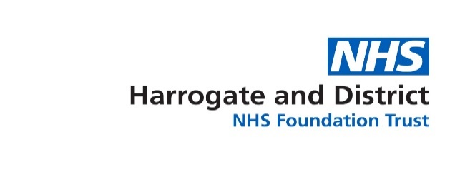

12 January 2026

Dear Parent/Carer,

Height and Weight Checks in Reception and Year 6 – the National Child Measurement Programme

As you may be aware, we have recently undertaken height and weight checks in school as part of the National Child Measurement Programme (NCMP). We would like to say THANK YOU to all of the families/children who took part – the programme gives us some really important information about the growth and health of our children, which helps us to better plan our health services and support for children and families (both nationally and locally).

This letter is being sent to ALL parents in school, in reception and year 6, regardless of whether the children took part. We wanted to share some information with all families, to give tips, ideas and information to support a healthy and active lifestyle. And to direct you to other services, support and information if needed.

How can I find out my child’s results (if I would like to)?

For parents whose children have measured above or below a healthy weight range, they may be contacted by the family health assistants (e.g. by phone call/text message/letter) to offer additional support and information. If you have not heard from the staff within the next few weeks, and would like to know your child’s results, please contact the team on:

Tel. 0300 303 0916 or email hdft.ncmp@nhs.net

Why is it important to keep an eye on how my child is growing and developing?

Seeing how your child is growing and developing for their age, gender and height can help you to understand how their health may be affected. When a child is within the healthy range for their age, it can prevent health problems like high blood pressure and the early signs of type 2 diabetes as they grow up. It can also help them to have better overall health, wellbeing and self-confidence.

What if my family would like some ideas and support for achieving a healthy lifestyle?

- You could contact the FREE Healthy You service, which helps families in North Yorkshire to make small, sustainable lifestyle changes. Our Healthy You Practitioners offer 1:1 support on healthy eating, sleep and physical activity, and can help you to access local activity sessions. For more information or to book a place, please visit: Healthy You | North Yorkshire Council
- Visit Children's growth - Healthier Families - NHS for handy tips such as ideas for enjoying moving more, or healthy food swaps.
- Another way to help maintain a balanced diet and physical activity for your family is the NHS Healthy Steps email programme. Sign up for the 8-week Healthy Steps emails and you will be sent lots of low-cost easy tips, fun games, healthy swaps and tasty recipes on a budget. Scan the QR code or visit Healthy Steps - Step this way. to sign up.
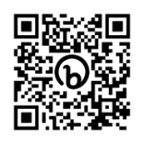
- Download the free NHS Food Scanner app: NHS Food Scanner app - Healthier Families - NHS Find out more at: Better Health Food Scanner App Explainer
- Children need to be active for at least an hour every day. If you are doing this already, that’s brilliant. For ideas on how and where to get active go to: https://www.northyorkshiresport.co.uk/participate and https://northyorkshireconnect.org.uk/
- Have a look at https://thegoto.org.uk/ for ideas to support mental health and wellbeing.
- Get ideas for saving money and cooking on a budget at: Cost Saving > Healthy Schools North Yorkshire
- Supporting your child to have healthy gums and teeth - Healthy gums and teeth are also part of a healthy lifestyle. Simple advice available at Children's teeth - NHS will help your child have healthy gums and prevent tooth decay.
- If you have concerns or are worried about your child’s growth, health and wellbeing please contact your family doctor.

I would like to thank you for taking the time to read this letter. Please do take advantage of the free support and advice on offer.

Yours sincerely,

Family Health Assistants, NCMP Team

P.S. If you have any thoughts you would like to share about your or your child’s experiences of taking part in the NCMP in North Yorkshire, please email Helen Ingle, Public Health Manager from North Yorkshire Council’s Public Health team: helen.ingle@northyorks.gov.uk



