
Policy Number
11

Statutory Supporting Pupils with Medical Conditions and Allergies including Administering Medicines in School

Approved By: Ebor Academy Trust Standards
Approved by: Standards Committee

Approval Date: July 2025

Review Period: Every 3 years

Review Date: July 2028

Policy for publication on school websites and promotion to staff

Author/Updated by: Deborah Meiklejohn (SEND Lead)
Date Created/updated: July 2025

Version Number: 6
Contents
- Aims 3
- Roles and Responsibilities 3
- Individual Health Care Plans 5
- Provision for children with health-related absences 5
- Specific Medical Conditions 6
- The Administration of Medicines 6
- How do we know which children have medical needs? 7
- Anaphylaxis 7
- Adrenaline Auto-injectors 8
- Asthma 9
- Managing Allergies in School…………………………………………………………………………………………………………………………….………..13
- Other Medical Conditions 13
- Complaints 14
- APPENDIX A – IHCP Flowchart 14
- APPENDIX B – Treatments 15
- APPENDIX C – Useful Links and resources 19
- APPENDIX D -Example of Medication Consent Form for schools………………………………………………21

Aims

This policy aims to ensure that:
  - All stakeholders understand their roles and responsibilities towards pupils with medical conditions and allergies.
  - All pupils with a medical condition and/or allergy are supported to access a full education, including physical education and school trips.
  - All schools at Ebor Academy Trust fulfil Section 100 of the Children and Families Act 2014 that places a statutory requirement on schools to make appropriate arrangements to support pupils with medical conditions. It is also based upon the Department for Education statutory guidance.
  - All schools at Ebor Academy Trust develop Individual Health Care Plans (IHCPs) for pupils with medical conditions and allergies, identifying the triggers, symptoms, medication required and level of support that is needed.
  - All schools at Ebor Academy Trust have procedures in place for managing and administering medication on the premises.
  - All schools at Ebor Academy Trust ensure that staff are appropriately trained and supported in medical conditions and allergies, including Anaphylaxis and Asthma awareness training.
Some pupils with a medical condition will also have a disability under the definition from the Equalities Act 2010. In this situation, schools should comply with the requirements outlined in this act. For pupils with Special Educational Needs, this policy should be read alongside the SEND Code of Practice 2015. This policy should be read in conjunction with the First Aid policy, Health and Safety policy, SEND policy, Behaviour and Anti-bullying policy, Accessibility policy and Admissions Policy.

Roles and Responsibilities

The Board of Trustees has overall responsibility for the contents of this policy. Implementation of this policy is delegated to individual schools in Ebor Academy Trust.

The Head of School has overall responsibility for the day-to-day implementation of this policy and must ensure that:
- Staff are aware of this policy and understand their roles and responsibilities for supporting pupils with medical conditions and allergies.
- Suitable arrangements are in place for the support of pupils with medical conditions and allergies. Cover arrangements should be in place so that someone is always available to support these pupils as required. Cover staff should be provided with the appropriate information.
-There is a named person in school with leadership responsibility who is responsible for medical conditions and for updating IHCPs with parents/carers (see section 3 for more details on IHCPs). This may or may not be the same individual who is the allergy lead. The Headteacher has overall responsibility for the development of IHCPs in school.
- There is a named allergy lead in each school who attends trust network meetings to share best practice and access updates.
- Staff access appropriate training to deliver the support outlined in IHCPs, including in emergency and contingency situations. This should be done in partnership with health care agencies where appropriate.
- Staff training for medical conditions is up to date and recorded in a central location.
- Staff access regular asthma and anaphylaxis awareness training.
- Along with the governing body, staff are appropriately insured to deliver support for individual pupils with medical conditions and allergies.
- Risk assessments and arrangements are in place for dealing with an emergency, including support required in the event of an evacuation. For school trips, risk assessments should include details of pupils who need adjustments or additional equipment to stay safe. As far as possible, all pupils should have equal access to all opportunities, unless there is clear medical advice to the
contrary. Staff with appropriate training should be on school trips when pupils with medical conditions and allergies attend.
  - Ensure that systems are in place for gathering information in a register about medical conditions and allergies and that this is held appropriately confidential, depending upon the circumstances of the individual, and kept up to date. This should include pupils who have asthma, and also those prescribed an inhaler.
  - The appropriate number of staff in school have appropriate First Aid training and Paediatric First Aid, and enhanced training is provided for those working directly with children with a known medical condition. See links for training information below (Appendix C).
-Supporting pupils with known allergies and for promoting allergy awareness across school.
Information for pupils with allergies should be up to date and accessible for relevant members of staff, including catering, support staff and lunchtime staff. This may be delegated to the allergy lead at the discretion of the Headteacher, although they retain overall responsibility.
-Ensuring that pupils are not refused entry on medical grounds. In line with their safeguarding duties, however, alongside the governing body, the Headteacher should ensure that people are not put at risk from, for example, infectious diseases. In such instances, they do not have to accept a child in school at times where it would be detrimental to the health of that child or others to do so. In such instances, Local Health Protection Team advice will be followed.
-School staff stress the importance of children not handling or taking another person’s medication and good hygiene procedures are promoted in school.

School Staff

Responsibility for providing support for pupils with medical needs should never be the sole responsibility of one individual member of staff. Any member of staff may be asked to provide support for pupils with medical conditions, although they will not be required to do so. This includes administering medicines. Staff that do take on responsibility for supporting pupils with medical needs must access the appropriate training to achieve the right level of competency before doing so.
Teachers should:
- know the IHCPs of pupils in their class and make reasonable adjustments as required.
-follow the school’s emergency and contingency procedures and plan for pupils with medical conditions, understanding what constitutes an emergency for each pupil with a medical condition or allergy.
-store equipment, such as inhalers and adrenaline auto-injectors (AAIs), in an accessible but secure location, following instructions on the label. They should take the necessary medication/equipment and copies of the IHCPs with them on any school trips/visits.
-carefully plan activities, including food or animal related activities, taking into account any known allergies.
-keep their own medication secure.
School staff should be aware that it is not generally acceptable to:
-prevent children accessing their inhalers and medication or administering it as required.
-assume that each child with the same condition requires the same treatment.
-ignore the views of parents/carers or medical advice (although this may be challenged on occasions).
-send children home frequently for reasons related to their medical condition or prevent them from accessing school activities (unless this is a medically advised and agreed decision).
-penalise a child when an absence is unavoidable due to a medical condition. In such circumstances, verification will be required from the child’s healthcare provider. The school where possible will look to authorise absence related to a child’s known healthcare needs.
-prevent a child from having a drink, snack, toilet/other break when they need to, in order to manage a medical condition.
-require or cause parents to feel obliged to attend school to provide medical support to their child, including attending school trips.
-separate a child with an allergy from their peers unless this is specified in their IHCP or requested by parents.
-leave a child unsupervised if they are feeling unwell in school. Staff should accompany pupils taken to hospital by ambulance or until a parent/carer arrives.
Parents and carers should:

-Provide up-to-date information regarding medical conditions and inform the school of any changes.
- Provide a copy of Allergy Action Plans/Medical Care Plans issued by healthcare professionals.
-Carry out any actions outlined in the IHCP, such as providing medicines. Medicines given to the school must be in date and replaced as required, such as inhalers and AAI’s. TWO AAI’s should be provided by parents/carers for children who have them prescribed. Parents can access expiry alerts for the relevant AAI their child is prescribed to ensure they get replacement devices in good time.
-As far as possible, administer medicines at home, unless giving it within the school day is unavoidable.
-Ensure that the school has up to date contact details in the event of an emergency or illness.
-Provide written permission for administration of prescription and non-prescription medicines with the correct information for each medicine to be administered (see section 6).

It is important that pupils:
- Follow their own IHCP (as far as appropriate for that individual child) and are involved in the discussions around support for their medical needs as far as possible.

Individual Health Care Plans

An Individual Health Care Plan (IHCP) should include key facts about a medical condition or allergy and any actions that are required. The detail of the plan will vary as the complexity of needs vary and not all pupils with minor conditions will necessarily require an IHCP (see appendix A). Pupils with a known allergy or asthma should also have an IHCP. These plans should be updated regularly in school, (at least annually) and when there are any changes. These reviews should be carried out by a named person in school who has a leadership role.
An IHCP should include the following:
- The medical condition or allergy – known allergens, triggers, signs, symptoms and treatment.
- The needs of the pupil – including known allergens, medication that should be administered, when it should be given and how much (dosage, side effects and storage). It should include any equipment required, dietary requirements, instructions for use of any treatments and any other adjustment requirements, such as rest breaks, how absences will be managed etc.
- Actions required, when these are required, and what to do in the case of an emergency. It should clearly outline what constitutes an emergency for that individual. The plan should clearly state when to call for an ambulance.
- Who will provide the support required in school and the level of support required, including support required and by whom in the event of an evacuation. It may also be appropriate to include who will provide any support required when an allocated person is absent.
- Who the plan will be shared with in school.
- Additional arrangements for school trips/visits.
- Support for any social, emotional or educational needs related to their medical condition.
- Medication required, including information on whether this will be provided at school or at home, and arrangements for permission from the Headteacher and the parents/carers for staff to administer medication or if it is to be self-administered during school hours.

Provision for children with health-related absences
The school will maintain on record pupils who have a more acute medical need that may result in a more prolonged period of absence. In most cases, a Medical Care Plan (MCP) will be written in consultation with healthcare professionals. This is different to an Individual Health Care Plan (IHCP) and is produced with healthcare professionals. Initially, an MCP will be reviewed on a weekly basis, and then at longer intervals as appropriate.
If the child goes into hospital, the medical team at the hospital will contact the school and the Local Authority to make further arrangements. The school will most likely provide some work. If the child has special educational needs with an EHCP (Education Health Care Plan) or an SEN learning plan, a copy of this will also be provided in consultation with parents/carers. Where pupils are not able to receive a suitable education in a mainstream school due to their healthcare needs, the local authority has a duty to make other arrangements. The guidance for local authorities states that they are responsible to make arrangements when it is apparent that a child will be away from school for 15 days or more because of healthcare needs.
It is possible that an MCP might also include an element of part-time attendance at school when this is advised by healthcare professionals. Where appropriate, remote learning might be used to provide and share learning with the child, set by the class teacher.

Procedures will be in place to make reasonable adjustments for pupils with medical needs to support transitional arrangements and reintegration following a period of absence or when pupils’ needs change. For new pupils due to enter at the start of the academic year where the transition process started in the previous academic year, these arrangements should be in place. For pupils transitioning into one of our academies during the academic year, or in the event of a new diagnosis, schools will make every effort to ensure arrangements are in place and are completed in no more than two weeks.

Specific Medical Conditions

Please see Appendix B for information on other specific medical conditions. This is not an exhaustive list, but it outlines guidance for some more commonly occurring medical conditions. This policy has been informed by the medical conditions that are present in schools at Ebor Academy Trust and is regularly reviewed to reflect this.

The Administration of Medicines

  - No pupils under 11 years old can be given medication in school without written consent from the child’s parents/carers, apart from in exceptional emergency circumstances. Pupils under 16 will not be given aspirin unless it has been prescribed by a doctor.

  - It may well not be within the contractual duty of all staff in school to administer medicines. However, staff may volunteer to do so. We are often asked to assist parents/carers by administering medicines to children. This arises when a child has a medical condition such as Asthma, Diabetes or Epilepsy, which is controlled by regular medication, or when they are recovering from a short-term illness and receiving a course of antibiotics.
  - Prescription and non-prescription medicines can only be administered at school if:
- it would otherwise be detrimental to the pupil’s health or attendance at school. As far as possible, medicine should be administered at home. For example, if antibiotics need to be taken 3 times a day, it is often appropriate for it to be given in the morning, at teatime and bedtime.
- Non-prescription medicines can be administered for up to 3 consecutive days only and schools reserve the right to decline an application to administer a non-prescription medicine.
- parents/carers have completed the appropriate documentation giving written permission for staff to administer the medicine, clarifying when and how it should be given and stating their understanding that the school cannot be held legally responsible if, for some reason, the medicine is not administered (see appendix D for example form).
- Prescribed medications are in date, labelled and provided in their original container, as dispensed by the pharmacist, with instructions on how to administer, the correct dosage and how to store it attached (Insulin may be provided inside an insulin pen or pump rather than the original container, but it must be in date).
- The consequences of a dose being missed will not be serious. Where a missed dose may lead to serious consequences, we may ask parents/carers to take responsibility for administration. For special schools or in special circumstances, there may be exceptions agreed between the school and parents/carers, or where staff have more advanced medical training or medical expertise/school nurses are on site.
  - A record of medicines administered must be kept up to date in school. From Autumn 2025, Arbor MIS will support this process. This record should state what was given, how much, when and by whom and it should be countersigned. Staff administering medicines should follow the prescriber’s instructions. Any side effects of medicines given should also be recorded and parents/carers informed. Parents should be informed when medication has been administered.

Records of medicines administered should be kept for the length of time a pupil remains at the school (please note: this is different to accident record keeping, injury and treatment that should be kept for 21 years).
  - Staff must keep medicines secure and store them as specified on the label. Medicines should be sent in the smallest practicable amounts. Medicines must be clearly labelled with the child's name, name of the medicine and dosage.

  - If parents feel an older child with asthma is responsible enough to look after their own inhaler, it is important that they still complete a consent form and they declare this on the form. The inhaler should be clearly labelled with the child’s name and class/form group to avoid these coming into the wrong individual’s possession.

  - Parents/carers are responsible for collecting medication at the end of the school day if required or for making arrangements with out-of-school providers to do so, where medicine needs to be taken home.

How do we know which children have medical needs?

The school will maintain a register. If there is uncertainty around whether a child requires an IHCP, the school should follow the flowchart on Appendix A below. In cases where a pupil’s medical condition is unclear, or where there is a difference of opinion, decisions should be based upon the available evidence. This would normally involve some form of medical evidence and consultation with parents. Where evidence conflicts, some degree of challenge may be necessary to ensure that the right support can be put in place.

Anaphylaxis

  - Anaphylaxis is a severe and often sudden, potentially life-threatening allergic reaction. It always requires an emergency response. Delays in giving adrenalin can result in fatality. Call 999 and state ‘ANA-FIL-AX-IS.’

  - An ambulance should always be called when an AAI has been administered. See Appendix B for advice on what to do when anaphylaxis occurs.
  - Anaphylaxis can occur as the result of exposure to an allergen such as food or an insect sting and onset is often within minutes of exposure to an allergen that a person is susceptible to. It can also occur 2-3 hours after exposure. The severity of a reaction depends on various factors, including asthma which can make individuals more at risk of anaphylaxis. The common cold can also make people more susceptible to anaphylaxis.
  - If a child has been exposed to a known allergen, known for them, they should be given their prescribed adrenaline to help avoid an allergic reaction progressing to anaphylaxis.

  - Common allergens that can cause anaphylaxis include tree nuts, peanuts, milk/dairy products, egg, wheat, fish/seafood, sesame, soya, insect bites (such as bee and wasp stings), medication (such as antibiotics or ibuprofen), latex (such as balloons, rubber gloves and swimming caps).

Adrenaline Auto-injectors

  - Pupils with a prescribed AAI should have TWO in school prescribed by healthcare professionals. If after 5-10 minutes their condition has not improved with the first dose, the second dose should be administered. When an AAI has been administered, an ambulance should always be called and the person should be taken to hospital.
  - AAIs should be stored at room temperature, protected from direct sunlight and extreme temperatures.
  - AAI’s are single use and should be disposed of in a sharps bin after use. They can also be given to ambulance crews to dispose of.
  - Any staff can administer an AAI in an emergency. However, schools should have designated staff in school who have received training on administering an AAI where a pupil/s or staff have one prescribed.
  - Schools should aim to have arrangements in place to check medical equipment expiry dates, such as on AAIs or inhalers every term as good practice, so they can remind parents/carers of the need to renew in good time. Parents can be signposted to expiry alerts for the relevant AAI their child is prescribed to ensure they get replacement devices in good time.

  - ALL staff should:
    - access awareness training in Anaphylaxis and Asthma with regular refresher courses.
-recognise the signs and symptoms of an allergic reaction. Posters and visual aids showing what to do should be displayed in staff communal areas to support them to feel confident so they know how to act in such an event. See page 1 for a flowchart at: https://assets.publishing.service.gov.uk/media/5a829e3940f0b6230269bcf4/Adrenaline_aut o_injectors_in_schools.pdf
    - understand how fast anaphylaxis can progress and that it should always be treated as an emergency.
    - recognise that a prescribed AAI must be administered as quickly as possible without delay
before the patient reaches a state of collapse.
-know who the designated staff are that are available to administer an AAI in the case of anaphylaxis, but understand that all staff can administer prescribed AAIs to the individual they are assigned to in an emergency situation, and it can be administered through clothing. Designated staff should:
      - recognise the signs and symptoms of an allergic reaction.
      - respond appropriately to requests for help from other staff.
      - understand what to do in an emergency.
      - administer a prescribed AAI following the instructions and record this in school.
      - receive regular refresher training.
  - It is considered best practice that all schools have a SPARE EMERGENCY AAI on the premises. These should only be administered in the event that a pupil’s own prescribed
device is not readily available, misfires or is unsuitable for use, or in the case of an emergency, where anaphylaxis is suspected in a person that has no known history of it. In such emergencies, these spare devices providing adrenalin immediately can be life saving. Every year, children and adults experience severe reactions and anaphylaxis for the first time without any prior warning or any known allergens. Please see the government advice at: https://assets.publishing.service.gov.uk/media/5a829e3940f0b6230269bcf4/Adrenaline_aut o_injectors_in_schools.pdf
which states ‘In the event of a possible severe allergic reaction in a pupil emergency services (999) should be contacted and advice sought from them as to whether administration of the spare emergency AAI is appropriate.’
If anaphylaxis is suspected in someone without a prescribed adrenaline pen or Allergy Action Plan, a member of staff will ensure they are lying down with their legs raised, call 999 and explain that anaphylaxis is suspected. They will inform the operator that spare adrenaline pens are available and follow instructions from the operator.

Asthma

This section is based on the York Schools Asthma Policy (2025).

Asthma is a common inflammation condition that causes swelling (inflammation) of the breathing tubes that carry air in and out of the lungs. This causes the tubes to be highly sensitive, and they temporarily narrow. Symptoms occur in response to exposure to a trigger e.g., pollen, dust, smoke, exercise etc. All school staff should know what signs to look out for. The common signs of an asthma attack include coughing, being short of breath (younger children may describe this as a tummy ache), wheezy breathing, feeling tight in the chest, being unusually quiet, nasal flaring, becoming unable to talk or complete a sentence, or a blue tinge around the lips.
Call an ambulance immediately if the person appears exhausted, has a blue/white tinge around the lips, is turning blue or has collapsed.

To administer a dose (one puff) of inhaled medication through a spacer:
1) Check the inhaler is in date and not empty
2) Shake the inhaler and remove the cap
3) Insert the inhaler into the spacer
4) Place the spacer mouthpiece between the teeth and lips or fit spacer
mask over the mouth and nose, ensuring a good seal
5) Press the inhaler canister down into the casing of the inhaler once, to
release one puff of medication
6) The child or young person should breathe in and out 5 times or for 10
seconds before removing the spacer
If another puff is required, start again at step 3.
7) Replace the cap
A video can be seen at: https://www.youtube.com/watch?v=fJpXvOixZRo

Use of inhalers in school

Preventer inhalers

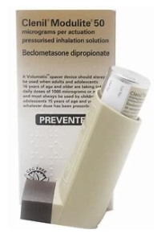

Preventer inhalers will only be required on residentials and will otherwise be administered at home. Only reliever inhalers should be kept in school.

Reliever inhalers

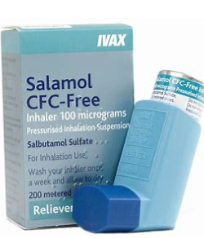

Salbutamol is a blue reliever inhaler used to relieve asthma symptoms, such as wheeze, cough and breathlessness.

MART

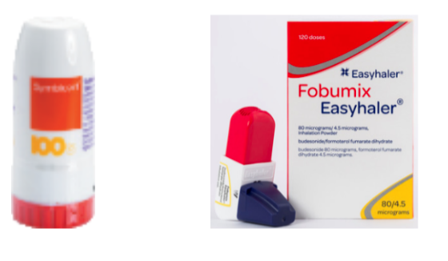

Maintenance and reliever therapy (MART) involves the use of a single inhaler that can act as both a preventer (maintenance) and as a reliever. The inhaler will be used regularly every day at home and will be brought to school and used to relieve symptoms, if they occur. There are currently two different brands of MART inhalers that are licensed for children and young people, Fobumix and Symbicort.
If the MART inhaler has not worked or is unavailable, then the school emergency Salbutamol (blue) inhaler should be used.

To administer one dose of Symbicort:

- Check the inhaler is in date and not empty
- Unscrew and lift off the protective cover
- Hold the inhaler upright, twist the red grip, at the bottom, as far it will go in one direction and then turn it back in the other direction. You should hear a click
- Breathe out (not into the inhaler)
- Tilt the chin slightly and put lips around the mouthpiece
- Breathe in – Quick and Deep
- Remove the inhaler from the mouth and hold breath for 5-10 seconds, then breath out
- Repeat all steps if more inhalations required

To administer one dose of Fobumix:

- Check the inhaler is in date and not empty
- Remove the cap
- Shake the inhaler and click down the red top and let it click back into its original position
- Breath out (not into the inhaler)
- Tilt the chin slightly and put lips around the mouthpiece
- Breathe in – Quick and Deep
- Remove the inhaler from the mouth and hold breath for 5-10 seconds, the breath ou
- Repeat all steps if more inhalations required

See the flowchart in appendix B i). for further details on what to do in the event of a suspected asthma attack.
Children with asthma need to be able to gain immediate access to their inhalers (and spacers as applicable). A mouthpiece spacer is generally recommended for a child over the age of five as it is more efficient at delivering the desired dose. Older children may be responsible for their own inhalers, but it is good practice to have more than one inhaler in school. One can be kept in the designated, safe medical storage area and one kept in a secure place in their bag/locker on consent from parents/carers.

For younger children, the class teacher will keep an inhaler in the classroom in an accessible (not locked) but secure location. Members of staff need to ensure that such devices and medicines are taken with them and available to children such as for PE, Forest Schools etc. and on off-site visits. Children with asthma are encouraged to participate fully in Physical Education. Teachers will remind children whose asthma is triggered by exercise to take their reliever inhaler before the lesson and make any required reasonable adjustments.

Parents sign a form to acknowledge that an inhaler has been provided and must ensure the inhaler is clearly labelled with the child’s name and class. Children with Asthma should have an IHCP, but some health practitioners also issue an Asthma Care Plan or Personal Asthma Action Plan. Where this is the case, parents/carers should share the plan with the school, and it should be shared with relevant staff and form the basis of the IHCP. For pupils who only have a medical condition of asthma, the Personal Action Asthma Plan can become the IHCP document.

Best practice is that schools hold a spare inhaler and spacer for use in an emergency but only for pupils who have been:

a).diagnosed with asthma, and prescribed a reliever inhaler, where their prescribed inhaler in unavailable or broken/unusable OR;

b).for pupils who have been prescribed a reliever inhaler AND for whom written parental consent for the use of the emergency inhaler has been given. This should be recorded in their IHCP.

A list of pupils this applies to should be kept up to date alongside the emergency inhaler. Spacers should not be reused; they can be given to the pupil for future use. It is the responsibility of all staff to know how and where to access the emergency inhalers and spacers.

When replacing the emergency salbutamol (blue) inhaler, be aware that an inhaler can run out of medication before it is actually empty. Salbutamol blue inhalers do not have dose counters. Each cannister of Salbutamol contains 200 puffs of medications. When the emergency inhaler
is used in school the number of puffs should be recorded for each inhaler and replaced when 200 puffs have been used or by the expiry date, whichever comes first. Out of date inhalers or empty inhalers, should be returned to the pharmacy for safe disposal. Inhalers and spacers can be purchased by the school for emergency use as recommended in Guidance on the use of emergency salbutamol inhalers in schools (Department of Health, September 2014). See appendix at end of this policy for a sample letter.

Pupils with asthma can have co-occurring conditions and may be more at risk of allergies and anaphylaxis. It is important that school staff access asthma and anaphylaxis awareness training. Sometimes, anaphylaxis can be mistakenly identified as an asthma attack, as it can mimic asthma due to similar symptoms, such as the throat tightening, difficulty breathing and high-pitched noises (Stridor). The advice above on use of an emergency inhaler must be followed to avoid a pupil being wrongly treated for asthma when in fact it could be another serious medical condition. It is important that staff understand this and consider if the person might be suffering anaphylaxis.

Managing Allergies in School
  - Schools should have an allergy register which is kept up to date with details of all pupils who have a known allergy. This should also be where any reactions are recorded, including near misses, when and where they occurred, how much medication was given and by whom.
  - If staff suspect that a pupil may have an allergy, they should inform the parents/carers.
  - Each school should have a designated allergy lead, preferably a more senior member of staff, who supports all staff in following best practice and promotes inclusion, safety and wellbeing for pupils with allergies, including communicating updates. This individual should attend network meetings and support their wider school community, including parents, to be allergy aware. They should also consider arranging an annual anaphylaxis drill in school.
  - Schools should work closely with caterers and suppliers to ensure that procedures are in place, and there is also a back-up system, to safeguard pupils with known allergies and reduce the risk of cross-contamination, and ensure that all catering staff in school know the allergies of pupils and that this information is kept up to date, and shared with any new staff or change of personnel as appropriate on a daily basis. School caterers follow the Food Information Regulations 2014 which states that allergen information relating to the ‘top 14’ allergens must be available for all food products.
  - As ‘allergy aware schools,’ we aim to provide a safe learning environment for all the school community. Individual schools may decide to produce their own risk assessment based on the known allergies of pupils in their school and they should communicate these allergies and the level of risk to the school community, including parents and carers, and request that products containing identified allergens are not included in lunches or sent in for snacks. In the case of food labels that state ‘may contain’ an allergen, it is up to the discretion of the local governing body and Head of School to decide if they will request parents to refrain from sending these products in to school where a known allergen poses a significant risk to a member/s of the school community.
  - As far as possible, pupils with allergies should not be excluded from activities or from joining in with their peers. Activities in class should be planned with allergies in mind as far as possible, and lunchtimes/snack times well managed to limit the risk of any cross- contamination but also promote inclusion.

Other Medical Conditions

In the event of any medical condition, schools will work closely with parents/carers, health care professionals and the pupil to ensure that these are well managed and do not create barriers to participation in any aspect of school life as far as possible.

Complaints

In the first instance, complaints about support for pupils with a medical condition should be made directly to the school. If this does not resolve the issue, a formal complaint can be made to Ebor Academy Trust as per our complaints procedure, details of which can be found on the Ebor Academy Trust website.

APPENDIX A – IHCP Flowchart

Flowchart to help schools decide whether or not a pupil should have an IHCP in place.

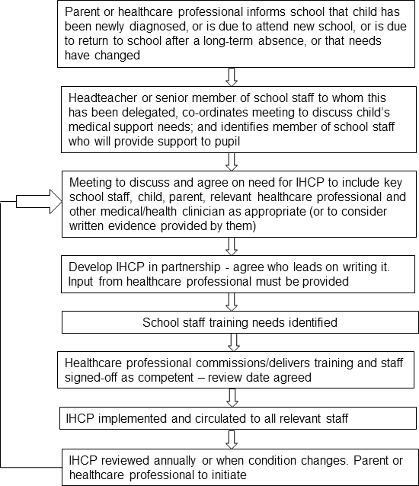

APPENDIX B – Treatments
- Treatment for Asthma

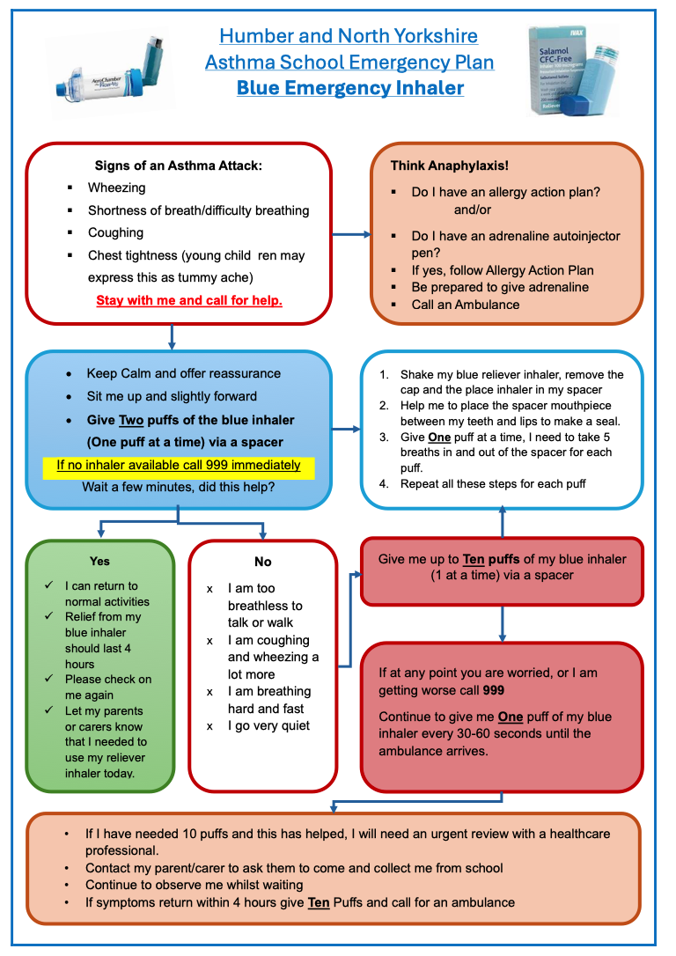

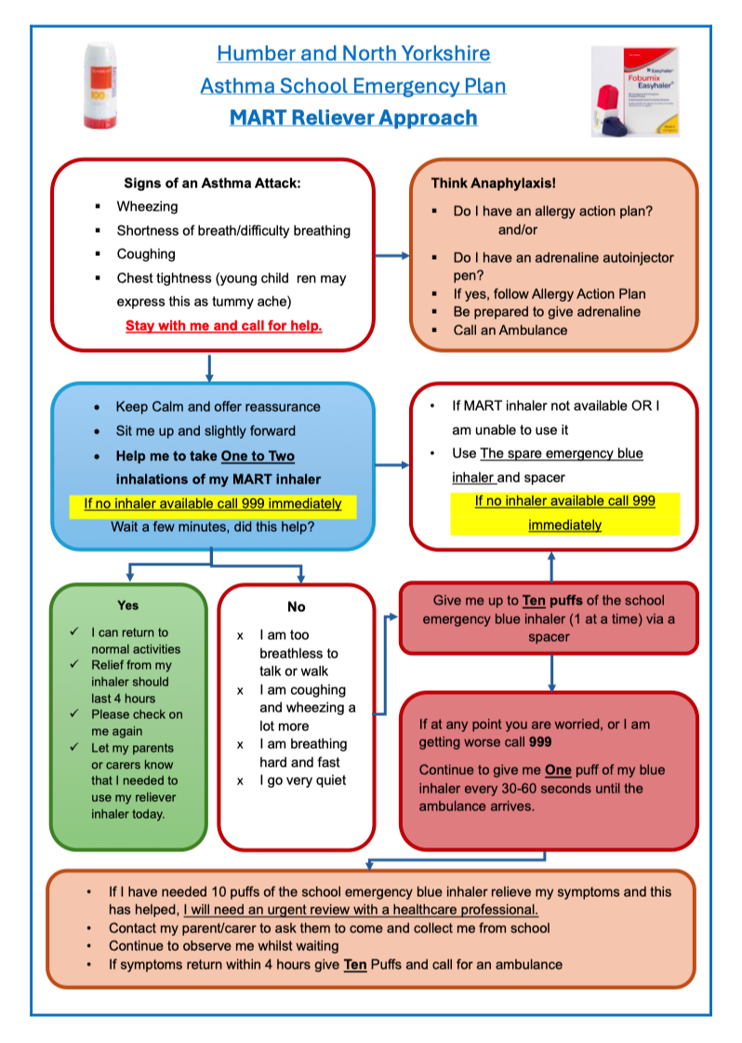

- Treatment for Diabetes

Diabetes is a serious condition where the blood glucose level is too high. There are two main types of diabetes; type 1 and type 2. Most children in school will have type 1 diabetes in which the body cannot make the hormone insulin. This type of diabetes is a lifelong condition. It can affect attention, memory and perceptual skills and must be well managed.
Treat a hypo immediately or it can lead to unconsciousness or fitting known as a severe hypo. How to treat a hypo should be written into an IHCP as it will be different for different people, but it will usually require a fast-acting carbohydrate. Do not leave a person who is having a hypo unattended.
Treating a hypo will usually involve testing blood sugar again after 10 to 15 minutes. More fast- acting carbohydrate may be required and a further retest after 10 minutes. Fast-acting carbohydrates for people for low blood sugar include:

- glucose or dextrose tablets
- jelly babies
- a small glass of a sugary (non-diet) drink
- a small carton of pure fruit juice
- two tubes of a glucose gel such as GlucoGel.
If you’re not sure how much carbohydrate is in a product, check the food label. It's important to check this often, as ingredients can change.
Always refer to the person’s Individual Health Care/Medical Care Plan
Aftercare for a Hypo
After a hypo, the person may need to eat or drink a bit more. This is to stop blood sugar levels going down again.
The advice suggests 15 to 20g of a slower-acting carbohydrate but this may be less for children, so
follow the IHCP. This could be a:

- sandwich
- piece of fruit
- bowl of cereal
- glass of milk
- next meal

Always refer to the person’s Individual Health Care/Medical Care Plan when treating diabetes in school.

What to do when someone is having a severe hypo
In the case of a severe hypo the individual may be unconscious and unable to swallow.

  - Put them into the recovery position (on their side, with their head tilted back and knees bent)
  - If they have a glucagon injection available for them to use and someone has had training to use it this should be administered or alternatively call 999. If 10 minutes after a glucagon injection the person has still not recovered, call 999 anyway.
- Treatment for Anaphylaxis

The symptoms of anaphylaxis include generalised flushing of the skin, rash (hives) anywhere on the body, a sense of impending doom, swelling of throat and mouth, difficulty in swallowing or speaking, alterations in heart rate, abdominal pain, nausea, vomiting, a sudden feeling of weakness, collapse and unconsciousness. In the event of an attack, it is important to administer a prescribed AAI as soon as possible and then call 999 for an ambulance. Anaphylaxis is likely when the following 3 things occurs:
- Sudden onset (a reaction can start within minutes) and rapid progression of symptoms
- Life-threatening airway/breathing difficulties or circulation problems – altered heart rate, sudden drop in blood pressure, feeling of weakness
- Changes to the skin eg., flushing, hives.
Adrenaline should be administered as soon as possible and on advice from 999, an emergency AAI held in school can be administered in case of suspected anaphylaxis. See section 10 of this policy for more details.
See additional links for further information and resources in school.
In the case of exposure to a known allergen, if ever a child has been exposed to a known allergen, known for them, they should be given their prescribed adrenaline to help avoid an allergic reaction progressing to anaphylaxis.

In the instance of anaphylaxis, the actions below should also be followed:
-Stay with the child and call for help- DO NOT MOVE THE CHILD OR LEAVE THEM UNATTENDED.
-Remove the trigger if possible (e.g., insect sting)
-Lie the child flat (with or without legs elevated), a sitting position may make breathing easier if they are struggling to breathe.
-ADMINISTER ADRENALINE WITHOUT DELAY and note the time given. Inject at the upper, outer thigh through clothing if necessary.
-CALL 999 and state ANA-FIL-AX-IS.
-If no improvement after 5 minutes, administer a second AAI.
-If no signs of life commence CPR/use a defibrillator if available.
-Phone parent/carer as soon as possible.

All individuals must go to hospital after anaphylaxis even if they appear to have recovered as a reaction can reoccur after treatment.

iv). Treatment for Epilepsy
Most children with epilepsy take anti-seizure medication (ASM) to prevent seizures. ASMs are usually taken once a day, or twice a day with a 12 hour interval, which usually means this happens outside school hours. This can sometimes cause memory issues or tiredness, so pupils may need support in class. If a seizure continues for more than five minutes, or one seizure follows another with no recovery in between, this is known as status epilepticus or 'status.’ Status during a tonic clonic (convulsive) seizure is a medical emergency and needs urgent treatment.
- only move them if they're in danger
- cushion their head if they're on the ground
- loosen any tight clothing around their neck, such as a collar, to aid breathing
- turn them on to their side after their convulsions stop – read more about the recovery position.
- stay with them and talk to them calmly until they recover
- note the time the seizure starts and finishes
- if the person is in a wheelchair, put the brakes on and leave any seat belt or harness on. Support them gently and cushion their head, but do not try to move them
- do not put anything in their mouth, including your fingers. They should not have any food or drink until they have fully recovered
- call 999 if: it's the first time someone has had a seizure, the seizure lasts longer than is usual for them, the seizure lasts more than 5 minutes, if you do not know how long their seizures usually last, the person does not regain full consciousness, or has several seizures without regaining consciousness, is seriously injured during the seizure or has difficulty breathing after the seizure, or if any seizure constitutes a medical emergency in their IHCP.

APPENDIX C – Useful Links and resources

The anaphylaxis campaign ‘Allergy Wise for Schools’ includes a free online e-learning course designed to ensure that all staff are aware of the signs, emergency treatment and the implications for management of severely allergic children: https://www.anaphylaxis.org.uk/education/allergywise-for-schools-information/
Also see The Safer Schools Programme: https://www.anaphylaxis.org.uk/education/safer-schools- programme/
This link enables you to download a fact sheet about non-food products and potential allergens: https://www.anaphylaxis.org.uk/fact-sheet/cosmetics-personal-care-products-and-medicines/ The Schools Allergy Code: https://theallergyteam.com/schools-allergy-code/

Anaphylaxis:
https://www.anaphylaxis.org.uk/education/about-safer-schools-programme/

https://www.anaphylaxis.org.uk/education/guidance-for-primary-schools/
https://www.allergyuk.org/resources/anaphylaxis-and-severe-allergic-reaction-factsheet/

https://www.allergyuk.org/resources/anaphylaxis-symptoms-and-action-sheet/
AAI’s:
https://www.gov.uk/government/publications/using-emergency-adrenaline-auto-injectors-in- schools

https://www.allergyuk.org/for-industry-and-education/schools-early-years/spare-pens-in-schools/

Asthma + Lung UK – www.asthma.org.uk
Beat Asthma- https://www.beatasthma.co.uk

How to Use a Turbohaler:
https://www.youtube.com/watch?v=fK7A0ECRCmg

How to use an Easyhaler:
https://www.youtube.com/watch?v=TvwRdPExNb0

Humber and North Yorkshire Healthier Together- https://www.hnyhealthiertogether.nhs.uk/

Diabetes – www.diabetes.org.uk Epilepsy - https://www.epilepsy.org.uk/
Infectious Diseases - https://www.gov.uk/topic/health-protection/infectious-diseases

Supporting Medical Conditions in Schools: https://assets.publishing.service.gov.uk/media/5ce6a72e40f0b620a103bd53/supporting-pupils-at- school-with-medical-conditions.pdf

Managing Allergies in School:

https://www.gov.uk/government/publications/using-emergency-adrenaline-auto-injectors-in- schools
https://www.gov.uk/government/publications/school-food-standards-resources-for-schools/allergy- guidance-for-schools

https://www.allergyuk.org/living-with-an-allergy/at-school/for-schools/

https://theallergyteam.com/resources-and-insight/

https://laca.co.uk/sites/default/files/attachment/basic- page/LACA%20Allergen%20Management%20Guidance%20%28c%29%20version%20SEPT%2020.pdf

- APPENDIX D – Example Consent Form for administering medicines

