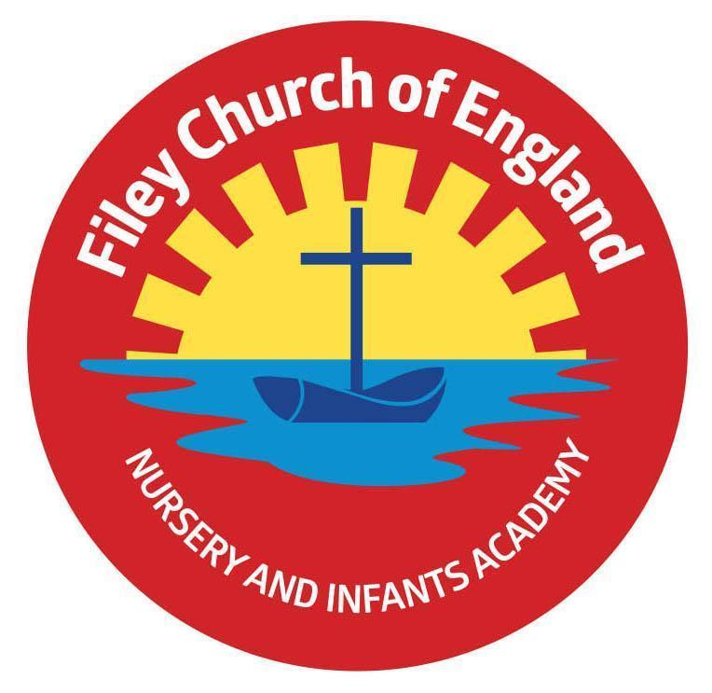
Friday 9th January 2026
Dear Parents and Carers
We hope you all had a lovely Christmas and have had a great start to the new year. As we start the Spring Term, I am writing to let you know what we will be learning and all of the exciting things we have planned.
Our Curriculum
As a school, we work tirelessly to make sure our curriculum is up-to-date as well as exciting and engaging for all our children. This half term our theme is Life on Earth. During our topic we will be answering the question Which animals live where? Our Literacy focus will be on writing recounts, fact files and narratives. We will do this through reading and sharing our class books ‘Little Turtle and the sea’, ‘Lots: Diversity of Life on Earth’ and ‘Dear Greenpeace’. In maths we begin our learning on multiplication, division and time. In Science we will be learning that animals, including humans, have offspring which grow into adults. In Computing we will be recapping our learning on E-Safety and exploring ways that we can create, communicate and collaborate using technology. In RE we will be revising our big question ‘Who are Muslims and what do they believe?’ with a focus on identifying objects and special events that are significant to Muslims. Our PSHE learning will focus on ‘People in my World’. Children will learn about stereotypes, friendships and celebrating differences between themselves and their friends. In PE we will be enjoying gymnastics. We will explore different balances and work with peers to create a routine. In Geography children will be able to name and locate the 7 continents and 5 oceans. In Music children will be exploring music across different continents on earth. In DT children will be creating a sliding picture linked to life on earth.
Enterprise
This half term Year 2 will be completing their first class enterprise. Keep your eyes peeled for further information.
PE
Children will have twice-weekly PE sessions. The days may change each half term (check the class window for changes). If your child is attending swimming lessons then this will count as their second PE lesson. On PE days please ensure that your child is properly prepared. If they wear earrings please remove them before school (staff are not able to support them with this). Please can all long hair be securely tied up to avoid any accidents.
Children must have the correct PE kit with them. This should include named; white t-shirt, black or navy blue shorts, and trainers for outside. Feel free to also include leggings/tracksuit bottoms and a warm jumper now the weather is colder. Children are welcome to leave this hanging on their peg all half term to make life easier!
Do not forget, as a school we are trying to do our bit for the planet and recycle as much as possible. If you would like some PE kit (or any uniform) from our good quality free second hand uniform cupboard, please phone the office or catch me on the door.

Phonics and Reading
In Year 2 children will have daily phonics/SPaG and Reading Practise sessions. In school, reading books are changed regularly. We aim to change books every week but on some occasions, this may be fortnightly. This book will be available to read the following week on our online reading platform, Collins eBooks.
Children will also bring home a physical book to read. This can be read and changed as regularly as they wish. In year 2, children are given the responsibility of changing this book themselves. Whilst we do remind them regularly, please let us know if it keeps getting missed! As a school we recommend that children read at home every day, so please read as regularly as you are able to.
Library
During the week, children will visit our Big Red Reading Bus twice. We will have a whole class story time on the bus, as well as allowing another opportunity for children to choose and borrow their own book. Please support your child to remember to bring their library book to change every week.
Homework
Throughout the year, children will receive weekly homework. We try to provide a range of engaging activities covering all different areas of the curriculum. Each week these can be found in children’s orange homework books. Every half term year 2 children also have a set of key words to practise. These are words which all children of this age should be able to read and write by the end of the year. Please support your child to practise these words at home throughout the half term, some suggestions of how to do this can also be found in their homework books.
Homework will be given out each Friday. Please help your child to return their homework to school by the following Thursday so we can mark and update their books. Although we encourage this to be completed every week, we understand that sometimes life is just a bit busy so please do not worry! Each week your child will receive a set of spellings based on the spelling rules we have been learning that week. Children will complete a short spelling check every Friday.
Weekly Newsletters
As always, Mrs Clark and Mrs Stubbs will continue to write weekly newsletters to keep you up-to-date with all the exciting things happening in school. To reduce our paper use and do our part for the planet, these will be emailed out every Friday and uploaded onto the school website. Please contact the office if you are not receiving them. These newsletters also include important upcoming dates that you need to be aware of so please take the time to check them weekly. Thank you in advance for all of your support. Please remember that we are here to help if you need us. Kind regards
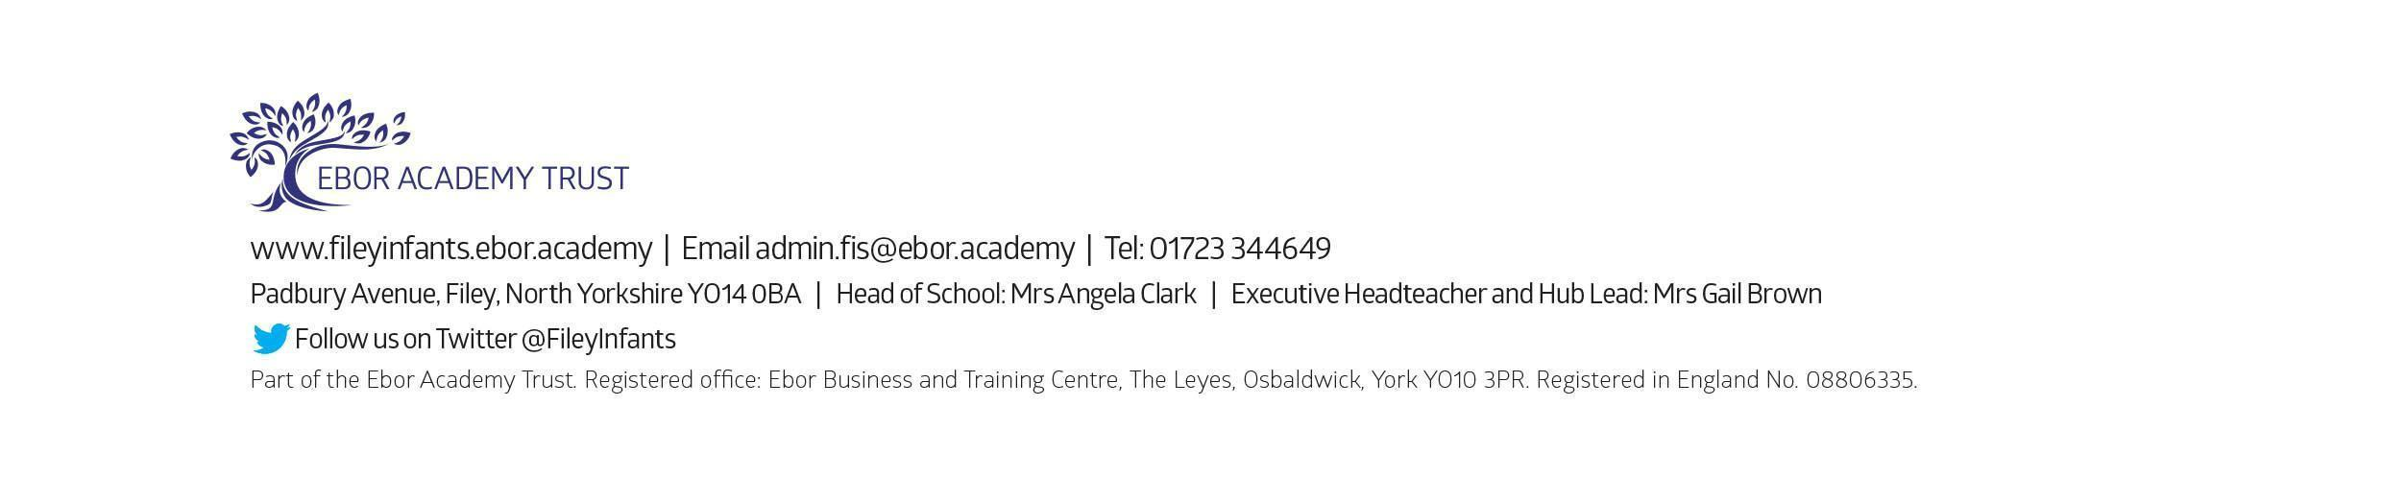
Mr Jackson and Miss Haldenby

