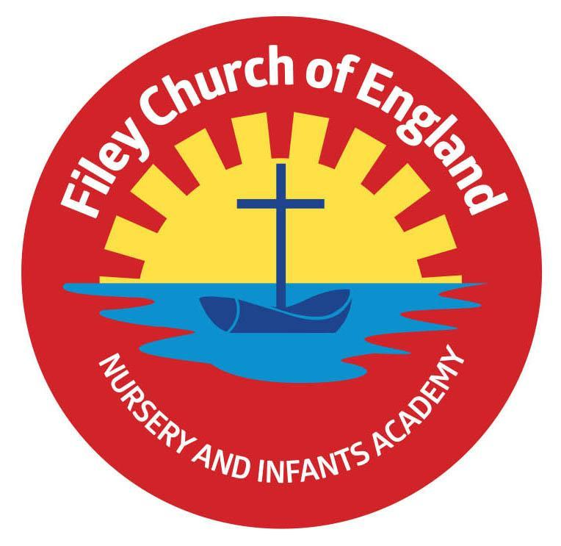Friday 5th September 2025

Dear Parents and Carers,

Welcome to Year 1! We have had a fantastic start to the year and are very much enjoying getting to know each other. We are writing to you to welcome you as Year 1 parents and carers and to give you some more information about what to expect in Year 1.

**Our Curriculum**

As a school we work tirelessly to make sure our curriculum is up-to-date as well as exciting and engaging for all our children. This half-term our theme is **Fantastic Filey**! Our themes for the year and more information about our long-term plan can be found on the school website, www.fileyinfants.ebor.academy under Teaching and Learning - Curriculum.

In Literacy we will be developing our writing skills focusing on writing labels and captions and including finger spaces in our writing. We will be exploring our key texts including Who are you? Storm Whale, Grandma Bird and Tree. In Maths we will begin practising to count within 100 before learning comparison of quantities and exploring part-whole relationships. In Science children will be naming and identifying common plants and trees. In RE we will be thinking about belonging, considering what we belong to and what it means to belong to the religious faiths of Christianity and Islam. In Geography we will be learning about human and physical features within our local area, exploring aerial photos and simple maps.

**Important dates for this half term:**

Monday 29th September - Miss Ring’s class trip to White Lodge Farm.

Wednesday 1st October - Miss Ghorst’s class trip to White Lodge Farm.

Friday 17th October - Miss Ring’s Class Poetry Assembly in the hall at 9am.

Friday 24th October - Miss Ghorst’s Class Poetry Assembly in the hall at 9am.

**PE**

Children will have twice-weekly PE sessions. The days may change each half term (check the class window for changes). This half term our PE days will be **Monday** and **Thursday**. On these days, please ensure that your child is properly prepared. If they wear earrings, please remove or cover them before school (staff are not able to support them with this). Please can all long hair be securely tied up to avoid any accidents.

Children must have the correct PE kit with them. This should include named; white t-shirt, black or navy shorts, and trainers for outside. Feel free to also include leggings/tracksuit bottoms and a warm jumper as the weather gets colder. Children are welcome to leave this hanging on their peg all half-term to make life easier!

**Uniform**

As a school we are trying to do our bit for the planet and recycle as much as possible.  If you would like any uniform or some PE kit from our good quality second hand uniform cupboard, please phone the office or catch me at the door.

**Phonics and Reading**

In Year 1 children have daily phonics and guided reading sessions. To enable you to best support your child’s phonics at home, we will be sending home a small sheet each Friday detailing what we have covered so you know what to practise with them.

In school guided reading books will be changed regularly. We aim to change books every week but on some occasions this may be fortnightly. This book will be available to read the following week on our online reading platform, Collins eBooks. Their log on details are the same as reception but please keep an eye out in your child’s reading record as we will be sticking them in very soon.

Children will also be able to bring home a physical book to read. This can be read and changed as regularly as they wish. In Year 1, children are given the responsibility of changing this book themselves. Whilst we do remind them regularly, please let us know if it keeps getting missed!

As a school we recommend that children read at home every day, so please read as regularly as you are able to.

**Library**

During the week children will visit our Big Red Reading Bus. Please support your child to remember to bring their library book to change every **Wednesday**.

**Homework**

Throughout the year children will receive weekly homework. We try to provide a range of engaging activities covering all different areas of the curriculum. Each week these can be found in children’s yellow homework books.

Homework will be given out each Friday. Please help your child to return their homework to school by the following **Wednesday** so we can update their books. Although we encourage this to be completed every week, we understand that sometimes life is just a bit busy so please do not worry!

**Weekly Newsletters**

As always Mrs Clark and Mrs Stubbs will continue to write weekly newsletters to keep you up-to-date with all the exciting things happening in school. To reduce our paper use and do our part for the planet, these will be emailed out every Friday. Please contact the office if you are not receiving them. These newsletters also include important upcoming dates that you need to be aware of so please take the time to check them weekly.

Thank you in advance for all of your support. Please always remember that school is here to help if you need us.

Kind regards,

Miss K Ring and Miss C Ghorst

Miss Ring and Miss Ghorst

