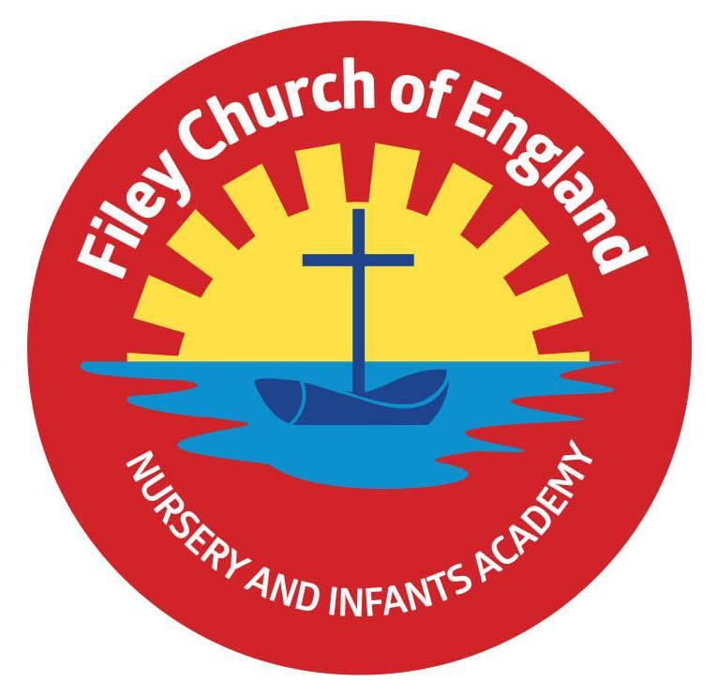
Friday 5th September 2025

Dear Parents/Carers
What a wonderful week we have had back at school. Our KS1 children have confidently entered school each morning and enjoyed being in their new classes. Our new starters are settling quickly into the school routine, although some do look a little tired today! Your child will bring home a welcome letter today from their class teacher, this gives you more information regarding what to expect during the school day. These letters can also be found on our school website www.fileyinfants.ebor.academy under: TEACHING & LEARNING – Classes – Teachers Name

Christian Distinctiveness
‘Wonder Time’ Church Group
‘Wonder Time’ church group for Year 1 children initially will take place each Monday lunchtime in school and is organised by our friends from St John’s Church. Children will enjoy Bible stories, craft activities and music. Year 1 children have already been given a letter with more information.
Year 2 children will receive their letter in January 2026 ready to start their sessions in the Spring & Summer terms. ‘Community, Compassion & Friendship’ are our core values, which are at the heart of everything we do.
Remember that we have a fully stocked good quality second hand uniform cupboard in school. If you would like any items please phone the school office or pass a list to the class teacher.

Starting School Meetings for Reception Parents/Carers
Starting school is an exciting time but can also be an anxious time for some children and their parents/carers. To help reduce these anxieties and to provide all necessary information our Reception teachers will be holding a ‘Starting School’ meeting next week.
This meeting will share school routines, expectations and provide an opportunity to ask any questions that you may have. The first meeting will take place on Monday 8th September at 2.20pm and a second meeting is after school at 5pm. Both meetings will take place in the school hall, please arrive via the main office.

Free Breakfast
Each morning we offer free breakfast in the classrooms at 8.40am. This includes a choice of cereal with milk and a drink of water. Your child will bring home a letter with a return slip so you can indicate whether you would like your child to have breakfast each morning or not. Please return this slip on Monday morning to ensure your child receives breakfast.

Milk
All children in Reception and Nursery receive free milk in school. If your child is in Year 1 or Year 2 and you would like them to have milk in school, you will need to pay for this via coolmilk.com
Please note: If your child is entitled to free school meals, you will not need to pay for milk.

Reception Baseline Assessments
The reception baseline assessment is a statutory assessment that must be administered within the first six weeks of a pupil joining reception. If you would like more information please follow this link: Information for parents: reception baseline assessment (publishing.service.gov.uk)

Important School Policies
We have a few updated policies to share at the start of this new school year. These policies have been attached to your email and are as follows:
- Parental Code of Conduct Policy
- Serial and Unreasonable Complaints
- Attendance & Privacy Notice
Please take the time to read these policies and be aware that all school policies are on our school website under: KEY INFO – POLICIES

Family Learning – starting again next week!
This is a wonderful opportunity to come into school and work with your child. We offer a choice of three sessions on either Wednesday’s at 9am, Wednesday’s at 1pm OR Thursday’s 1pm. Your child will have brought home a letter with more information. Mrs Keary is available during these sessions to help look after younger siblings so please bring them along. If you would like to attend, please return the slip by Monday 8th September.

‘Big Red’ the reading bus – starting again Monday 15th & Wednesday 17th
We will be starting our family reading club Monday 15th September and Wednesday 17th September.. It will take place on ‘Big Red’ and starts at 2.40pm. Parents/family members are welcome to come and read with their child on the reading bus. Children will collect a stamp each time they attend the club with a grown up and earn prizes. This is a weekly club on either Monday or Wednesday, please come to the main office on either day at 2.40pm. Everyone welcome! You will receive a letter with more information on Monday, please return this indicating which day you would like to attend so we can monitor numbers and prepare the children.

School Photos
Thursday 18th September will be our school photograph day. If you would like to bring siblings that do not attend our school to have a family photo you can do this between 8.30am and 9am. All children will have their photograph taken individually and with any siblings that they have in our school. If your child is in Nursery and you would like them to have their photograph taken, please bring them to the office at 10am. ONLY if they do not normally attend Nursery on a Thursday morning.

Year 2 PE Club
After school PE club for Year 2 pupils will start on Thursday 11th September in the school hall from 3pm-4pm. Your child should have been given a letter, please return the slip ASAP if your child would like to take part. Places will be offered on a first come first served basis, you will be notified by letter if your child has a place. If your child does not have a place this time, they will be first on the list for the Spring term.

Swimming Lessons
We are extremely fortunate to be able to offer all Year 1 and 2 children swimming lessons totally FREE of charge. These lessons take place every Thursday throughout the year and will start with Mr Jackson’s class. Your child will be bringing home a letter with more information and a consent slip that must be returned before they can start their lessons.

YMCA
The YMCA in Scarborough is offering FREE taster sessions this Saturday 6th September. The following sessions are available: Nursery/Reception children 9.30-10.30am and Year1/Year2 children 10.30-12.30pm
YMCA Yorkshire Coast
St Thomas Street
Scarborough
YO11 1DY
www.ymcayorks.uk
www.facebook.com/scarboroughymca
PINS Coffee Morning
Before the summer holidays we shared the exciting news that we are taking part in the PINS Project. (Partnerships for Inclusion of Neurodiversity in Schools.) Parents and careers are invited to a coffee morning held at the school on Thursday 18th September at 2pm. Please see the attached invitation for more details.

We are very much looking forward to working with all children and families this new school year and thank you for your continued support. Remember we are here to help however we can, if you have any concerns or questions please just ask. Please see the diary dates below.
Best Wishes
Mrs Angela Clark & Mrs Hannah Stubbs
Angela Clark
Hannah Stubbs
Co-Headteachers
Diary Dates – Please keep these dates safe for your information (more dates will be added as they arise).

September
Monday 8th September - Starting School Meetings for Reception parents/carers 2.20pm & 5pm
Wednesday 10th September – Family Learning sessions start with Lucy
Thursday 11th September - Swimming lessons start for Mr Jackson’s class
Thursday 11th September - After School PE club starts for Year 2
Monday 15th September & Wednesday 17th September – Family Reading club starts 2.20pm
Monday 15th September - Wonder Time for Year 1 starts at lunchtime
Thursday 18th September - School Photo Day
Thursday 25th September - Reverend Phil leads Collective Worship
Friday 26th September - Family Sponsored Walk 1.15pm
Monday 29th September - Miss Ring’s class Farm Visit

October
Wednesday 1st October - Miss Ghorst’s class Farm Visit
Friday 3th October – Provisional Harvest Festival 9am in the school hall
Friday 3rd October - Flu Vaccinations
Tuesday 7th October – Parent Meetings with teachers 3.10pm – 6pm
Wednesday 8th October – Parent Meetings with teachers 3.10 – 6pm
Thursday 9th October - Reverend Phil leads Collective Worship
Friday 10th October – ‘Hello Yellow’ World Mental Health Day
Friday 17th October – Miss Ring’s class poetry assembly 9am in the school hall
Friday 24th October – Miss Ghost’s class poetry assembly 9am in the school hall
Friday 24th October - School closes for half term

November
Tuesday 4th November – school opens
Thursday 6th November - After School PE club for Year 1
Thursday 6th November - Reverend Phil leads Collective Worship
Monday 10th November - Last Wonder Time for group 1
Tuesday 11th November - Remembrance Service for year 2 children
Friday 14th November - Children In Need Day
Monday 17th November - First Wonder Time for group 2
Thursday 20th November - Last swimming lesson for Mr Jackson’s class
Thursday 27th November - First swimming lesson for Miss Haldenby’s class
Thursday 27th November - Year 2 visit St John’s Church (Christmas Labyrinth)

