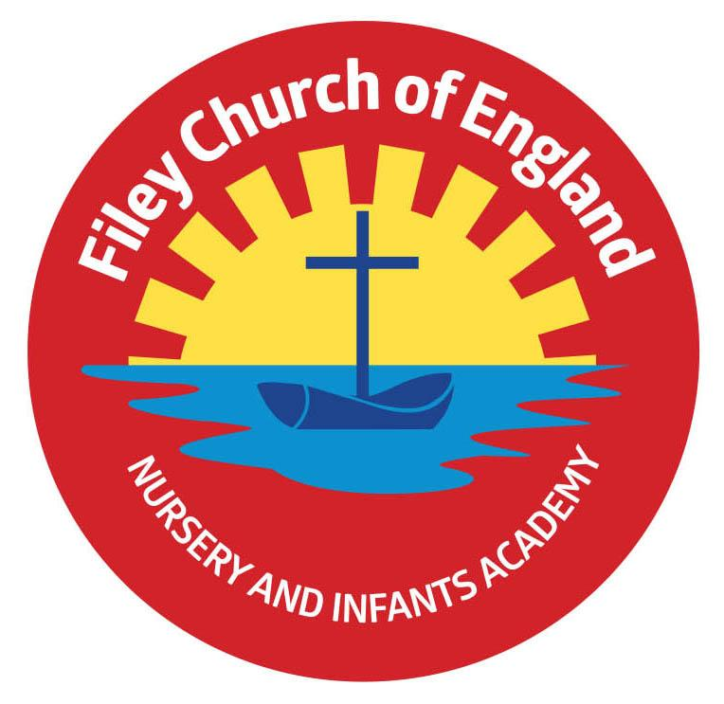Friday 4th July 2025

Dear Parents/Carers

Thank you to everyone who brought a bottle to school today for our Summer Fair ‘Bottle Tombola’ the children enjoyed their non-uniform day as a thank you treat. Transition days have been a great success this week with all children spending time in their new classrooms with their new teachers ahead of September. This week Miss Haldenby’s class won the attendance award with 100%, a big well done to them. Next week the lunch menu will be following week 2, please see attached to your email.

**Christian Distinctiveness**

This week we welcomed Major Geoff into our collective worship to share his thoughts on the importance of truth and truthfulness. This afternoon another group of our year 2 children when to St John’s Church to spend time with the ‘Happy to Help’ group. The children play games, sing and chat with the dementia group and thoroughly enjoy this friendship. *‘Community, Compassion & Friendship’* are our core values, which are at the heart of everything we do.

**Sports Days**

Year group sports days will take place on the dates below. They will all start at 1.15pm on the field at the back of school. The gate at the back of school (Clarence Drive) will be opened between 1pm-1.15pm for visitors to arrive.

Nursery – Monday 7th July (Nursery children that do not attend our Nursery on this afternoon are welcome to join us, please drop them off at the Nursery door between 12:50pm and 1:00pm.)

Year One Classes – Tuesday 8th July

Year Two Classes – Wednesday 9th July

Reception Classes – Thursday 10th July

**Summer Fair**

This year our Summer Fair will take place after school on Friday 11th July from 3pm-4.30pm. There will be a variety of stalls including bottle tombola, raffle, cakes, hot dogs, face painting, games and competitions. The Fair will take place at the back of school on the field area, weather permitting. If the weather is wet or extremely windy, the Fair will take place inside the school building. A text message will go out to parents/carers on the day if plans do need to change.

We have some great raffle prizes again with the star prize being a Summer food and drink hamper worth over £50 other prizes include local shop vouchers, theatre vouchers, games, toys, chocolates and pamper sets. Your child will bring home a raffle ticket sheet should you wish to buy some tickets in advance of the Fair. Any donations of cakes/buns/biscuits will be gratefully received on the morning of Friday 11th July.

**Parent/Carer Questionnaires**

Just a reminder to send back your completed parental questionnaire sheet by Friday 11th July. Your thoughts and suggestions are always much appreciated and help us to shape the future of our school. Thank you.

**Earrings**

If you are planning for your child to have, their ears pierced, please consider the following information. The recommendation is 6 weeks before earrings can be removed. If children have their ears pierced near the start of the summer holiday they should be almost ready to take out for PE lessons and Swimming lessons in September. We do not want children to miss their lessons and naturally we need to keep everyone safe by ensuring earrings are removed for both PE activities and swimming. Covering earrings with tape is not safe practice and should be avoided if possible.

**Nursery News**

This week in Nursery we have enjoyed our transition day in Reception classes and meeting new friends for Nursery in September. We had a great morning meeting the animals that Neil from Whitby Falconers brought to show us and we have been practising our Sports day races down on the main field on the track in preparation for Monday.

**Reception News**

This week in Reception the children have been reading the story ‘Captain Beastlies Pirate Party’. In maths the children have explored problem solving using our wide range of maths knowledge. The children have spent lots of time practicing ready for their sports day next week. The children also had an exciting visit from Neil at the Whitby Falconers. The children enjoyed meeting and holding Colin the owl, Misty the owl, Bert the snake and Sid the blue-tongued skink lizard.

**Year One News**

Year 1 have had a very exciting week this week. In Literacy we have been writing our recounts all about our trip to Glen Gardens last week. In DT we have been designing and making our own shelters for an explorer. In PSHE we have been thinking about what we are looking forward to in Year 2 and any questions we might have about Year 2. We then brought these with us to our Year 2 teachers on transition day. In Music we have been looking at musical notation for different beats and performed the Can Can using our percussion instruments.

**Year 2 News**

Year 2 have enjoyed the time at the junior’s this week;

If you have any questions or need support with anything please just ask.

Best Wishes

Mrs Angela Clark & Mrs Hannah Stubbs

Angela Clark Hannah Stubbs

Co-Headteachers

Diary Dates – Please keep these dates safe for your information (more dates will be added as they arise).

July

Monday 7th July – Nursery Sports Day 1.15pm

Tuesday 8th July – Year 1 Sports Day 1.15pm

Wednesday 9th July – A group of Reception children visit Filey Fields

Wednesday 9th July – Year 2 Sports Day 1.15pm

Thursday 10th July – Reception Sports Day 1.15pm

Friday 11th July – School Summer Fair 3pm-4.30pm

Monday 14th July – RNLI Visit to School

Tuesday 15th July – Year 2 visit Filey Juniors to watch the year 6 production

Wednesday 16th July – Filey Library visit ‘Summer Reading Challenge’

Thursday 17th July – Last Swimming Session for Miss Wither’s class

Thursday 17th July – Year 2 Leavers Party 5pm-6.30pm

Friday 18th July – 11am Year 2 Leavers Collective Worship

Friday 18th July – 12pm Family Picnic

Friday 18th July – School Closes for Summer

September

Tuesday 2nd September – School Opens