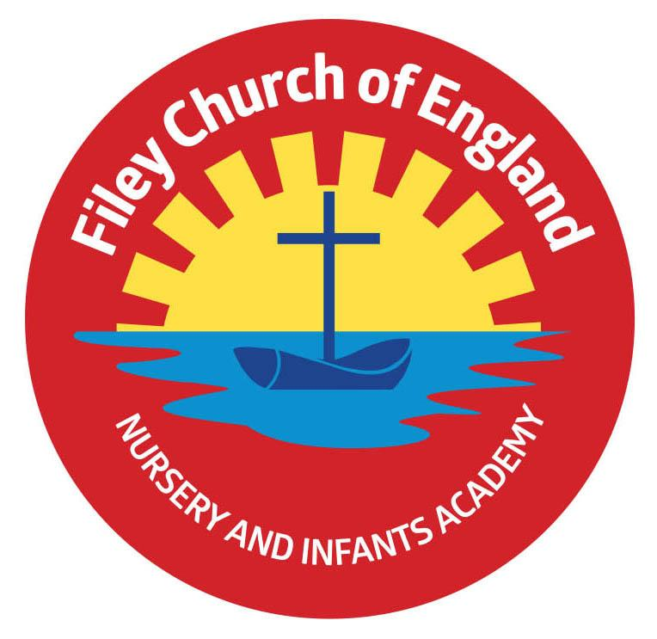Friday 11th July 2025

Dear Parents/Carers

Just a reminder that our Summer Fair will take place today from 3.10pm until 4.30pm. All our stalls and games will be set up at the back of school on the field. Hot dogs and refreshments will be served in Miss Haldenby’s class and the cakes/bun sale will be in Mr Jackson’s class. Please come along and support us if you can.

Thank you to everyone who came to our year group sports days this week. We were very lucky with the weather this year; all our children tried their very best and supported each other. This week Miss Haldenby’s class won the attendance award with 100%, a big well done to them. Next week the lunch menu will be following week2, please see attached to your email.

**Christian Distinctiveness**

This week some of our Reception children went to Filey Fields Court to entertain the residents and share their handmade flowers. The children thoroughly enjoyed singing their songs, nursery rhymes and chatting to all our friends. *‘Community, Compassion & Friendship’* are our core values, which are at the heart of everything we do.

**Ofsted Report**

On Tuesday 17th and Wednesday 18th June, we had the pleasure of welcoming Helen Haunch (Ofsted inspector) into school for our Ofsted inspection. The report has now been finalised and we are able to share this with Parents, Staff and Governors. It is a super report and I am sure you join us in being immensely proud of our school and community. The report is available to view on our school website.

**My Happy Mind Accreditation**

We are proud to announce that our school is officially a myHappymind Bronze Accredited school. The accreditation recognises schools that are embedding the myHappymind curriculum into school life and taking real action to improve the mental health and well-being of the school community.  As we were successful with our application, we will receive some fantastic resources to help us embed the myHappymind curriculum next year including a ‘Wheel of Gratitude’ to help us develop an ‘Attitude of Gratitude.’

**PINS (Partner in Neurodiversity in Schools)**

We are really excited to let you know that we have been selected to take part in the PINS project next academic year. The project’s aim is to work with schools to improve the lives of children and young people by ensuring families’ voices are heard by planners and decision-makers who shape local services and to support parents and carers to be equipped with the knowledge and information they need to be able to support their children and young people in the best way possible. A letter is attached to your email containing more information about this project. This letter also contains a link for parents and carers to complete an anonymous survey. Please could you submit the survey by **Wednesday 16th July 2025.** It only takes 5 minutes to complete per child.

**Earrings**

If you are planning for your child to have, their ears pierced, please consider the following information. The recommendation is 6 weeks before earrings can be removed. If children have their ears pierced near the start of the summer holiday they should be almost ready to take out for PE lessons and Swimming lessons in September. We do not want children to miss their lessons and naturally we need to keep everyone safe by ensuring earrings are removed for both PE activities and swimming. Covering earrings with tape is not safe practice and should be avoided if possible.

**Nursery News**

This week in Nursery we had our sports day which we thoroughly enjoyed. The children were brilliant and tried their hardest in all the races and were good sports if they did not win. Well done everyone! We also drew some pictures for a Remembrance competition and talked about poppies and why we wear them on Remembrance Day. Good luck to the children who chose to draw a picture and entered the competition. Winners will be revealed at a later date.

**Reception News**

This week in Reception, the children have continued reading the story ‘Captain Beastlie’s Pirate Party’. They have also written their own invitations to attend a pirate party. In maths, the children have been practising careful counting. The children had a wonderful time at their sports day on Thursday, having spent the week practicing their races and demonstrating sportsmanship. Additionally, the children have been learning about the artist Monet and have used their painting and colour mixing skills to create their own piece of art inspired by his ‘Haystacks’ painting.

**Year One News**

Year 1 had a fantastic time at their sports day on Tuesday. The children all did brilliantly and we are very proud of their positive attitude and achievements on the day. In maths this week we have been learning to tell the time to o'clock and half past on an analogue clock. In Literacy we have started reading our final whole class guided reading book; Space Tortoise. During RE we thought about the Golden Rule of treating others as we wish to be treated and thought about things we can do to follow this special rule. In PSHE we thought about sun safety and learnt the rap, Splat, Hat rule to be safe over the summer months. During music the children had a go at writing and performing their own stick notations using ta and ti-ti rhythms. We are very much looking forward to our last week as year 1's and have some special things planned to celebrate.

**Year Two News**

This week Year 2 enjoyed taking part in sports day. They have been reading the story Grey Island, Red Boat in their literacy lessons and practising their comprehension skills. In maths they have enjoyed solving different number challenges. During science they created their own posters about being healthy. In RE they compared St John's Church in Filey with a church in Australia. They have also been very busy preparing for their leavers' assembly.

If you have any questions or need support with anything please just ask.

Best Wishes

Mrs Angela Clark & Mrs Hannah Stubbs

Angela Clark Hannah Stubbs

Co-Headteachers

Diary Dates

July

Friday 11th July – School Summer Fair 3pm-4.30pm

Monday 14th July – RNLI Visit to School

Tuesday 15th July – Year 2 visit Filey Juniors to watch the year 6 production

Wednesday 16th July – Filey Library visit ‘Summer Reading Challenge’

Thursday 17th July – Last Swimming Session for Miss Wither’s class

Thursday 17th July – Year 2 Leavers Party 5pm-6.30pm

Friday 18th July – 11am Year 2 Leavers Collective Worship

Friday 18th July – 12pm Family Picnic

Friday 18th July – School Closes for Summer

September

Tuesday 2nd September – School Opens