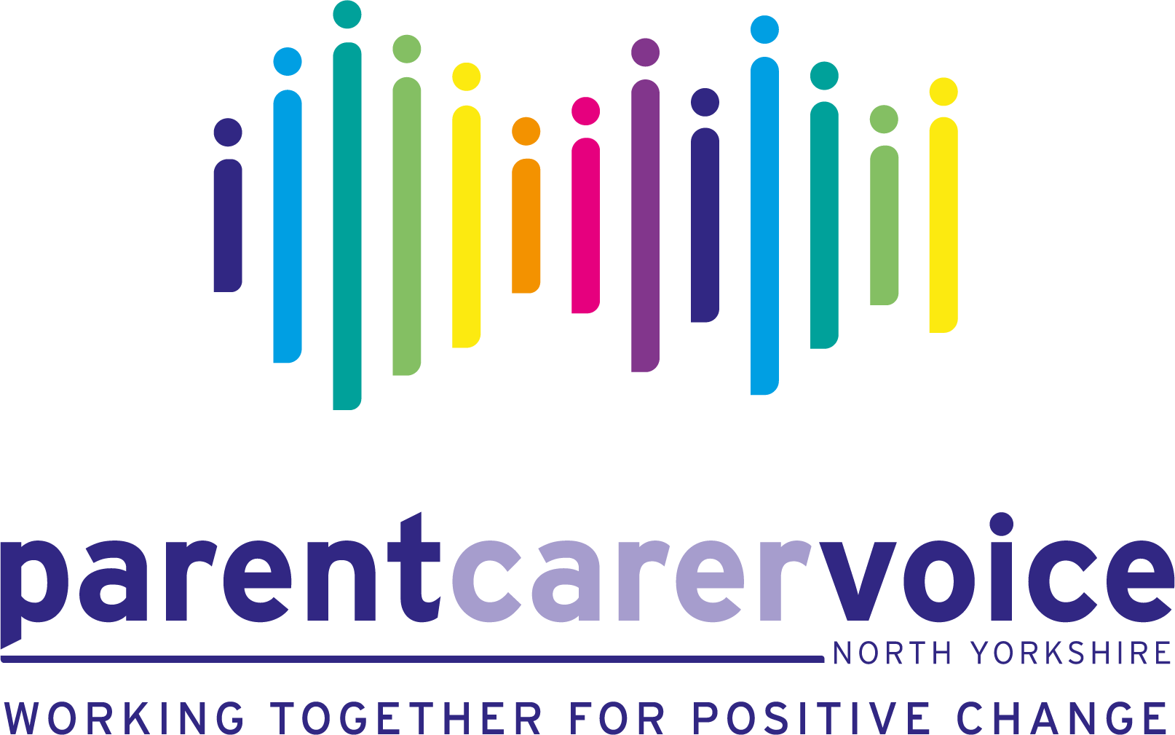

8th July 2025

Dear Parents and Carers

**Partnerships for Inclusion of Neurodiversity in Schools (PINS) Programme**

Parent Carer Voice North Yorkshire are going to be leading the parent carer engagement within your school’s new Partnerships for Inclusion of Neurodiversity in Schools (PINS) programme. We are the Parent Carer Forum for North Yorkshire, representing and supporting families with children and young people (0-25 years old) with Special Educational Needs and/or Disabilities (SEND). Please see our attached flyer for more info.

The purpose of the PINS programme is to improve the experience of mainstream school for *ALL* children who have an additional educational need, undiagnosed as well as diagnosed. Partnerships for Inclusion of Neurodiversity in Schools will bring health and education specialists and expert parent/carers into mainstream primary settings to:

• Help shape whole school SEND provision.  
• Provide early interventions at a whole school level.  
• Upskill school staff.  
• Support the strengthening of partnerships between schools and parents and carers.  
• Ascertain the needs of families with neurodivergent children and provide supportive training and information.

We are an integral part of the project, working very closely with your school over the next 10 months. To make this programme a success, we will require your experience, knowledge and support. We will be **hosting a coffee morning at the beginning of the Autumn term** to meet you and discuss your child/ren’s needs and **to discuss the support you can expect through the PINs programme.**

For us to assess your school’s current support for neurodivergent children, we are asking for **ALL** parents and carers attending your school to **fill in the attached brief, anonymous survey**. If you have more than one child attending the school, do please respond for each child separately as there may be variances in the support each child receives. We repeat, all responses are completely anonymous. We will use the information from the survey to understand the current strengths and areas for improvement in your child/ren’s school. We are particularly keen for feedback from families with children who have just completed Year 6 at the school.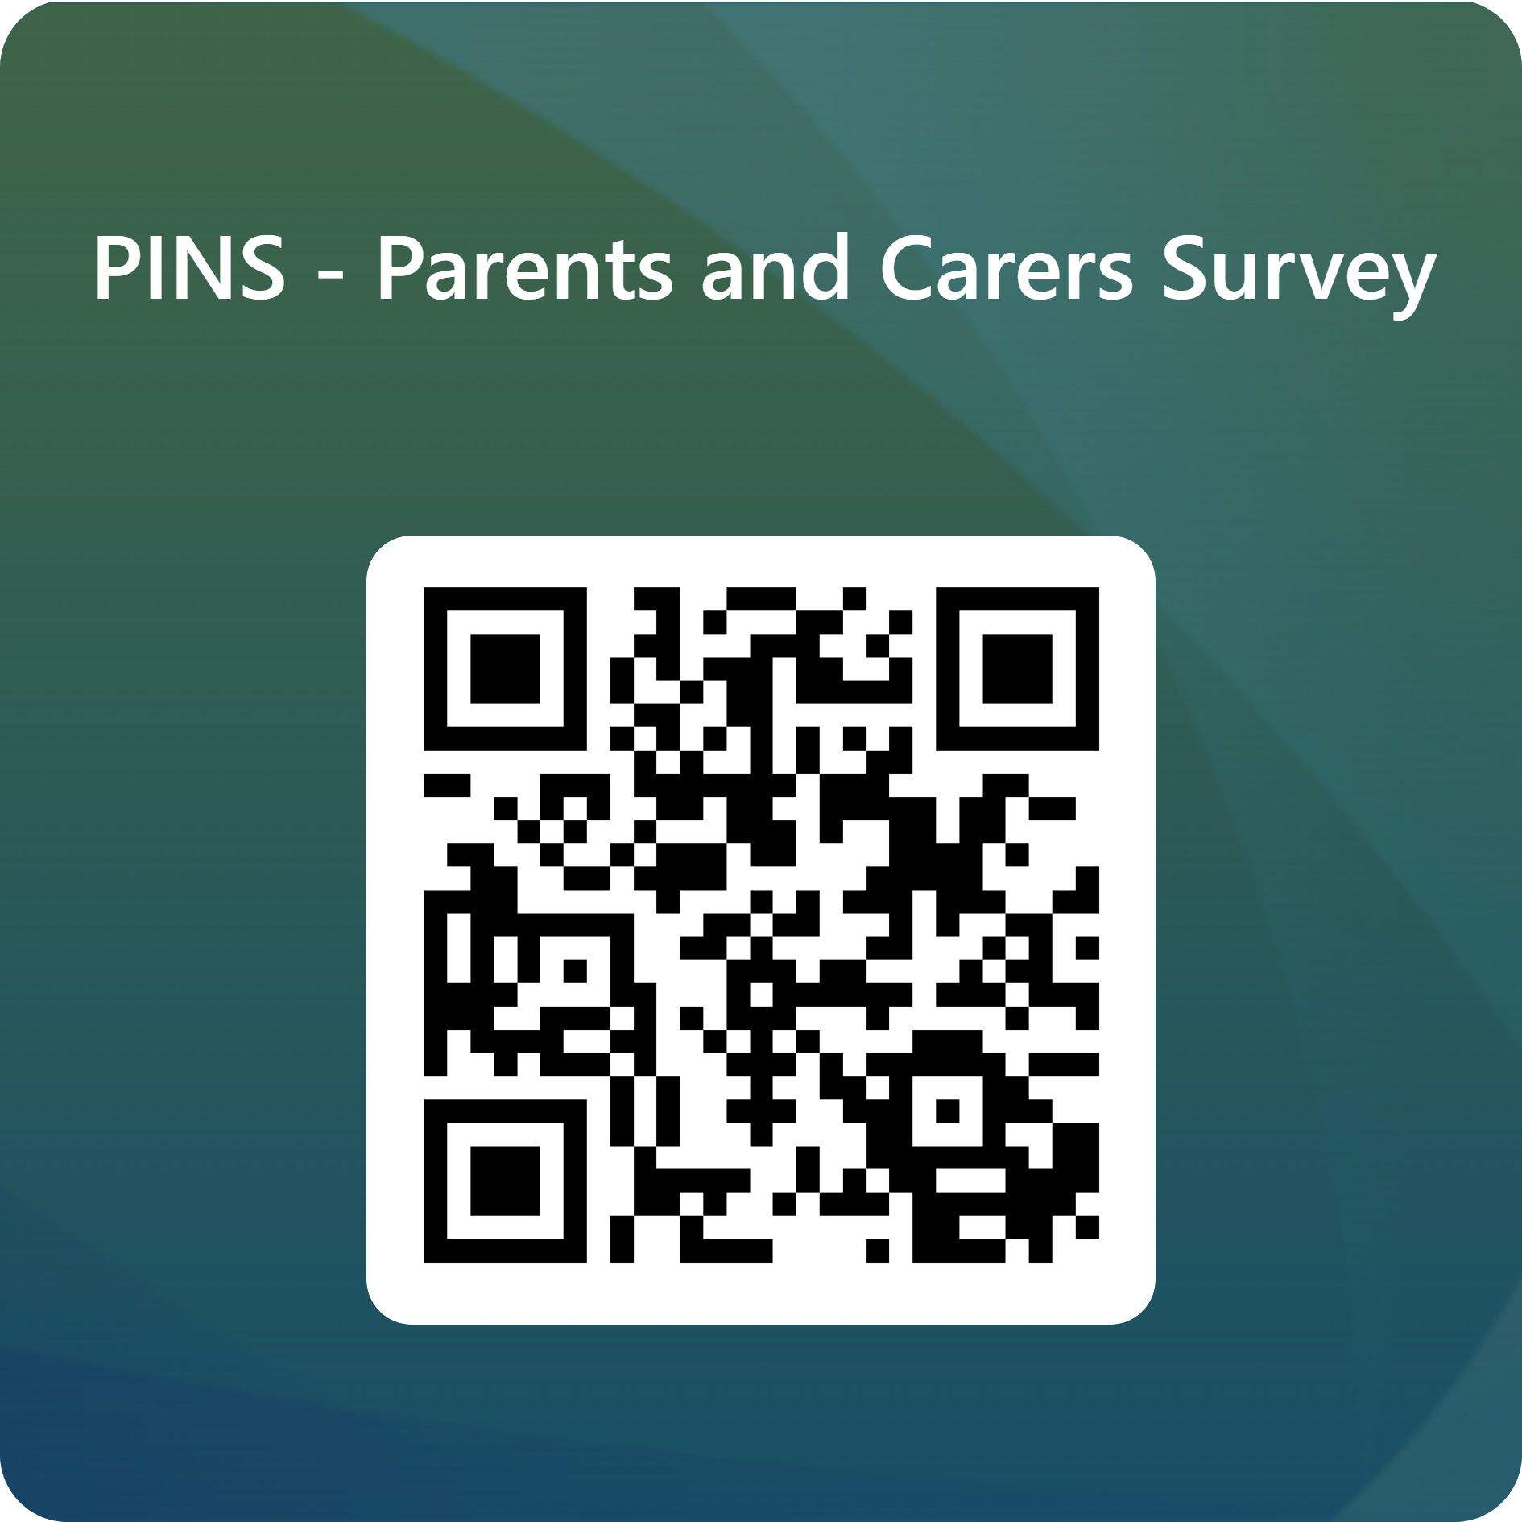

The parent carer survey can **also** be found here - <https://forms.office.com/e/icLHEeZDeA>

Please could you submit the survey by **Wednesday 16th July 2025.** It only takes 5 minutes to complete per child.

All information provided will be stored, used and accessed confidentially in accordance with Data Protection legislation. The individual information provided will only be accessible to Parent Carer Voice North Yorkshire. Your individual survey response will NOT be shared. The only time information will be shared is if it raises a concern for someone’s safety.

We are delighted to be included within the project and look forward to meeting you soon!

Yours sincerely

***Catherine, Sarah, Donna, Mel, Janet*** and ***Janine***

Parent Carer Voice North Yorkshire

Registered Charity: 1201947

[www.parentcarervoiceuk.org](http://www.parentcarervoiceuk.org)