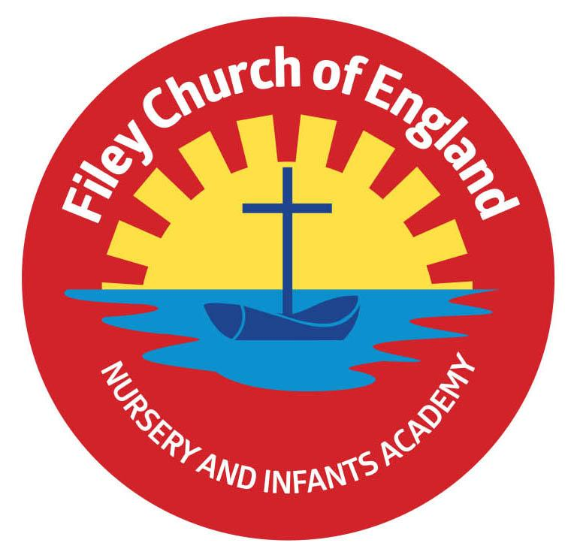
Friday 6th June 2025
Dear Parents/Carers
Class teachers have written information letters for the start of this half-term, which your child should have brought home with them today. These letters can also be found on our school website: www.fileyinfants.ebor.academy under TEACHING & LEARNING – Classes – Teacher’s name.
This week our year 2 children had a great time on their outdoor education day at Wydale Hall. They were all very well behaved and enjoyed many team building games and activities. Please return the year 1 and Reception trip letters as soon as possible, they came home earlier in the week.
Next week the lunch menu will be following week 2, please see attached to your email.
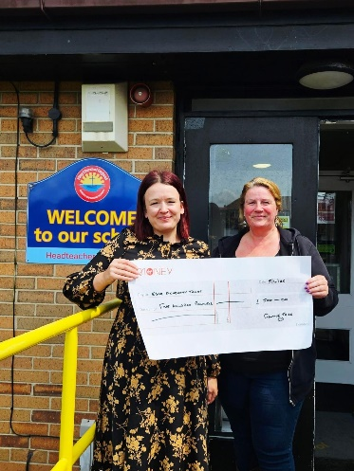
Christian Distinctiveness
Please remember we have a large selection of clothes in our FREE second hand uniform cupboard. Including summer dresses in all sizes, please ask at the office if you would like anything sending home with your child. Thank you so much to the organisers of the ‘Filey Fishtive Tree’ event for the £500 cheque which we received this week. The children always look forward to participating in this event and are very appreciative of their generosity. ‘Community, Compassion & Friendship’ are our core values, which are at the heart of everything we do.

Early Years Entitlement
Government Funding begins the term after the child turns the relevant age. Please see the leaflet attached to this email for more information.

Bramcoat School Athletic Clubs
Bramcoat in Scarborough are offering athletic clubs for children. These can be booked at: www.bramcoteathletics.co.uk
Please see session times below:
Monday 6-7PM 6-8 year olds
Monday 7-8PM 15+ years
Tuesday Pole vault Club
Wednesday - 6-7PM - 6-8 Year olds
Wednesday 7-8PM - 11-14 year olds
Thursday 6-7PM 9-10 year olds
Thursday 7-8PM 11-14 year olds
If you have any questions or need support with anything please just ask. Thank you for your continued support.
Best Wishes
Mrs Angela Clark & Mrs Hannah Stubbs
Co-Headteachers

Diary Dates – Please keep these dates safe for your information (more dates will be added as they arise).

June
Thursday 5th June – First Swimming Session for Miss Wither’s class
Wednesday 11th June – A group of year 1 children visit Filey Fields
Monday 16th June – Open the Book Collective Worship
Thursday 5th June – Year 2 Outdoor Education Day at Wydale Hall New Date!
Thursday 5th June – After school PE club starts for Nursery
Thursday 12th June – Reception Outdoor Education Day
Thursday 19th June – Year 1 Outdoor Education Day Date Changed
Friday 20th June – School Reports go out to parents/carers
Tuesday 24th June – Year 1 Outdoor Education Day New Date!
Wednesday 25th June – Reception classes Enterprise even 2.30pm
Thursday 26th June – School Open Evening 4pm-6pm
July
Tuesday 1st July – Whole School Transition Day (all classes including year 2 to Filey Junior School)
Wednesday 2nd July – Y2 transition to Filey Junior School
Thursday 3rd July - Y2 transition to Filey Junior School
Friday 4th July – Non-uniform day (bring a bottle for the Summer Fair)
Monday 7th July – Nursery Sports Day 1.15pm
Tuesday 8th July – Year 1 Sports Day 1.15pm
Wednesday 9th July – A group of Reception children visit Filey Fields
Wednesday 9th July – Year 2 Sports Day 1.15pm
Thursday 10th July – Reception Sports Day 1.15pm
Friday 11th July – School Summer Fair 3pm-4.30pm
Thursday 17th July – Last Swimming Session for Miss Wither’s class
Thursday 17th July – Year 2 Leavers Party 5pm-6.30pm
Friday 18th July – 11am Year 2 Leavers Collective Worship
Friday 18th July – 12pm Family Picnic
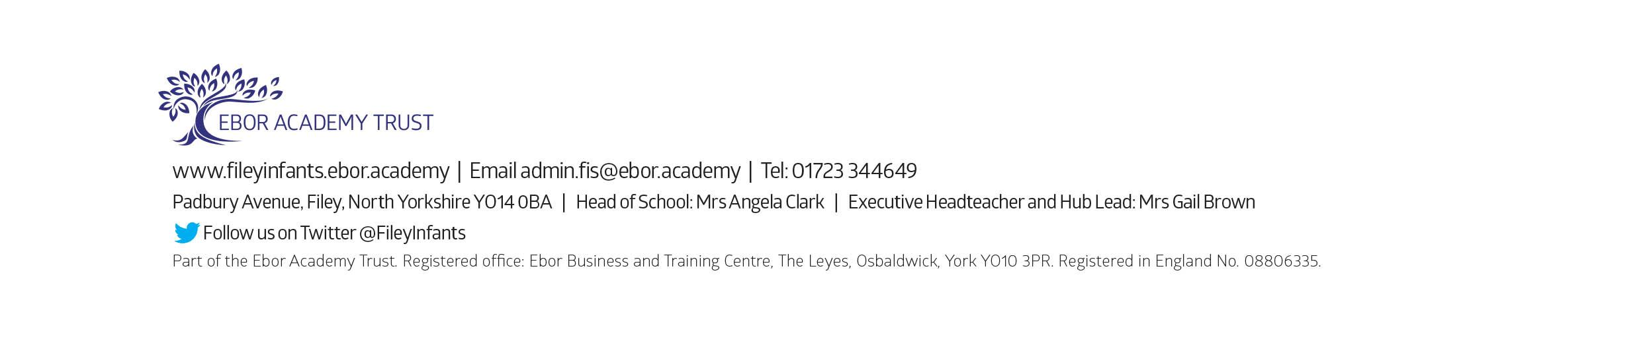
Friday 18th July – School Closes for Summer

