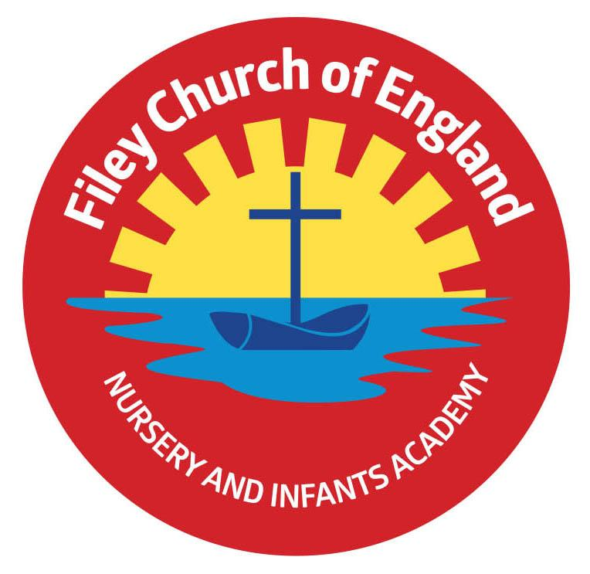Friday 27th June 2025

Dear Parents/Carers

Thank you to everyone who came to our school open evening this week. It is always wonderful to see so many families around school. This week Mrs Stubbs/Mrs Kerr’s class won the attendance award with 100%, a big well done to them. Next week the lunch menu will be following week 1, please see attached to your email.

**Christian Distinctiveness**

Thank you to everyone who came to support the Reception classes Enterprise event this week. The children have all worked hard and thoroughly enjoyed their topic.

Their next task will be to decide how to spend their profits. This will involve a shared discussion of ideas and a democratic vote to reach a final decision.

Thank you to Reverend Phil for leading another fantastic collective worship this week. With the children, he explored how we all experience different feelings in different situations.

There is a ‘Muddy Church’ event being held at St Johns church on Tuesday the 8th of July. Please find the details of this event on the leaflet attached to your email.

*‘Community, Compassion & Friendship’* are our core values, which are at the heart of everything we do.

**Non-uniform Day**

Friday 4th July is a non-uniform day in school. Children and staff are invited to come to school in casual clothes for the day and bring a bottle for the very popular ‘bottle tombola’ stall at our Summer Fair. This can be any kind of unopened bottle including; bubble bath, juice, sauces, pop or alcohol (please ensure alcohol is passed over to a member of staff or dropped off at the office). As always, we thank you for your support.

**Sports Days**

Year group sports days will take place on the dates below. They will all start at 1.15pm on the field at the back of school. The gate at the back of school (Clarence Drive) will be opened between 1pm-1.15pm for visitors to arrive.

Nursery – Monday 7th July (Nursery children that do not attend our Nursery on this afternoon are welcome to join us, please drop them off at the Nursery door between 12:50pm and 1:00pm.)

Year One Classes – Tuesday 8th July

Year Two Classes – Wednesday 9th July

Reception Classes – Thursday 10th July

**Parent/Carer Questionnaires**

Your child will have brought home a parental questionnaire sheet with them today. We would be very grateful if you could help us by filling in this questionnaire and returning it to school by Friday 11th July 3pm. Your thoughts and suggestions are always much appreciated and help us to shape the future of our school. Thank you.

**Family Learning**

Please note that next week there will be no family learning sessions due to our transition days.

The week after (week beginning 7th July) will be the last week for Family Learning sessions for this academic year. A big thank you to Lucy and Mrs Keary for all their hard work during these sessions.

We look forward to them starting again next academic year.

**After School Clubs**

The last week for Family Reading Club will be next week, so the last session is Wednesday 2nd July. PE Club will not take place in the last week of school; so the last session will be Thursday 10th July.

**Whole School Transition Day**

Tuesday 1st July is our school transition day for all year groups. You will drop off and collect your child at the normal place; your child’s new teacher will collect them and take them to their new classroom after registration and return them at the end of the day. Nursery children moving into Reception will have received a letter with more information, if you have any questions please phone the school office.

**Year 2 Transition Days**

Our year 2 children will enjoy three transition days to Filey Junior School. These will take place on Tuesday 1st, Wednesday 2nd and Thursday 3rd July. Please bring year 2 children to our school as normal on Tuesday 1st July, we will walk them to the Junior School in the morning and hand them over to their new teachers. You will need to collect your child from the Junior School on Tuesday & Wednesday at 3.30pm, you will also drop them at the Junior school both Wednesday and Thursday mornings. **On Thursday afternoon, the Junior School staff will walk the year 2 children back to our school so you can collect them as normal from us at 3.05pm.**

**Head lice**

A friendly reminder to please regularly check your child's hair for head lice. Routine checks are an important step in preventing the spread of head lice within our school community. If you do happen to find head lice, please treat them promptly. We really appreciate your support in helping us maintain a healthy environment for all our children.

**Nursery News**  
This week in Nursery we have been looking after the ducklings. We have been feeding them and we made a paddling pool for them. We have loved watching them and caring for them. We have also made lots of junk models and have been practicing phonics and maths. We have also looked at shapes.

**Reception News**

This week, Reception children have been reading Jonny Duddle's book, 'The Pirates Next Door,' and creating their own treasure maps. In Maths, we have been applying our learning of addition and subtraction to problem solving questions. In PSHE, we have been thinking about how we feel about our new classes for September and what change is. In Music, we continued to explore how music can inspire artwork, listening to Offenbach's 'Corporal Galop infernal' (Can-Can) and creating artwork or doodles to express our feelings. In RE, the children heard stories from and about Jesus from the Bible. We also had a fantastic time sharing our learning with all our grown-ups at our Enterprise. We raised an amazing £83.

**Year One News**

Year 1 had a brilliant day on Tuesday at Glen Gardens for our Outdoor Education Day. The children took part in lots of team activities including cross the swamp, orienteering, parachute games, foot rounders and team races. Despite a slightly soggy lunchtime we all had a lot of fun! In class this week we have started planning a recount of our trip during literacy. In maths we started learning about money. We identified 1p, 2p, 5p and 10p coins and used our skip counting skills to find total amounts. In PSHE we have been talking about different ways of coping with big emotions around change ahead of next week's transition day. During History the children learnt about modern day explorers and shared where they would like to explore and what they could discover. During RE we listened to this Islamic story "Be My Guest" and thought about what it means to sacrifice and care for others. In PE lessons we have been busy practising for our upcoming sports day.

**Year Two News**

This week Year 2 have enjoyed reading the story Festival of Colours in literacy. They have planned and written their own instructions based on the story. In maths they have solved problems involving measure using all four operations. They have also explored reading temperatures and measuring in centimetres. In science they learnt about the importance of hygiene for humans to stay healthy. They learnt about the features of a Mosque in their RE lesson. They enjoyed athletics activities in PE. In their DT lesson they enjoyed taste testing a range of salad vegetables. During geography they created their own map of the route from our school to the Junior School.

If you have any questions or need support with anything please just ask..

Best Wishes

Mrs Angela Clark & Mrs Hannah Stubbs

Angela Clark Hannah Stubbs

Co-Headteachers

Diary Dates – Please keep these dates safe for your information (more dates will be added as they arise).

July

Tuesday 1st July – Whole School Transition Day (all classes including year 2 to Filey Junior School)

Wednesday 2nd July – Y2 transition to Filey Junior School

Thursday 3rd July - Y2 transition to Filey Junior School

Friday 4th July – Non-uniform day (bring a bottle for the Summer Fair)

Monday 7th July – Nursery Sports Day 1.15pm

Tuesday 8th July – Year 1 Sports Day 1.15pm

Wednesday 9th July – A group of Reception children visit Filey Fields

Wednesday 9th July – Year 2 Sports Day 1.15pm

Thursday 10th July – Reception Sports Day 1.15pm

Friday 11th July – School Summer Fair 3pm-4.30pm

Thursday 17th July – Last Swimming Session for Miss Wither’s class

Thursday 17th July – Year 2 Leavers Party 5pm-6.30pm

Friday 18th July – 11am Year 2 Leavers Collective Worship

Friday 18th July – 12pm Family Picnic

Friday 18th July – School Closes for Summer