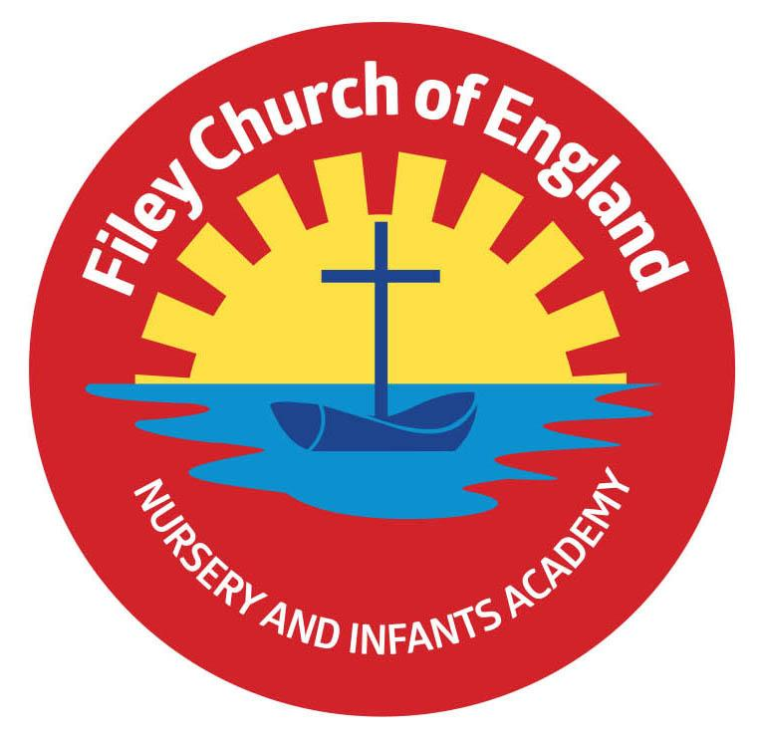
Friday 13th June 2025
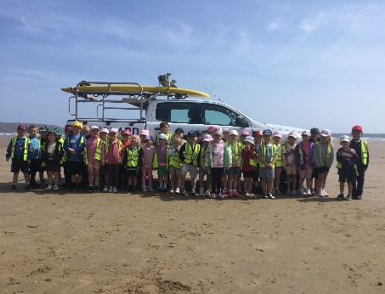
Dear Parents/Carers
This week our Reception children had a great time on their outdoor education day at Filey Beach. They were all very well behaved and enjoyed many team building games and activities. They finished their day off building sandcastles and having an ice-cream. Please return the year 1 trip letters as soon as possible.
This week Miss Ring’s Class won the attendance award with 99%, well done to them, they shared the box of Maltesers as a reward. Next week the lunch menu will be following week 1, please see attached to your email.

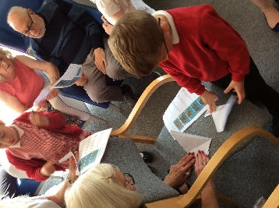
Christian Distinctiveness
Please remember we have a large selection of clothes in our FREE second hand uniform cupboard. Including summer dresses in all sizes, please ask at the office if you would like anything sending home with your child. On Wednesday a group of our Year 1 children visited Filey Fields. They sang a selection of songs about the importance of friendship and then taught the residents how to make origami dogs. ‘Community, Compassion and; Friendship’ are our core values, which are at the heart of everything we do.

Nursery News
This week in Nursery we have been preparing for our Enterprise and practising our sports day races. We have been talking about summer and being safe in the sun and why it is important to wear a sunhat, sun cream and why it is important to drink plenty of fluids.

Reception News
This week in Reception the children have continued their learning of the book ‘The Singing Mermaid’ by Julia Donaldson creating ‘WANTED’ posters for a character in the story. In maths the children have been learning about weight and capacity. Children have also been thinking about the changes that have happened in their lifetime including how they have changed during their year in Reception. In music children have been exploring how music can inspire artwork. The children have listened to ‘Wellerman’ and created artwork/doodles to represent how they feel. The children have also had a fantastic time on their end of year beach trip. They enjoyed beach combing, sandcastle building, running races and delicious ice cream!

Year One News
Year 1 have been continuing their new topic of explorers in History. This week we learnt about Captain James Cook and Earnest Shackleton. In Maths we have finished our unit on numbers within 20 by looking at using the number facts we know within 10 to help us within addition and subtraction within 20. In Literacy we have started to learn about writing a recount. In Whole Class Guided Reading we have been reading the book The Lonely Giant. In RE this week we learnt about the parable of The Lost Sheep and what Christians believe this teaches them about caring for others. In PSHE we talked about the differences between boys and girls bodies and revisited the NSPCC Pantosaurus rules. In Computing we have been using the BeeBots to begin learning about simple programming.

Year Two News
This week in literacy Year 2 have enjoyed exploring the story 'In Every House, On Every Street.' They have written about their favourite room in their own home and practised using commas in a list. In maths they have been learning about mass and using the scales to measure in grams. During science they have been learning about what animals, including humans, need to survive. During R.E. they learnt about the different parts of a church. In geography they learnt about the four compass points and then went outside to explore which direction different parts of the school are in.

Bramcoat School Athletic Clubs
Bramcoat in Scarborough are offering athletic clubs for children. These can be booked at: www.bramcoteathletics.co.uk
Please see session times below:
Monday 6-7PM 6-8 year olds
Monday 7-8PM 15+ years
Tuesday Pole vault Club
Wednesday - 6-7PM - 6-8 Year olds
Wednesday 7-8PM - 11-14 year olds
Thursday 6-7PM 9-10 year olds
Thursday 7-8PM 11-14 year olds
If you have any questions or need support with anything please just ask. Thank you for your continued support.
Best Wishes
Mrs Angela Clark & Mrs Hannah Stubbs
Co-Headteachers

Diary Dates – Please keep these dates safe for your information (more dates will be added as they arise).
June
Monday 16th June – Open the Book Collective Worship
Thursday 5th June – Year 2 Outdoor Education Day at Wydale Hall New Date!
Thursday 5th June – After school PE club starts for Nursery
Thursday 12th June – Reception Outdoor Education Day
Thursday 19th June – Year 1 Outdoor Education Day Date Changed
Friday 20th June – School Reports go out to parents/carers
Tuesday 24th June – Year 1 Outdoor Education Day New Date!
Wednesday 25th June – Reception classes Enterprise even 2.30pm
Thursday 26th June – School Open Evening 4pm-6pm
July
Tuesday 1st July – Whole School Transition Day (all classes including year 2 to Filey Junior School)
Wednesday 2nd July – Y2 transition to Filey Junior School
Thursday 3rd July - Y2 transition to Filey Junior School
Friday 4th July – Non-uniform day (bring a bottle for the Summer Fair)
Monday 7th July – Nursery Sports Day 1.15pm
Tuesday 8th July – Year 1 Sports Day 1.15pm
Wednesday 9th July – A group of Reception children visit Filey Fields
Wednesday 9th July – Year 2 Sports Day 1.15pm
Thursday 10th July – Reception Sports Day 1.15pm
Friday 11th July – School Summer Fair 3pm-4.30pm
Thursday 17th July – Last Swimming Session for Miss Wither’s class
Thursday 17th July – Year 2 Leavers Party 5pm-6.30pm
Friday 18th July – 11am Year 2 Leavers Collective Worship
Friday 18th July – 12pm Family Picnic
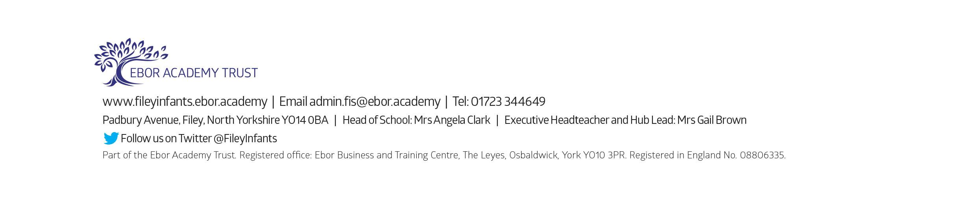
Friday 18th July – School Closes for Summer

