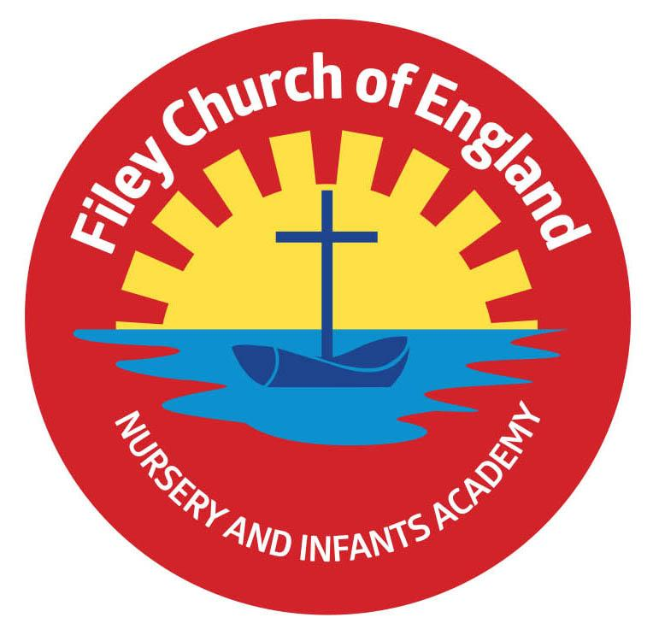
Friday 9th May 2025 Dear Parents/Carers
We have all had a wonderful week in school with our VE Day celebrations. Next week the lunch menu will be following week 1, please see attached to your email. Please note we will be having a special seaside lunch on Thursday next week, which will include ‘Seaside Fish Stars’ with ‘Helter Skelter Fries’ followed with ice cream and sauce or sprinkles.
Christian Distinctiveness
This week we welcomed some of our friends from Filey Fields Court to join our VE Day celebrations. Our year 2 children sang them songs and served refreshments. Some of our year 1 children shared a craft activity with them and Reception pupils recited poems. In the afternoon Filey Child Care joined our whole school on the playground for a tea party!
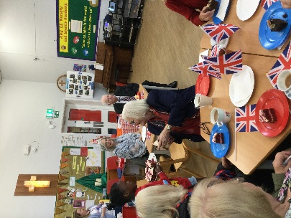
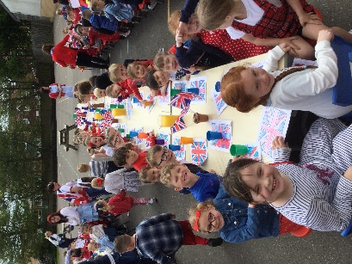

‘Community, Compassion & Friendship’ are our core values, which are at the heart of everything we do.

Year 2 and Year 1 Class Enterprise Projects
Year 2 and Year 1 classes invite you to attend their upcoming Enterprise events. These will take place in the school hall from 2.30pm-3pm on the following dates:
Mr Jackson - Monday 19th May
Miss Haldenby - Tuesday 20th May
Miss Ghorst - Wednesday 21st May
Miss Withers- Thursday 22nd of May
Miss Ring- Friday 23rd of May
This is a great opportunity to see what the children have been learning about in school whilst giving them an opportunity to share, perform and practice their entrepreneurial skills.

Nursery News
This week in nursery we have drawn pictures of beautiful blossom for our art books. We used oil pastels to draw the flowers and leaves. We have also used scissors to cut along lines to practice our scissor skills. We enjoyed a VE day party on the back playground and ate cake, biscuits and drank juice. The year 2 children sang songs from war time which we enjoyed listening to.

Reception News
This week in Reception the children have been reading the book Oliver’s Vegetables. Children have explored different vegetables and have done some vegetable printing. In maths they have been counting beyond 20, looking at patterns in numbers and continuing in 10s. Children have also been learning about VE day and preparing for our tea party. The children have helped write a poem that they shared with the visitors from Filey Fields. The children enjoyed their visit to the reading bus where they swapped their book and listened to a story.

Year One News
Year 1 have had a very exciting week this week. In Geography we took a flight to Kenya to explore all the different human and physical features of the country. In Literacy we have been writing our Animal ‘What am I’ poems ready for our class enterprise and in Art we have been designing and making our animal printing blocks ready to make our animal prints next week. We have also been very busy this week celebrating VE day. Some of us met with some of the residents at Filey Fields and enjoyed making VE day crafts together.

Year Two News
This week Year 2 have enjoyed planning and writing their own newspaper reports about important people who have changed our world. In maths they have continued learning about fractions including halves, thirds and quarters. During science they learnt about the lifecycle of a plant and were excited to observe how much their seeds have grown. During computing they learnt more about algorithms. They all enjoyed learning songs from World War One and Two which they sang at our special celebratory VE Day tea party.

Please note that we have added as many diary dates for the summer term as we could; please keep them safe so you do not miss anything. If you have any questions or need support with anything please just ask. Thank you for your continued support.
Best Wishes
Mrs Angela Clark & Mrs Hannah Stubbs
Angela Clark Hannah Stubbs
Co-Headteachers
Diary Dates – Please keep these dates safe for your information (more dates will be added as they arise).

May
Monday 12th May – Open the Book Collective Worship
Monday 19th May – Reception children heights and weights measured in school
Thursday 22nd May – Last Swimming Session for Miss Ring’s class
Friday 23rd May – School Closes for half term
June
Tuesday 3rd June – School Opens
Thursday 5th June – First Swimming Session for Miss Wither’s class
Monday 16th June – Open the Book Collective Worship
Thursday 5th June – Year 2 Outdoor Education Day at Wydale Hall New Date
Thursday 5th June – After school PE club starts for Nursery
Thursday 12th June – Reception Outdoor Education Day
Thursday 19th June – Year 1 Outdoor Education Day
Friday 20th June – School Reports go out to parents/carers
Thursday 26th June – Year 2 Outdoor Education Day Date Changed
Thursday 26th June – School Open Evening 4pm-6pm
July
Tuesday 1st July – Whole School Transition Day (all classes including year 2 to Filey Junior School)
Wednesday 2nd July – Y2 transition to Filey Junior School
Thursday 3rd July - Y2 transition to Filey Junior School
Friday 4th July – Non-uniform day (bring a bottle for the Summer Fair)
Monday 7th July – Nursery Sports Day 1.15pm
Tuesday 8th July – Year 1 Sports Day 1.15pm
Wednesday 9th July – Year 2 Sports Day 1.15pm
Thursday 10th July – Reception Sports Day 1.15pm
Friday 11th July – School Summer Fair 3pm-4.30pm
Thursday 17th July – Last Swimming Session for Miss Wither’s class
Thursday 17th July – Year 2 Leavers Party 5pm-6.30pm
Friday 18th July – 11am Year 2 Leavers Collective Worship
Friday 18th July – 12pm Family Picnic
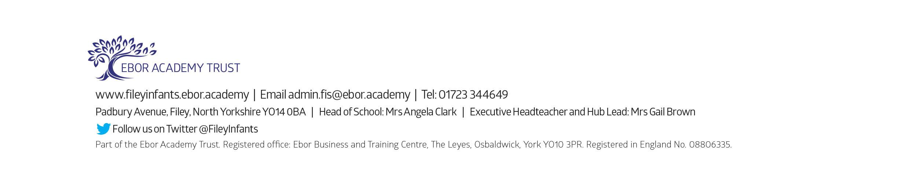
Friday 18th July – School Closes for Summer

