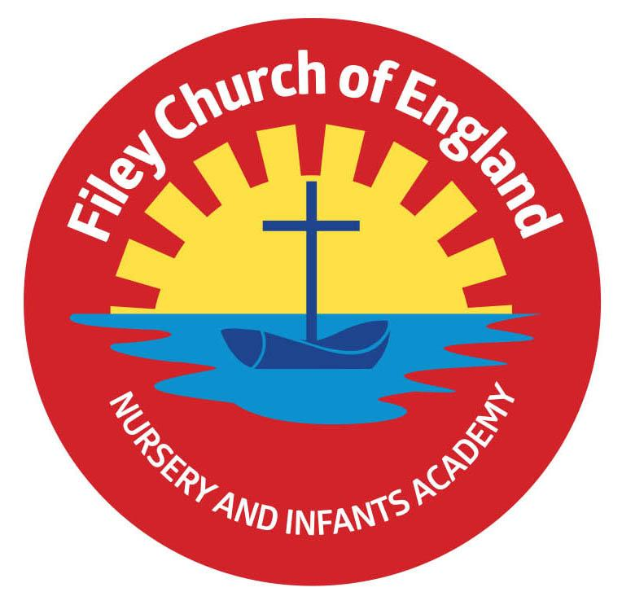
Friday 23rd May 2025
Dear Parents/Carers
It is with mixed emotions that we say a fond farewell to one of our mid-day supervisors this week, Mrs Gill Steel. Mrs Steel has worked for our school as a teaching assistant and more recently an MSA for over 25years! We wish her a very happy retirement and thank her for such wonderful service to the children of Filey. She will be greatly missed!
This week Miss Williams’ class won the attendance award with 99%, a big well done to them. The first week back after the half term, the lunch menu will be following week 2, please see attached to your email.

Christian Distinctiveness
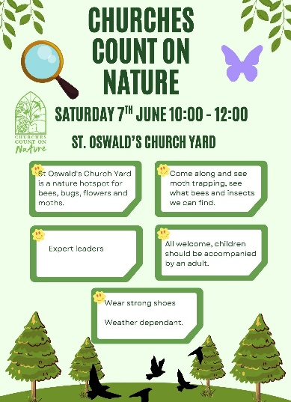
Thank you to everyone who came to support one of the year 1 and year 2 class Enterprise events this week. The children have all worked hard and thoroughly enjoyed these topics.
Their next task will be to decide how to spend their profits. This will involve a shared discussion of ideas and a democratic vote to reach a final decision.

Please see the poster opposite advertising an event happening at
St John’s Church on the 7th June. Everyone welcome!

‘Community, Compassion & Friendship’ are our core values, which are at the heart of everything we do.

Summer Outdoor Education Days
Each summer we plan exciting & fun outdoor education days for all our classes to experience and enjoy. Year group letters will come home with more information nearer the time. Please see below the dates and venues for each of these days:
Year 2 classes – Thursday 5th June - Wydale Hall
Year 1 classes – Tuesday 24th June - Glenn Gardens
Reception classes – Thursday 12th - June Filey Beach
Please note the year 1 and year 2 dates have changed from the original dates given, see the diary date list at the end of this letter.

Tempest Class Photographs
You should have received an email with the link to order class photographs. If you have not received this, please telephone the school office as soon as possible.

Solihull Approach for Families
The Solihull Approach is about emotional health and wellbeing for all children, their parents, carers and grandparents. They are passionate about sensitive relationships, early years support and understanding brain development to help nurture kind, emotionally aware children as they grow. This valuable NHS service offers a large selection of FREE courses to help parents/carers support their children. Please explore this link for the latest Solihull Approach information available to families – Falling out and making up.
inourplace | Solihull Approach – Falling out and making up: skills for life
The access code remains the same for any North Yorkshire families wishing to access the courses for free. Access Code: NYFAMILIES
Free wellbeing online courses in North Yorkshire – inourplace

Nursery News
This week in Nursery the children have enjoyed creating art using junk modelling. These are going to be displayed in the art corridor. In our My Happy Mind session we have shared some of the things we are thankful for. We have had lots of fun in our outdoor classroom and enjoyed completing an obstacle course.

Reception News
This week in reception we have been reading the book ‘The Odd Egg’ by Emily Gravett. The children have written character descriptions. In maths, the children have started learning about subtraction including how to use number lines and their fingers to help them with their careful counting. In PSHE the children learnt about healthy foods. In RE we learnt about what a place of worship is. We looked at different churches and mosques and considered why they might be important. The children have learnt about the artist Matisse and recreated his artwork of ‘The Snail’.

Year One News
Year 1 have had a busy last week of term. Thank you to everyone who was able to come along to our class enterprises. In Literacy we finished our poetry books and filmed our gameshow ready for enterprise. In Maths we started looking at teen numbers, concentrating on how they are made of one ten and some ones. In Geography we compared the UK to Kenya and were very surprised to learn that Kenya only had two seasons! During RE we looked at churches from around the UK and churches in Kenya and found that although they could look very different on the outside they actually have a lot of similarities. In PSHE we thought about how to be a hygiene hero; thinking of all of the ways we can protect ourselves from germs.

Year Two News
Year 2 thoroughly enjoyed taking part in their class enterprises this week and were excited to share all of their learning from this half term. Thank you so much to everyone who came to support them. In literacy the children have enjoyed sharing the story of Ossiri and the Bala Mengro. They explored the story together and wrote descriptions of the story setting. In maths they have been learning about position and direction. During RE they thought about good news in their lives and what the good news is that Christians believe Jesus brings. In computing they designed algorithms to guide the Beebots on a route and then tested them out. In science they observed the growth of their bean plants and used their findings to decide what a plant needs to grow well. They also enjoyed a live Lyfta lesson about identity and diversity.

Please note that we have added as many diary dates for the summer term as we could; please keep them safe so you do not miss anything. If you have any questions or need support with anything please just ask. Thank you for your continued support, we hope you all have a lovely half term. Please note that school reopens on Tuesday 3rd June.
Best Wishes
Mrs Angela Clark & Mrs Hannah Stubbs
Angela Clark Hannah Stubbs
Co-Headteachers
Diary Dates – Please keep these dates safe for your information (more dates will be added as they arise).

May
Friday 23rd May – School Closes for half term
June
Tuesday 3rd June – School Opens
Thursday 5th June – First Swimming Session for Miss Wither’s class
Wednesday 11th June – A group of year 1 children visit Filey Fields
Monday 16th June – Open the Book Collective Worship
Thursday 5th June – Year 2 Outdoor Education Day at Wydale Hall New Date!
Thursday 5th June – After school PE club starts for Nursery
Thursday 12th June – Reception Outdoor Education Day
Thursday 19th June – Year 1 Outdoor Education Day Date Changed
Friday 20th June – School Reports go out to parents/carers
Tuesday 24th June – Year 1 Outdoor Education Day New Date!
Wednesday 25th June – Reception classes Enterprise even 2.30pm
Thursday 26th June – Year 2 Outdoor Education Day Date Changed
Thursday 26th June – School Open Evening 4pm-6pm
July
Tuesday 1st July – Whole School Transition Day (all classes including year 2 to Filey Junior School)
Wednesday 2nd July – Y2 transition to Filey Junior School
Thursday 3rd July - Y2 transition to Filey Junior School
Friday 4th July – Non-uniform day (bring a bottle for the Summer Fair)
Monday 7th July – Nursery Sports Day 1.15pm
Tuesday 8th July – Year 1 Sports Day 1.15pm
Wednesday 9th July – A group of Reception children visit Filey Fields
Wednesday 9th July – Year 2 Sports Day 1.15pm
Thursday 10th July – Reception Sports Day 1.15pm
Friday 11th July – School Summer Fair 3pm-4.30pm
Thursday 17th July – Last Swimming Session for Miss Wither’s class
Thursday 17th July – Year 2 Leavers Party 5pm-6.30pm
Friday 18th July – 11am Year 2 Leavers Collective Worship
Friday 18th July – 12pm Family Picnic
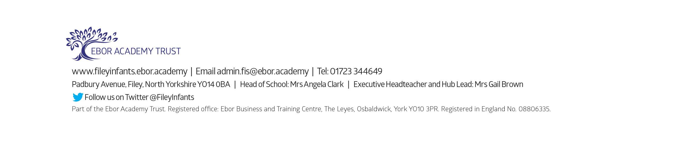
Friday 18th July – School Closes for Summer

