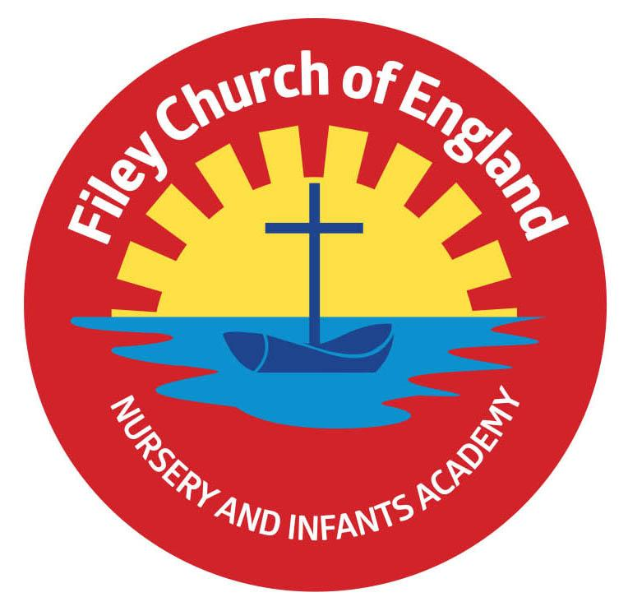
Friday 16th May 2025
Dear Parents/Carers
This week Mr Jackson’s Class won the attendance award with 97%, a big well done to them. Next week the lunch menu will be following week 2, please see attached to your email.

Christian Distinctiveness
We are very happy to continue to grow our intergenerational work within the local community. As you already know, we are very proud to have a wonderful relationship with many residents at Filey Fields Court. Our children make regular visits to Filey Fields and on VE day, many of their residents came to celebrate this event with us in school.
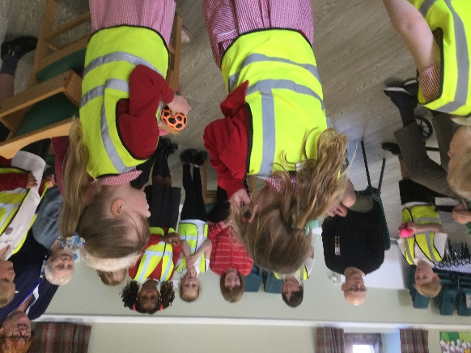
We have now started to visit St John’s Church each Friday afternoon to join the ‘Happy to Help’ dementia group. A group of year 2 children will take it in turns each week to join the ‘Happy to Help’ team for games and singing. It is always a delight to see our young children making so many elderly people in our community happy and smiling. In return, our children learn to respect the elderly community, learn to share special times with others, and always thoroughly enjoy these visits. ‘Community, Compassion & Friendship’ are our core values, which are at the heart of everything we do.

Summer Outdoor Education Days
Each summer we plan exciting & fun outdoor education days for all our classes to experience and enjoy. Year group letters will come home with more information nearer the time. Please see below the dates and venues for each of these days:
Year 2 classes – Thursday 5th June - Wydale Hall
Year 1 classes – Tuesday 24th June - Glenn Gardens
Reception classes – Thursday 12th - June Filey Beach
Please note the year 1 and year 2 dates have changed from the original dates given, see the diary date list at the end of this letter.

The Little Princess Trust
One of our year 1 pupils (Riley) is donating a minimum of 14 inches of her hair to the Little Princess Trust in May half term. This was all her idea after seeing an advert for the charity. If you would like to support Riley by making a donation, here is the link to her Just Giving page: www.justgiving.com/page/rileys-haircut

Year 2 and Year 1 Class Enterprise Projects
Year 2 and Year 1 classes invite you to attend their upcoming Enterprise events. These will take place in the school hall from 2.30pm-3pm on the following dates:
Mr Jackson - Monday 19th May
Miss Haldenby - Tuesday 20th May
Miss Ghorst - Wednesday 21st May
Miss Withers- Thursday 22nd of May
Miss Ring- Friday 23rd of May
This is a great opportunity to see what the children have been learning about in school whilst giving them an opportunity to share, perform and practice their entrepreneurial skills.

Nursery News
This week in Nursery we have been so busy. We have been looking at numbers 1-5 and thinking about initial sounds in words. We have been learning a new song for our enterprise and down on the big field, we have been playing hockey and football. We also had races around our track.
In P.E with Mr Ellis we went on the big apparatus in the hall. The children were climbing, jumping and swinging and being very safe and sensible. We have enjoyed the sunny weather and talked about being safe in the sun.

Reception News
This week in Reception the children have continued their learning of Oliver’s Vegetables. The children have written letters to Oliver to tell him what vegetables they like. In maths, the children have been practising counting on using number lines. In PSHE, children have read the story ‘Grow Strong’ and have been thinking about the ways we can keep ourselves healthy such as riding a bike and going for a walk. In RE, children have considered what special places we have in school.

Year One News
Year 1 have had another busy week preparing for next week's enterprise. In Literacy, we have been working towards publishing our own class book of ‘What Am I’ poems. In Art we have been printing our own animal prints and in Music we have been singing a traditional African call and response song. In Science, we continued our learning on animals. This week focussing on features of fish and birds. In PSHE we have been thinking about how to keep ourselves safe, including medicine safety and identifying safe and unsafe situations.

Year Two News
This week, Year 2 have been busy preparing for their class enterprise next week. They have been thinking about what changes they want to see in the world and in literacy they have written speeches about their ideas. In their art lessons they have decorated bags by relief printing in a pop art style onto their bags and stitching on their initials using running stitch. In maths they have been learning about time and have learnt to tell times including o' clock, half past, quarter past and quarter to. During science they have been excited to see how their seeds have grown in different conditions. In their RE lesson they thought about what matters most to them.

Please note that we have added as many diary dates for the summer term as we could; please keep them safe so you do not miss anything. If you have any questions or need support with anything please just ask. Thank you for your continued support.
Best Wishes
Mrs Angela Clark & Mrs Hannah Stubbs
Angela Clark Hannah Stubbs
Co-Headteachers
Diary Dates – Please keep these dates safe for your information (more dates will be added as they arise).

May
Monday 19th May – Reception children heights and weights measured in school
Thursday 22nd May – Last Swimming Session for Miss Ring’s class
Friday 23rd May – School Closes for half term
June
Tuesday 3rd June – School Opens
Thursday 5th June – First Swimming Session for Miss Wither’s class
Monday 16th June – Open the Book Collective Worship
Thursday 5th June – Year 2 Outdoor Education Day at Wydale Hall New Date!
Thursday 5th June – After school PE club starts for Nursery
Thursday 12th June – Reception Outdoor Education Day
Thursday 19th June – Year 1 Outdoor Education Day Date Changed
Friday 20th June – School Reports go out to parents/carers
Tuesday 24th June – Year 1 Outdoor Education Day New Date!
Thursday 26th June – Year 2 Outdoor Education Day Date Changed
Thursday 26th June – School Open Evening 4pm-6pm
July
Tuesday 1st July – Whole School Transition Day (all classes including year 2 to Filey Junior School)
Wednesday 2nd July – Y2 transition to Filey Junior School
Thursday 3rd July - Y2 transition to Filey Junior School
Friday 4th July – Non-uniform day (bring a bottle for the Summer Fair)
Monday 7th July – Nursery Sports Day 1.15pm
Tuesday 8th July – Year 1 Sports Day 1.15pm
Wednesday 9th July – Year 2 Sports Day 1.15pm
Thursday 10th July – Reception Sports Day 1.15pm
Friday 11th July – School Summer Fair 3pm-4.30pm
Thursday 17th July – Last Swimming Session for Miss Wither’s class
Thursday 17th July – Year 2 Leavers Party 5pm-6.30pm
Friday 18th July – 11am Year 2 Leavers Collective Worship
Friday 18th July – 12pm Family Picnic

Friday 18th July – School Closes for Summer

