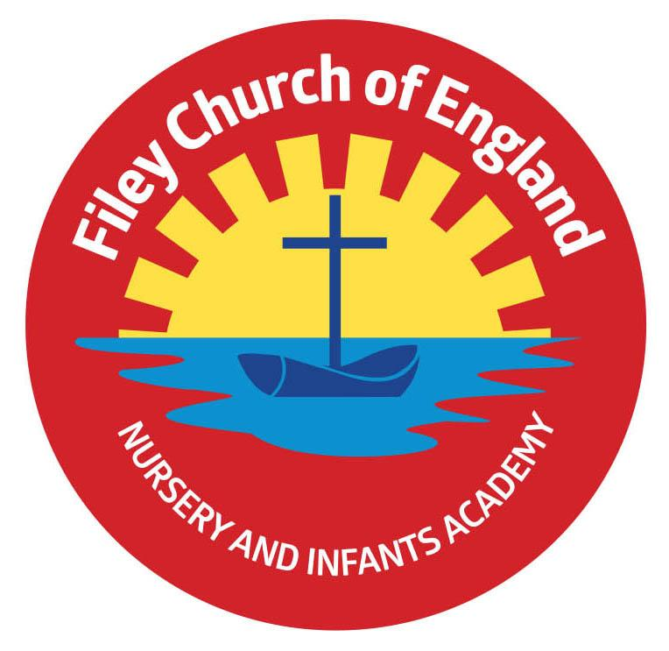Friday 4th April 2025 Dear Parents/Carers Thank you to everyone who joined us for the Easter hat parade around school this afternoon. This is a long-standing school tradition and one we always enjoy. Well done to all the winners of the Easter egg raffle, together we raised a fabulous £320 towards school funds. Well done to the winners of the decorated egg and Easter hat competitions and thank you to Mrs Wilson our Chair of Governors who had the difficult job of judging!

This week Miss Haldenby’s Class won the attendance award with 99%, well done to them, they of course shared the box of Maltesers as a reward. All the children with 100% attendance for the spring term also received their prize today, a very big well done to them. Remember there will be another prize for 100% attendance at the end of the summer term, so another chance to win starts again on Tuesday 22nd April. School Governors have recently reviewed our school attendance reward systems and are satisfied that children have three chances throughout each academic year to achieve a reward. As a school, we reward many areas of school life e.g. good manners, perseverance, academic achievements, sporting awards, swimming badges etc. outstanding attendance is rewarded as another important aspect of school life. When we return after the Easter holiday there will be a new lunch menu. We will be starting with week one, please see this attached.

**Christian Distinctiveness**

A group of year 2 children spent time with elderly residents at Filey Fields Court this week. They sang for them, spent time chatting and gave everyone a handmade Easter card. This intergenerational work is always a heart-warming experience and thoroughly enjoyed by everyone taking part.

This week each class enjoyed time with Reverend Phil telling the Easter story and making things ready to take to church with them for the Easter Service on Thursday. We thank Reverend Phil for his time and lovely activities and wish him a very Happy Easter.

*‘Community, Compassion & Friendship’* are our core values, which are at the heart of everything we do.

**Open Church Event**

St John’s Church has an open church event during the Easter holidays it will be running from Friday 11th to Monday 14th April (Palm Sunday weekend) from 11am-3pm each day at St John's Church. There will be lots of crafts and activities for families to do around the Easter story.

**New Website and Instagram Page**

Please remember to check out our new school website and familiarise yourself with the new pages. We are no longer using Twitter (**X**), so in order to see all the wonderful things your children do in school you will need to follow us on Instagram. Our handle is @fileyinfants and our page can be found following this link: <https://www.instagram.com/fileyinfants/>   
Instagram posts can also be viewed on our school website on the News & Updates page: <https://fileyinfants.ebor.academy/news-updates-2/>

**Parental Consultation**

On Tuesday 29th April, we will be offering parents the opportunity to consult with us regarding our statutory RSE (Relationships and Sex Education) policy. It is important to note that due to the age of our children this relates to our PSHE (personal, social, health and education lessons and NOT sex education, which is not taught until year 5 or 6). We will hold two sessions: either 2.30pm OR 5pm, these should last approximately 30 minutes depending on the level of discussion.

**Football Team**

If any Year 1 children are interested in joining the Filey Town under 7’s team for the 2025/2026 season they are now looking for players. Training is on a Saturday morning 9am until 10am down at Filey Sports field. All abilities both boys and girls are welcome. For further information please contact Rob Haddington on 0775468430 or Andy Micklethwaite 07411271773.

**Whole Class Photographs**

On Tuesday 6th May, we will have a professional photographer taking whole class photographs of each class including Nursery. Any Nursery children that are not in session on a Tuesday morning are welcome to join us at 9.30am if they would like to be part of the Nursery group photo. Please bring them to the main office and wait while the photograph is taken. These are a wonderful memory of the academic year 2024/2025. Please note that if your child is already on our NO PHOTO list, they will not be included, otherwise they will appear in the photograph. If you DO NOT want your child to appear in this photo, please inform the school office via email: [admin.fis@ebor.academy](mailto:admin.fis@ebor.academy)

**Please note that we have added many diary dates for the summer term already as we appreciate parents/carers need advance notice in order to attend.** If you have any questions or need support with anything please just ask. Thank you for your continued support, we hope you all have a wonderful Easter.

Best Wishes

Mrs Angela Clark & Mrs Hannah Stubbs

Angela Clark Hannah Stubbs

Co-Headteachers

Diary Dates – Please keep these dates safe for your information (more dates will be added as they arise).

April

Tuesday 22nd April – School Opens

Thursday 24th April – After school PE club starts for Year 1

Tuesday 29th April – PSHE (RSE) Parental Consultation 2.30pm or 5pm

May

Thursday 1st May – Road Safety in School

Monday 5th May – School Closed for Bank Holiday

Tuesday 6th May – Class Photographs

Monday 12th May – Open the Book Collective Worship

Thursday 22nd May – Last Swimming Session for Miss Ring’s class

Friday 23rd May – School Closes for half term

June

Tuesday 3rd June – School Opens

Thursday 5th June – First Swimming Session for Miss Wither’s class

Monday 16th June – Open the Book Collective Worship

Thursday 5th June – After school PE club starts for Nursery

Thursday 12th June – Reception Outdoor Education Day

Thursday 19th June – Year 1 Outdoor Education Day

Friday 20th June – School Reports go out to parents/carers

Thursday 26th June – Year 2 Outdoor Education Day

Thursday 26th June – School Open Evening 4pm-6pm

July

Tuesday 1st July – Whole Transition Day (all classes including year 2 to Filey Junior School)

Wednesday 2nd July – Y2 transition to Filey Junior School

Thursday 3rd July - Y2 transition to Filey Junior School

Friday 4th July – Non-uniform day (bring a bottle for the Summer Fair)

Monday 7th July – Nursery Sports Day 1.15pm

Tuesday 8th July – Year 1 Sports Day 1.15pm

Wednesday 9th July – Year 2 Sports Day 1.15pm

Thursday 10th July – Reception Sports Day 1.15pm

Friday 11th July – School Summer Fair 3pm-4.30pm

Thursday 17th July – Last Swimming Session for Miss Wither’s class

Thursday 17th July – Year 2 Leavers Party 5pm-6.30pm

Friday 18th July – 11am Year 2 Leavers Collective Worship

Friday 18th July – 12pm Family Picnic

Friday 18th July – School Closes for Summer