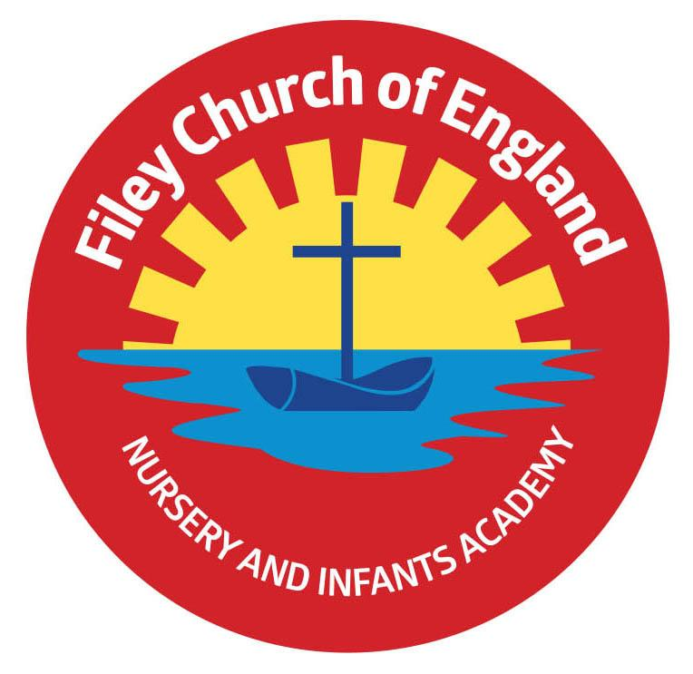Friday 25th April 2025 Dear Parents/Carers It has been great to be back in school for the start of the summer term. Please ensure you check the diary dates to find out about all the wonderful things happening this term. Class teachers have written information letters for the start of this half-term, which your child should have brought home with them today. These letters can also be found on our school website: [www.fileyinfants.ebor.academy](http://www.fileyinfants.ebor.academy) under TEACHING & LEARNING – Classes – Teacher’s name. Next week the lunch menu will be following week 2, please see attached to your email.

**Christian Distinctiveness**

VE Day celebrations will take place in school on Thursday 8th May. We will rejoice in this very special 80th anniversary by holding an afternoon tea party at school. Children are invited to wear anything red, white or blue for the day; we will make flags, sing songs and remember the events of 8th May 1945. A group of year 2 children will also visit Filey Fields to share in this special occasion and sing a selection of wartime songs. *‘Community, Compassion & Friendship’* are our core values, which are at the heart of everything we do.

**Year 2 and Year 1 Class Enterprise Projects**

Year 2 and Year 1 classes invite you to attend their upcoming Enterprise events. These will take place in the school hall from 2.30pm-3pm on the following dates:

Mr Jackson - Monday 19th May

Miss Haldenby - Tuesday 20th May

Miss Ghorst - Wednesday 21st May

Miss Withers- Thursday 22nd of May

Miss Ring- Friday 23rd of May

This is a great opportunity to see what the children have been learning about in school whilst giving them an opportunity to share, perform and practice their entrepreneurial skills.

**Tennis Coaching**



**New Website and Instagram Page**

Please remember to check out our new school website and familiarise yourself with the new pages. We are no longer using Twitter (**X**), so in order to see all the wonderful things your children do in school you will need to follow us on Instagram. Our handle is @fileyinfants and our page can be found following this link: <https://www.instagram.com/fileyinfants/> Instagram posts can also be viewed on our school website on the News & Updates page: <https://fileyinfants.ebor.academy/news-updates-2/>

**Parental Consultation**

On Tuesday 29th April, we will be offering parents the opportunity to consult with us regarding our statutory RSE (Relationships and Sex Education) policy. It is important to note that due to the age of our children this relates to our PSHE (personal, social, health and education lessons and NOT sex education, which is not taught until year 5 or 6). We will hold two sessions: either 2.30pm OR 5pm, these should last approximately 30 minutes depending on the level of discussion.

**Whole Class Photographs**

On Tuesday 6th May, we will have a professional photographer taking whole class photographs of each class including Nursery. Any Nursery children that are not in session on a Tuesday morning are welcome to join us at 9.30am if they would like to be part of the Nursery group photo. Please bring them to the main office and wait while the photograph is taken. These are a wonderful memory of the academic year 2024/2025. Please note that if your child is already on our NO PHOTO list, they will not be included, otherwise they will appear in the photograph. If you DO NOT want your child to appear in this photo, please inform the school office via email: [admin.fis@ebor.academy](mailto:admin.fis@ebor.academy)

**Please note that we have added as many diary dates for the summer term as we could; please keep them safe so you do not miss anything.** If you have any questions or need support with anything please just ask. Thank you for your continued support.

Best Wishes

Mrs Angela Clark & Mrs Hannah Stubbs

Angela Clark Hannah Stubbs

Co-Headteachers

Diary Dates – Please keep these dates safe for your information (more dates will be added as they arise).

April

Monday 28th April – Major Geoff leads Collective Worship in school

Tuesday 29th April – PSHE (RSE) Parental Consultation 2.30pm or 5pm

May

Thursday 1st May – Road Safety in School

Friday 2nd May – Happy 2 Help – a group of year 2 children singing at St John’s church

Monday 5th May – School Closed for Bank Holiday

Tuesday 6th May – Class Photographs

Thursday 8th May – VE Day afternoon tea party!

Monday 12th May – Open the Book Collective Worship

Monday 19th May – Mr Jackson’s Class Enterprise

Tuesday 20th May – Miss Haldenby’s Class Enterprise

Wednesday 21st May – Miss Ghorst’s Class Enterprise

Thursday 22nd May – Last Swimming Session for Miss Ring’s class

Thursday 22nd May – Miss Withers’ Class Enterprise

Friday 23rd May – Miss Ring’s Class Enterprise

Friday 23rd May – School Closes for half term

June

Tuesday 3rd June – School Opens

Thursday 5th June – First Swimming Session for Miss Wither’s class

Monday 16th June – Open the Book Collective Worship

Thursday 5th June – After school PE club starts for Nursery

Thursday 12th June – Reception Outdoor Education Day

Thursday 19th June – Year 1 Outdoor Education Day

Friday 20th June – School Reports go out to parents/carers

Thursday 26th June – Year 2 Outdoor Education Day

Thursday 26th June – School Open Evening 4pm-6pm

July

Tuesday 1st July – Whole School Transition Day (all classes including year 2 to Filey Junior School)

Wednesday 2nd July – Y2 transition to Filey Junior School

Thursday 3rd July - Y2 transition to Filey Junior School

Friday 4th July – Non-uniform day (bring a bottle for the Summer Fair)

Monday 7th July – Nursery Sports Day 1.15pm

Tuesday 8th July – Year 1 Sports Day 1.15pm

Wednesday 9th July – Year 2 Sports Day 1.15pm

Thursday 10th July – Reception Sports Day 1.15pm

Friday 11th July – School Summer Fair 3pm-4.30pm

Thursday 17th July – Last Swimming Session for Miss Wither’s class

Thursday 17th July – Year 2 Leavers Party 5pm-6.30pm

Friday 18th July – 11am Year 2 Leavers Collective Worship

Friday 18th July – 12pm Family Picnic

Friday 18th July – School Closes for Summer