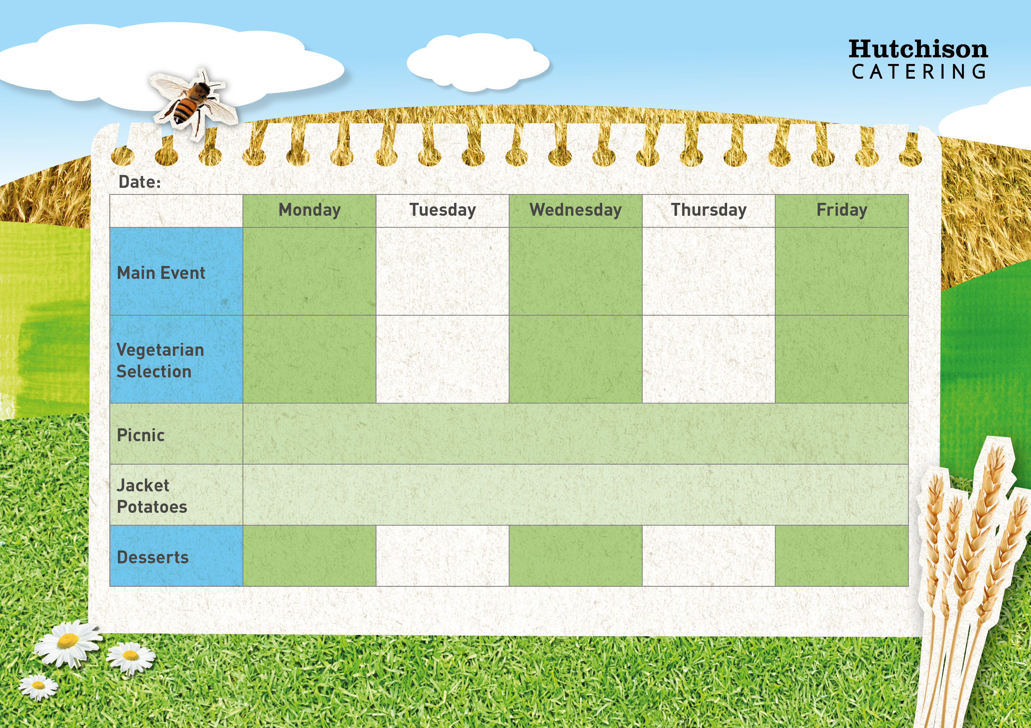

Strawberry Bun with Fresh Fruit (V)

**Freshly Prepared Bread Bun served with Vegetable Sticks**

**and the Dessert of the Day, Yoghurt or Fresh Fruit**

**Spring and Summer 2025 Week 1 WC 22nd April 5th May,19th May, 2nd June,16th June, 30th June, 14th, July,1st Sept,15th Sept,29th Sept 13th Oct**

**Key: V – Vegetarian, VE – Vegan**

**Available Daily:** Water, Bread, Salad, Fresh Fruit, and Yoghurt

Ice Cream with Mandarins (V)

Chocolate and Beetroot Brownie (V)

Iced Sponge School Cake (V)

Strawberry Whip (V)

**Crispy Baked Jacket Potato with a Choice of Baked Beans (VE), Tuna Mayo or Cheese (V) with Vegetable Sticks (VE)**

**Dessert of the Day, Yoghurt (V) or Fresh Fruit (VE)**

Quorn Nuggets with Chips & Baked Beans or Peas (VE)

Tomato & Basil Pasta with Homemade Bread & Cucumber Sticks or Sweetcorn (VE)

Quorn Fillet in Gravy with Roast Potato, Yorkshire pudding & Carrots or Broccoli

Vegetarian Enchiladas served with Rice & Peas or Salad (V)

Homemade Sweet Potato & Chickpea Curry served with Rice & Carrot Sticks or Sweetcorn (VE)

Margherita Pizza served with Homemade Potato Wedges & Carrot Sticks or Sweetcorn (V)

Homemade Chicken Tikka Curry with Rice & Peas or Sweetcorn

Roast Chicken in Gravy with Roast Potato, Yorkshire Pudding & Carrots or Broccoli

Beef Lasagne served with Homemade Bread & Cucumber Sticks or Sweetcorn

Oven Baked Fish Fingers with Chips & Baked Beans or Peas