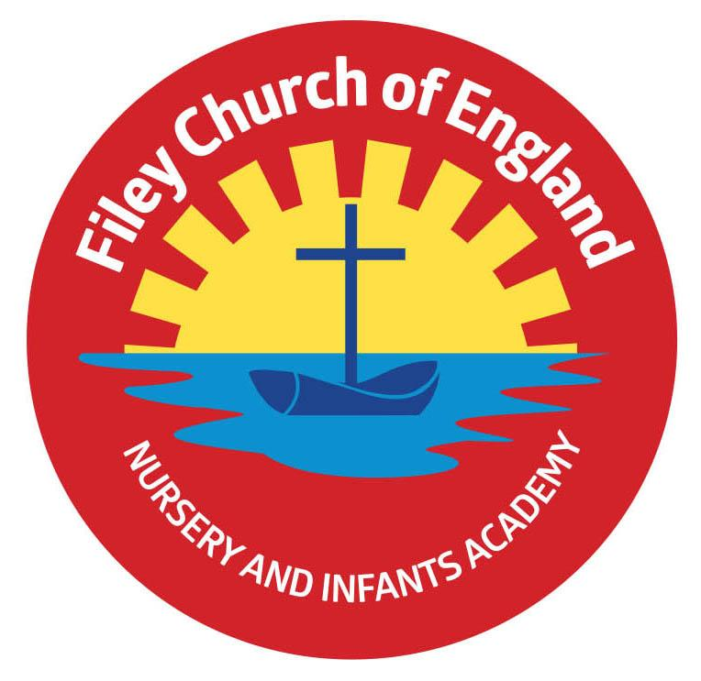
Friday 12th July 2024

Dear Parents/Carers
Next week on Thursday 18th July from 5pm till 6.30pm our year 2 children are invited to a special leavers party in the school hall. We will roll out the red carpet and have fun dancing and playing games! Miss Williams’ class won the attendance award this week with 98% they of course celebrated with a box of Maltesers! Next week the lunch menu is following week 2, please see attached to this email.

Christian Distinctiveness
Thank you to everyone who came to our Summer Fair today, it was as always a huge success. Sadly, we cannot do anything about the weather and the rain has forced us to make quite a few changes recently. On Tuesday, we had the pleasure of welcoming Natalie Dodd (SIAMS inspector) into school for our SIAMS inspection (Statutory Inspection of Anglican and Methodist Schools). We are hoping that the inspection report will be available to share with everyone on our last day of this academic year (Friday 19th July) otherwise it will be in September. ‘Community, Compassion & Friendship’ are our core values, which are at the heart of everything we do.

Changes to Sports Days
It is always very difficult when we are relying on the great British weather and it is impossible to please everyone, however, after carefully checking every weather report available, we have made the following decisions regarding sports days:
Nursery sports day will remain the same on Monday 15th July 1.15pm
Thursday is looking like it could be a dry day so year 1 and year 2 sports days will now take place then! FINGERS CROSSED!
Year 1 will start at 9.15am and year 2 at 1.15pm
The gate at the back of school (Clarence Drive) will be opened between 1pm-1.15pm for year 2 visitors to arrive.

Come on England!
We have had great fun today making a special video in support of the England football team. Children have been football crazy, enjoying team games, penalty shootouts and making flags. Please watch our amazing film by following this link: https://www.youtube.com/watch?v=P4ZqnjA79aE
We wish the team all the very best of British luck for Sunday.
COME ON ENGLAND!

The Little Princess Trust
One of our pupils is making a very kind gesture by donating her hair to a young girl who has lost hers through recent cancer treatment. The Little Princess Trust provides free real hair wigs to children and young people, up to 24 years, who have lost their own hair through cancer treatment or other conditions. If you would like to sponsor Esmae and help her raise money for this wonderful charity please give your donations to Mrs Newlove in the school office.

Family Reading Club & School Clubs
Please note that family reading club will still take place next week but all other clubs have now
finished.

Reading Challenge
Filey Library have a Summer reading challenge and other activities on offer during the holidays. Please see the flyer attached for more information.

Nursery News
This week in nursery, we have been practising for sports day and enjoying climbing and balancing on the apparatus in P.E. We have been tending to our vegetables and the courgettes have started to flower. Today we celebrated England getting to the finals of the Euros by painting flags.
Reception News
This week Reception children all took part in sports day. They did a great job in all their races and thoroughly deserved their special medals. In art the children have been looking at art work by Monet and painted their own water lilies. In Literacy, the children made their own missing posters to help find the singing mermaid! In PE, children enjoyed a penalty shootout and made flags to support the England football team.
Year One News
Year 1 have been busy in maths continuing their learning about measuring. We have been looking at mass and volume this week. We have finished our PSHE topic on dreams and goals thinking about how to overcome obstacles when working towards our goals, and also sharing and celebrating the things that we are successful at. During RE this week we learnt about the Islamic story of "Be My Guest" which teaches Muslims to look after the people around them. We also thought about how and why all people should look after the world. In Computing, we have been learning about algorithms and have been programming our BeeBots.
Year Two News
In RE this week, Year 2 pupils have been learning about Christianity around the world and discovered that the explorer James Cook introduced Christianity to Australia. In maths, the children have been using their knowledge of the number system to play competitive maths games. In computing, the children have finished the programming unit by writing their own codes. In Literacy they have made advertising leaflets for our school (these are amazing and we will choosing a few to go on our school website)! PE lessons have of course involved football and penalty shootouts.

Thank you for your continued support, if you have any questions or concerns please just ask. We are here to help however we can.
Best Wishes
Mrs Angela Clark
Angela Clark
Headteacher

Diary Dates (Please keep these dates for your diary)
July
Friday 12th July – School Summer Fair 3pm-4.30pm
Monday 15th July – Nursery Sports Day 1pm
Wednesday 17th July – last swimming session for group 5
Thursday 18th July – 9.15am Year 1 Sports Day
Thursday 18th July – 1.15pm Year 2 Sports Day
Thursday 18th July – Year 2 Party 5pm-6.30pm
Friday 19th July – 11am Year 2 Collective Worship (parents/carers invited)
Friday 19th July – 12pm – 1pm whole school family picnic (everyone welcome)
Friday 19th July – 3.05pm School closes

Tuesday 3rd September - School reopens for the start of the new academic year.
