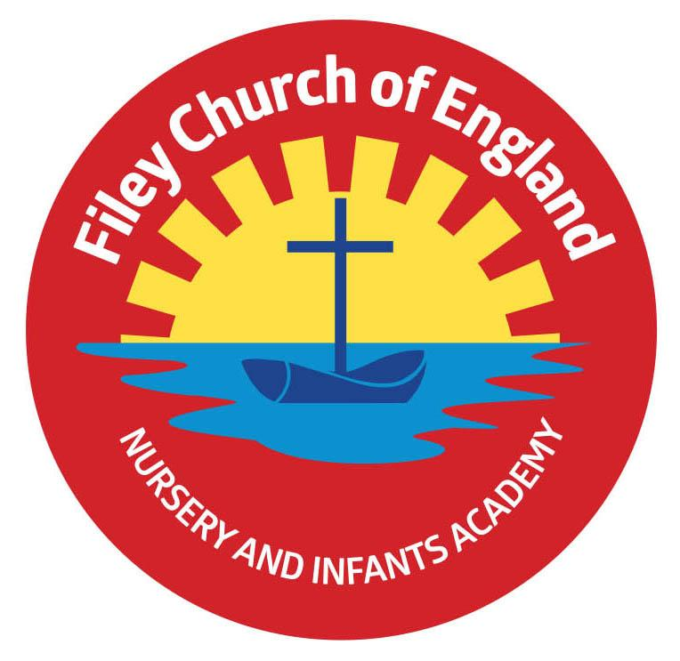
Friday 28th June 2024
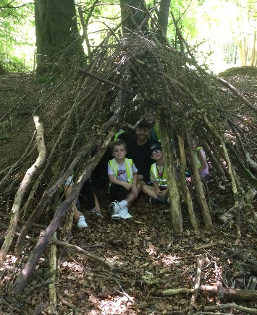
Dear Parents/Carers
Year two children had a fabulous time in Dalby Forest this week and enjoyed den building and lots of other team work activities. Miss Ring’s class won the attendance award this week with 95% they of course celebrated with a box of Maltesers! Next week the lunch menu is following week 2, please see attached to this email. Please remember sun cream and sun hats now the weather is finally looking good!

Christian Distinctiveness
Thank you to everyone who attended our school open evening on Thursday. It was lovely to see so many families in school visiting both old and new classes. A big thank you to Danielle in our school kitchen for providing school meal samples for everyone to try, the curry was a huge hit!
All year groups are currently deciding how they would like to spend their Enterprise profits for this academic year and have some great ideas. We will let you know very soon what they have planned! Next week we look forward to welcoming Reverend Phil into school to lead our Collective Worship. ‘Community, Compassion & Friendship’ are our core values, which are at the heart of everything we do.

Non-uniform Day
Friday 5th July is a non-uniform day in school. Children and staff are invited to come to school in casual clothes for the day and bring a bottle for the very popular ‘bottle tombola’ stall at our Summer Fayre. This can be any kind of unopened bottle including; bubble bath, juice, sauces, pop or alcohol (please ensure alcohol is passed over to a member of staff or dropped off at the office). As always, we thank you for your support.

Sports Days
Year group sports days will take place on the dates below. They will all start at 1.15pm on the field at the back of school. The gate at the back of school (Clarence Drive) will be opened between 1pm-1.15pm for visitors to arrive.
Reception Classes – Monday 8th July
Year One Classes – Tuesday 9th July
Year Two Classes – Wednesday 10th July
Nursery – Monday 15th July

Parent/Carer Questionnaires
Your child will have brought home a parental questionnaire sheet with them today. We would be very grateful if you could help us by filling in this questionnaire and returning it to school by Friday 12th July 3pm. Your thoughts and suggestions are always much appreciated and help us to shape the future of our school. Thank you.

Family Learning
Please note that next week there will be no family learning sessions due to our transition days.
The week after (week beginning 8th July) will be the last week for Family Learning sessions for this academic year. A big thank you to Lucy and Mrs Keary for all their hard work during these sessions.
We look forward to them starting again next academic year.

After School Clubs
Family Reading Club, Cookery Club and PE Club will not take place in the last week of school. The last reading club session will be on Wednesday 10th July. The last Cookery and PE Club will take place on Thursday 11th July.
Whole School Transition Day
Thursday 4th July is our school transition day for all other year groups. You will drop off and collect your child at the normal place; your child’s new teacher will collect them and take them to their new classroom after registration and return them at the end of the day. Nursery children moving into Reception will have received a letter with more information, if you have any questions please phone the school office.

Year 2 Transition Days
Our year 2 children will enjoy three transition days to Filey Junior School. These will take place on Tuesday 2nd, Wednesday 3rd and Thursday 4th July. Please bring year 2 children to our school as normal on Tuesday 2nd July, we will walk them to the Junior School in the morning and hand them over to their new teachers. You will need to collect your child from the Junior School on Tuesday & Wednesday at 3.30pm, you will also drop them at the Junior school both Wednesday and Thursday mornings. On Thursday afternoon, the Junior School staff will walk the year 2 children back to our school so you can collect them as normal from us at 3.05pm.

Earrings
If you are planning for your child to have, their ears pierced, please consider the following information. The recommendation is 6 weeks before earrings can be removed. If children have their ears pierced near the start of the summer holiday they should be almost ready to take out for PE lessons and Swimming lessons in September. We do not want children to miss their lessons and naturally we need to keep everyone safe by ensuring earrings are removed for both PE activities and swimming. Covering earrings with tape is not safe practice and should be avoided if possible.

Job Vacancies
We currently have some vacancies advertised on our School Website: These positions include a midday supervisory assistant, two cleaners and a caretaker. Please follow the link bellow for more information: https://fileyinfants.ebor.academy/careers-vacancies/
The caretaker hours (15hrs) and a cleaners (17.5hrs) hours can be added together to make a fulltime position (32.5hrs) for one person if required.
If you know anyone that might be interested in any of these opportunities to work in our lovely school, please let them know as soon as possible.

Nursery News
This week in nursery, we have been tending to the garden vegetables and eating the radishes we have grown. Some of the children really enjoyed them and some not so much! We have also been practicing for sports day and have been to the climbing frames down on the main playground. We have been talking about summer and thinking about keeping safe in the sunshine.
Reception News
This week the reception children have been busy problem solving in maths and consolidated their understanding of addition and subtraction by working out a variety of mathematical problems. They have continued to enjoy the pirate ship role-play area and have looked closely at maps to solve simple route puzzles using mathematical language. They used their phonic knowledge to write instructions on how to find the pirate gold on treasure maps. The children have also enjoyed working in the outdoor area and practising for sports day on the field.
Year One News
This week in literacy lessons, Year 1 have explored the story of The Lonely Giant. In maths, they have been learning how to tell the time using o' clock and half past. In science, they have been learning more about summer and comparing seasonal changes. In PE, the children have begun to prepare for Sports Day races. During history, they have compared Captain James Cook and Ernest Shackleton, thinking about similarities and differences between the two explorers. In RE, they have learned about what Muslims believe about caring for other people and how they show this.

Year Two News
Year 2 has had another exciting week continuing with maths problem solving activities. The children have had to work in pairs to complete the tricky challenges. Year 2 have been thinking about screen time in computing and have thought about healthy alternatives to always using our tablets and devices. In Science, Year 2 have continued to learn about the food groups and have used our school menu to analyse our healthy eating habits. In PSHE, children have learnt about the body parts and the difference between male and female bodies. We all had an excellent outdoor education day at Dalby Forest exploring the enchanted forest, den building and the Gruffalo trail. In Literacy, the children wrote a recount about their amazing trip!

Thank you for your continued support, if you have any questions or concerns please just ask. We are here to help however we can.
Best Wishes
Mrs Angela Clark
Angela Clark
Headteacher

Diary Dates (Please keep these dates for your diary)
July
Tuesday 2nd July – Year 2 transition day to the Junior School
Wednesday 3rd July – Year 2 transition day to the Junior School
Thursday 4th July – Whole School transition day
Friday 5th July – Non Uniform Day – bring a bottle for the Summer Fayre bottle tombola
Monday 8th July – Reception Sports Day 1pm
Tuesday 9th July – Year 1 Sports Day 1pm
Wednesday 10th July – Year 2 Sports Day 1pm
Thursday 11th July – last PE club for Nursery
Thursday 11th July – last cookery club for group 6
Friday 12th July – School Summer Fayre 3pm-4.30pm
Monday 15th July – Nursery Sports Day 1pm
Wednesday 17th July – last swimming session for group 5
Thursday 18th July – Year 2 Party 5pm-6.30pm
Friday 19th July – 11am Year 2 Collective Worship (parents/carers invited)
Friday 19th July – 12pm – 1pm whole school family picnic (everyone welcome)
Friday 19th July – 3.05pm School closes

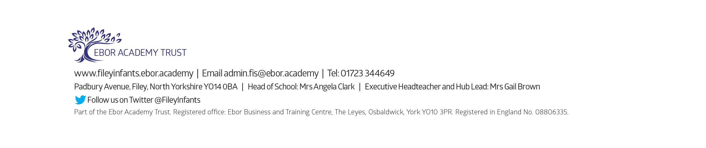
Tuesday 3rd September - School reopens for the start of the new academic year.

