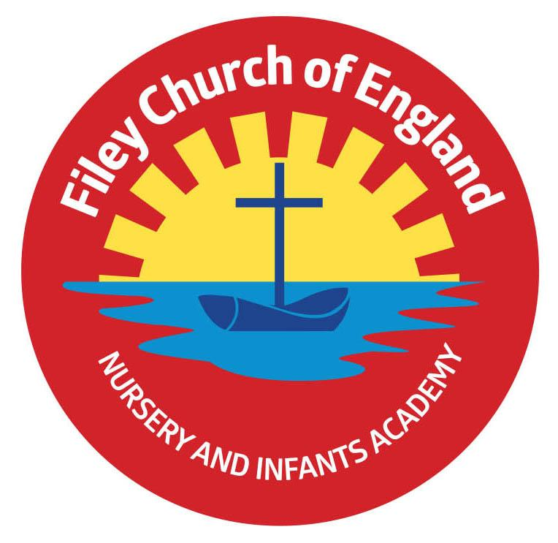
Friday 24th May 2024

Dear Parents/Carers
This week Miss Ring’s class won the attendance with 100% and celebrated with a class certificate, stickers and of course the box of maltesers!
After half term the lunch menu is following week 1, please see attached to this email.

Christian Distinctiveness
This week our three year one classes wowed us with their Enterprise events. The Animal Game Shows were wonderfully presented and enjoyed by all. Well done to the children for planning and performing such a super event and thankyou to everyone who managed to join us. Please remember that our year 2 classes will be holding their Enterprise events in the first week back after half term. Please support them if you can, you will only need a pound or two for voluntary donations and as always, there is no pressure to spend at all!
We know financially times are difficult and it is your company the children and staff would really like.
Please see the following dates for your child’s class Enterprise event, taking place in the school hall:
Miss Williams – Friday 7th June 9am
Mr Jackson – Friday 7th June 2.30pm
‘Community, Compassion & Friendship’ are our core values, which are at the heart of everything we do.

School Assessments Year 2 SAT’s are now non-statutory but are still printed and sent to schools from the Department of Education if requested. It is for each school to decide whether they would like to use these resources in part, completely or not at all. Year 2 assessments do not have to be completed on set dates and times like the year 6 assessments.
With the exception of The Phonic Screening Check (which does have an allocated 2 weeks) all other teacher assessments (including children achieving a Good Level of Development in Reception and Teacher Assessments in Year 2) take place over time.
Teacher assessments during year 2 use a broad range of evidence from across the curriculum and knowledge of how a pupil has performed over time and in a variety of contexts, including written, practical, oral classwork and information gathered from using some of the optional test booklets in reading and mathematics. The benefit of using some of the optional test booklet questions is to inform classroom practice, next steps for pupils and support teacher planning.
Dates and times of pupil assessments carried out in our school are not and have not previously been shared with parents/carers. Assessments are an important part of our normal school practise throughout school years and not designed to be stand-alone formal tests.
Assessment reporting for pupils at the end of year 2
There are no statutory reporting requirements, if schools choose to administer the optional end of KS1 teacher assessment questions; they do not have to report the results to parents. We however, do feel it is important to give parents/carers information regarding their child’s teacher assessments. This will be communicated in their school report as one of the following statements for reading, writing and mathematics:
- Working below the expected standard
- working towards the expected standard
- working at the expected standard
- working above the expected standard
If your child needed to complete the phonic screening check again in year 2, you will also receive this information.

Assessment reporting for pupils at the end of Year 1
You will be informed of your child’s score in the phonic screening check. This information will be included in their school report.

Assessment reporting for children at the end of Reception
You will be informed how your child has achieved against the 17 areas of learning within the Foundation Stage Profile. This information will be included in their school report.

I hope this information is helpful, should you have any further questions please ask your child’s class teacher.

Blue Peter Badges
All year 2 children have brought home a Book Badge Application Form. This is so we have permission for them to apply for a Blue Peter Badge. Children have been doing all the work in school so there is nothing for them to do at home. Simply return the application form after the half term holiday so your child can earn their special badge!

Outdoor Education Days
Next half term we have exciting outdoor education days planned for Reception, Year 1 and Year 2 classes. A letter has gone home with all Reception children today with more information. Year 1 and Year 2 letters will be sent home after the half term holiday.
Reception – Friday 7th June 2024 (Filey Beach)
Year 1 – Thursday 13th June 2024 (Glenn Gardens)
Year 2 – Thursday 27th June 2024 (Dalby Forest)

Year 2 Open Evening at Filey Junior School
Filey Junior School have invited all our year 2 children and their families to attend an open evening on Wednesday 26th June between 3.45pm and 5pm. This is a great opportunity to have a look around the school, visit new classrooms and chat with the teachers. The year 3 teachers will be making quite a few visits to our school to work and chat with the children before the transition days on 2nd, 3rd & 4th July. More information regarding these days will follow nearer the time.

Nursery News
This week in nursery, we have been enjoying dressing up and using the stage in the outdoor area to tell stories and sing songs. We have been tending to our vegetables and flowers and enjoying the warmer weather. Following on from our minibeast investigations, we have decided to paint some pebbles, which are going to be bees.
Reception News
We have had a busy last week of the half term. The children have been practising everything they have learnt in art and produced some detailed paintings of different flowers.
In maths, the children have been learning all about length and height. They have used the language longer/shorter, and longer/taller to compare the length and height of different items. The children used cubes to compare the length and height of the different items in the classroom, including the dinosaurs.
The children are becoming much more confident with their independent writing. This week we have seen some amazing sentences and labels. Many children have also been keen to write their own school prayer to put in Mrs Clark's special prayer box.
Year One News
This week Year 1 children have enjoyed delivering their class enterprise gameshow. They enjoyed sharing their traditional Kenyan song, animal art prints and ‘What am I?’ poems. Thank you to everyone who came along and showed their support. In Maths this week, the children have continued to count and recognise coins. We applied this knowledge to help us to count our donations raised through the enterprise events. In Science, we learnt about carnivores, herbivores and omnivores and sorted different animals according to what they eat. In RE we looked at Christian churches in both the UK and Kenya, identifying the similarities and differences found within them. In Geography, we have been learning about the different landscapes and the animals found in Kenya.
Year Two News
This week Year 2 have continued to revisit mathematical learning from throughout the year. They have also practised their comprehension skills when answering questions about the text provided.
In PE, year 2 have been practising relay races and also applied their knowledge of throwing and catching to field games including rounders. In Art, the children have started printing onto their canvas bag and in DT, they have attached their cut out initials to the same bag. They have really enjoyed working on this project ready for our class enterprise in the first week back after half term. Year 2 have also been working towards a blue peter badge and have written a book review about a book of their choice.

We hope everyone has a lovely half term holiday. School reopens on Tuesday 4th June for the last half term of this academic year. Thank you for your continued support, if you have any questions or concerns please just ask. We are here to help however we can.
Best Wishes
Mrs Angela Clark
Angela Clark
Headteacher

Diary Dates (Please keep these dates for your diary) more dates will be added as they arise!
June
Tuesday 4th June – school opens
Wednesday 5th June – first swimming session for group 5
Thursday 6th June – first PE club for Nursery
Thursday 6th June – last cookery club for group 5
Friday 7th June – Reception Outdoor Education Day (Filey Beach)
Friday 7th June – Miss Williams’ class Enterprise 9am in the school hall
Friday 7th June – Mr Jackson’s class Enterprise 2.30pm in the school hall
Thursday 13th June – Year 1 Outdoor Education Day (Glenn Gardens)
Thursday 13th June – first cookery club for group 6
Monday 17th June – Open the Book Collective Worship
Friday 21st June – School reports go out to parents/carers
Wednesday 26th June – Year 2 children and their families are invited to Filey Junior School Open Evening
Thursday 27th June – Year 2 Outdoor Education Day (Dalby Forest)
Thursday 27th June – School Open Evening 4pm – 6pm
July
Tuesday 2nd July – Year 2 transition day to the Junior School
Wednesday 3rd July – Year 2 transition day to the Junior School
Thursday 4th July – Whole School transition day
Friday 5th July – Non Uniform Day – bring a bottle for the Summer Fayre bottle tombola
Monday 8th July – Reception Sports Day 1pm
Tuesday 9th July – Year 1 Sports Day 1pm
Wednesday 10th July – Year 2 Sports Day 1pm
Thursday 11th July – last PE club for Nursery
Thursday 11th July – last cookery club for group 6
Friday 12th July – School Summer Fayre 3pm-4.30pm
Monday 15th July – Nursery Sports Day 1pm
Wednesday 17th July – last swimming session for group 5
Thursday 18th July – Year 2 Party 5pm-6.30pm
Friday 19th July – 11am Year 2 Collective Worship (parents/carers invited)
Friday 19th July – 12pm – 1pm whole school family picnic (everyone welcome)
Friday 19th July – 3.05pm School closes
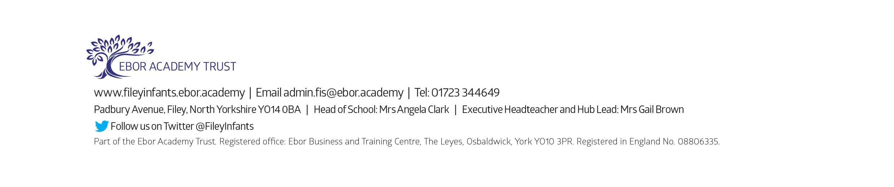
Tuesday 3rd September - School reopens for the start of the new academic year.

