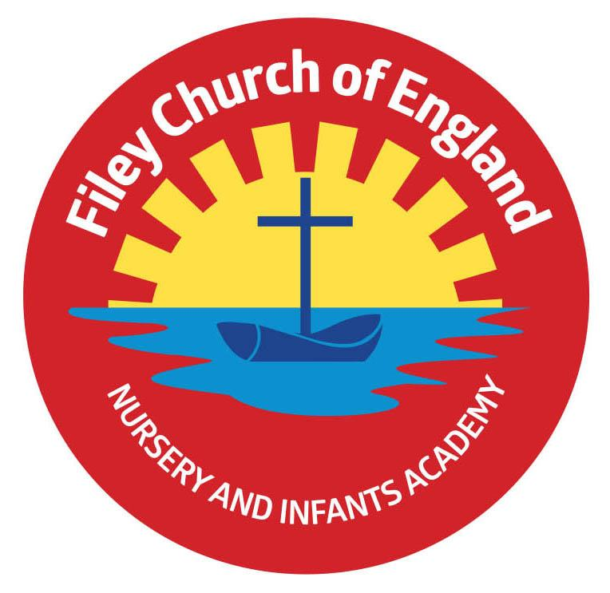
Notice of consultation on the proposal to change the age range of
Filey CE Nursery & Infants Academy (part of Ebor Academy Trust)
Ebor Academy Trust (the “Academy Trust”) is consulting on a proposal to change the age range of Filey CE Nursery & Infants Academy, from 3-7 to 2-7 years old. The purpose of this consultation is to provide information relating to the proposal to expand the age range of the Academy’s nursery (the “Proposal”) and to seek views of parents and the wider community.
Objectives of the proposal
Filey CE Nursery & Infants Academy currently offers teacher-supported learning through play, based around the Early Years Foundation Stage curriculum, for 3 and 4 year olds prior to their entry into school.
The Academy Trust feels that this proposal presents an exciting opportunity to expand its provision of high quality education to include 2 year olds.
The expansion will help extend and improve the Early Years facilities, making Filey CE Nursery & Infants Academy increasingly attractive to local families. Other objectives of the proposal are:
• To provide children with the best possible start in their education;
• To raise educational standards on entry into Reception;
• To ensure relationships with parents are developed at the earliest possible point;
• To develop key speech and language skills from an earlier age;
Additional Information
Filey CE Nursery & Infants Academy currently provides up to 32 places in the morning and afternoon, for pupils aged 3 and 4 years old. This consultation only covers the proposed change in age range to include 2 year olds; the following nursery provision arrangements will remain unchanged:
- Nursery provision is available 190 days per year, i.e. on each day that the school is open.
- A morning session is from 9am to 12pm, and an afternoon session is from 12pm to 3pm;
- Parents may use government funded hours to ‘purchase’ these sessions, and may also purchase additional sessions at the agreed hourly rate;
- Parents may also purchase additional hours before school from 7.30am to 9am and after school from 3pm to 6pm, either using government funded hours or at the agreed hourly rate.
- 30 hour funded places are offered from 9am to 3pm each day. Parents may also purchase additional hours before school from 7.30am to 9am and after school from 3pm to 6pm, either using government funded hours or at the agreed hourly rate.
Have your say
This is an opportunity for parents, carers, staff, the local community and other people who have an interest in the school to express their views, respond to the proposal and ask questions on the proposal to expand the Academy’s age range.

The consultation period starts on Tuesday 7th May 2024.
You can state whether you support the proposal or not by emailing to the Academy Trust; consultation.fileyinfants@ebor.academy or in writing to Filey CE Nursery & Infants Academy, Padbury Avenue, Filey, North Yorkshire, YO14 0BA, marked for the attention of the Head teacher, Mrs Angela Clark by no later than Tuesday 4th June
All views and responses to the proposal will be considered after the consultation ends on Tuesday 4th June 2024.
If the Academy Trust then decides to proceed with the Proposal, it will submit an application to the Department for Education, requesting that the change in age range takes effect from Tuesday 3rd September 2024.
We will inform you of the outcome of the consultation and the decision whether or not to proceed with the application to extend the age range of the Academy at the end of the consultation period.
