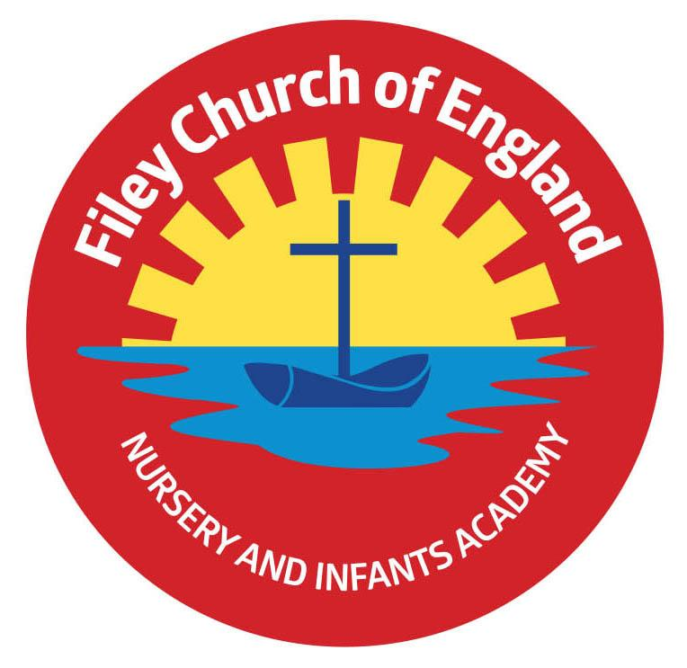
Friday 26th April 2024

Dear Parents/Carers
Another very busy and fun filled week in school. This week Mrs Stubbs’ class won the attendance with 98% and celebrated with the box of maltesers prize! Next week our lunch menu is following week 1, please see attached to this email.

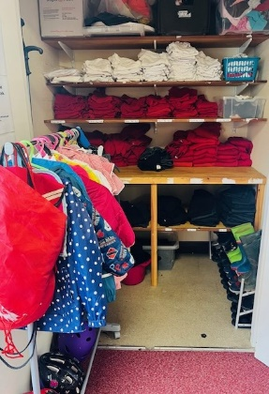
Christian Distinctiveness
Our FREE school uniform cupboard has been refreshed and reorganised this week. It is fully stocked with lovely summer dresses, shorts, trousers, polo tops, jumpers, cardigans, PE kits and bags, vests, shoes and cycling helmets. This is a great way for us to recycle as much as possible, helping the environment and stopping out grown items going into landfill. It is also a great way of saving money too! Please phone the school office and let us know what you would like and it can be bagged up for your child to take home. We also welcome any of your child’s good quality outgrown items for us to share. ‘Community, Compassion & Friendship’ are our core values, which are at the heart of everything we do.

Book Fair
The last day for the Scholastic Book Fair is Monday 29th April. This is available in our school hall from 3pm-3.30pm. They have a 3 for 2 price offer on all books. A percentage of the money you spend comes back to school so we can choose some lovely new free books for the children to enjoy.

The Retreat Clinics
The Retreat Clinics are offering a variety of online courses for parents and carers. If you are interested in signing up for one of the following, please follow this link: https://theretreatclinics.org.uk/events/
- Understanding and Supporting your Child’s Anxiety
- Autistic Communication
- Life with an Autistic Family Member

Parent Survey Link
Just a reminder! We would really appreciate you spending a few minutes to complete a parental experience survey for parents of primary schools, which are part of Ebor Academy Trust

Taking part in this survey will help us to really understand your thoughts and impressions so that we, and Ebor Academy Trust, can be more responsive to your needs; Ebor is launching this, our first wide-ranging survey.

The survey is anonymous, although there is the opportunity at the end for you to provide your email address should you wish us to contact you.

The link in its full form is: https://forms.gle/x1VJsUYrw2Hfjze5A Thank you for your time and support.

Nursery News
This week in nursery, children have been learning about planting and new growth because it is spring. They have planted some sunflower seeds and some courgettes seeds and are looking forward to them sprouting. Once they have, they will plant them in their allotment. The children are also looking forward to the results of an experiment they are trying with strawberry seeds. If you dry strawberry skins then get the seeds out you can plant them. We will let you know how we get on!
Reception News
Reception children have had another busy week this week. They have been exploring lots of different vegetables and been writing shopping lists for Oliver’s Grandpa from the story, Oliver's Vegetables. Mrs Clark brought in an aubergine and many of the children had not seen one before.
In maths, children have been learning all about teen numbers. They now know that all teen numbers have one ten and some extra ones. The children did a fantastic job matching the correct numerals to the teen numberblocks. In PSHE, children have been thinking about how we can challenge ourselves. They have been setting each other challenges in the classroom. The children have also been very creative this week. They have done some fantastic observational drawing and made lots of different vegetables using playdough.
Year One News
In Literacy this week, the children have been exploring fiction and non-fiction texts about animals. In Maths, they have continued to use number facts within 10 to support addition and subtraction within 20. In Science, they have explored the features and names of some fish then designed and labelled their own. In PSHE, all children took part in the NSPCC Speak Out, Stay Safe campaign. The children thought about who their safe adults are that they can speak to when feeling unsure about something. In RE year 1 have been thinking about how Christians give thanks to god for creating the world.
Year Two News
This week Year 2 have been reading our new class story 'Ossiri and the Bala Mengro' and have explored the themes of identity, Ossiri is a traveller. In Maths Year 2 have learnt about position and direction. In Science, they have observed the seeds that they planted and measured their growth. In Computing Year 2 have been learning about algorithms and in PSHE they have been continuing to celebrate differences. In PE Year 2 applied their knowledge of athletics to complete circuits.

Please note there have been a few changes to dates below shown in red. Thank you for your continued support, if you have any questions or concerns please just ask. We are here to help however we can.
Best Wishes
Mrs Angela Clark
Angela Clark
Headteacher

Diary Dates (Please keep these dates for your diary) more dates will be added as they arise!
April
Monday 29th April – Last day for the school Book Fair
Tuesday 30th April - Reverend Phil leads Collective Worship in school
May
Wednesday 1st May – RNLI safety talk in school
Thursday 2nd May – First cookery club for group 5
Monday 6th May – BANK HOLIDAY
Tuesday 7th May – Class Photo’s (am only)
Friday 10th May – Visiting Author Event for Y1 and Y2 classes5
Wednesday 22nd May – Last swimming session for group 4
Thursday 23rd May – Last PE Club for year 1
Friday 24th May – School closes for half term
June
Tuesday 4th June – school opens
Wednesday 5th June – first swimming session for group 5
Thursday 6th June – first PE club for Nursery
Thursday 6th June – last cookery club for group 5
Thursday 6th June – Reception Outdoor Education Day (Filey Beach) Changed Date!
Friday 7th June – Reception Outdoor Education Day (Filey Beach)
Thursday 13th June – Year 1 Outdoor Education Day (Glenn Gardens)
Thursday 13th June – first cookery club for group 6
Monday 17th June – Open the Book Collective Worship
Thursday 20th June – Year 2 Outdoor Education Day (Dalby Forest) Changed Date!
Friday 21st June – School reports go out to parents/carers
Thursday 27th June – Year 2 Outdoor Education Day (Dalby Forest)
Thursday 27th June – School Open Evening 4pm – 6pm

July
Tuesday 2nd July – Year 2 transition day to the Junior School
Wednesday 3rd July – Year 2 transition day to the Junior School
Thursday 4th July – Whole School transition day
Monday 8th July – Reception Sports Day 1pm
Tuesday 9th July – Year 1 Sports Day 1pm
Wednesday 10th July – Year 2 Sports Day 1pm
Thursday 11th July – last PE club for Nursery
Thursday 11th July – last cookery club for group 6
Friday 12th July – School Summer Fayre 3pm-4.30pm
Monday 15th July – Nursery Sports Day 1pm
Wednesday 17th July – last swimming session for group 5
Thursday 18th July – Year 2 Party 5pm-6.30pm
Friday 19th July – 11am Year 2 Collective Worship (parents/carers invited)
Friday 19th July – 12pm – 1pm whole school family picnic (everyone welcome)
Friday 19th July – 3.05pm School closes

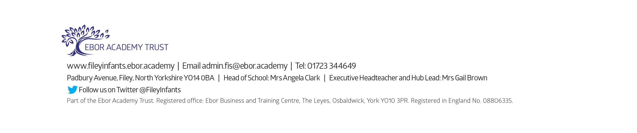
Tuesday 3rd September - School reopens for the start of the new academic year.

