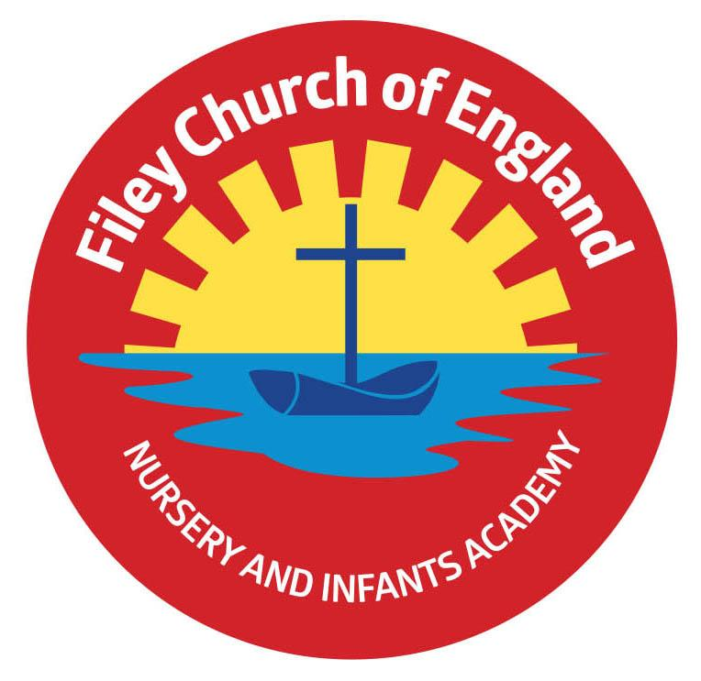
Friday 19th April 2024

Dear Parents/Carers
Another wonderful week in school with lots of busy children. Thankfully, the roadworks outside school should have moved past our buildings by Monday and I thank everyone for their patience and understanding during a tricky time. Next week our lunch menu is following week 2, please see attached to this email. This week Miss Wither’s class won the attendance with 99% and celebrated with the box of maltesers prize!

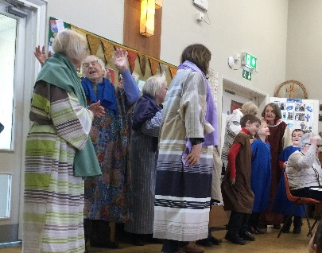
Christian Distinctiveness
This week some of our year two children helped tell a bible story during Collective Worship. Our friends from St John’s Church told the story of Jesus healing ten men in a special ‘Open the Book’ worship time. Everyone in school looks forward to these visits and we thank them all for their time and enthusism. Our last ‘Open the Book’ collective worship is on Monday 17th June. ‘Community, Compassion & Friendship’ are our core values, which are at the heart of everything we do.

Book Fair
The Scholastic Book Fair arrives in school on Tuesday 23rd April and will be available in the school hall from 3pm-3.30pm each day after school for a week. They have a 3 for 2 price offer on some lovely books. Please note the £1 World Book day voucher cannot be used at this fair.

Parent Survey Link
We would really appreciate you spending a few minutes to complete a parental experience survey for parents of primary schools, which are part of Ebor Academy Trust

Taking part in this survey will help us to really understand your thoughts and impressions so that we, and Ebor Academy Trust, can be more responsive to your needs; Ebor is launching this, our first wide-ranging survey.

The survey is anonymous, although there is the opportunity at the end for you to provide your email address should you wish us to contact you.

The link in its full form is: https://forms.gle/x1VJsUYrw2Hfjze5A Thank you for your time and support.

Contact Details
We are required to hold three contact numbers for all children on our school system. If we do not have three contact/emergency numbers for your child, Mrs Newlove will be phoning you for these details.
If your contact details change, it is important that you let us know as soon as possible.

Card Payment Machine
We are pleased to say that we now have a card machine in our school office for any payments needing to be made to school. You can still make payments using Parent Pay this is just another option.

Ofsted SEND Parent Survey
North Yorkshire’s education, health and social care services are being jointly inspected by Ofsted and the Care Quality Commission (CQC) to see how well they meet their responsibilities towards children and young people with SEN and disabilities (SEND).
They would like to hear your views about the support that your child/young person receives and how it has helped your child.
You can provide your views by completing an online survey. What you share will be treated in confidence: Parent/Carer - https://ofsted.smartsurvey.co.uk/s/AreaSEND-ParentCarer/10299835

Guidance, Easy Read and more information can be found:
Area SEND inspections: information about ongoing inspections - GOV.UK (www.gov.uk)
Your views are important and will help Inspectors to understand your child/young person’s experience of the SEND arrangements in North Yorkshire. The survey links and guidance can also be on the SEND Local Offer | North Yorkshire Council website.
The surveys will close at 9am on 23rd April 2024.
Thank you in advance for your help with the arrangements for the inspection process.

Nursery News
This week in nursery, the children have been painting symmetrical butterflies and making mini beasts out of junk modelling. They have planted some sunflower seeds that we grew and harvested from last year and are really excited to see if they grow. The children have also been playing instruments, singing songs and enjoying the sunshine when it hasn't been raining!
Reception News
This week the children have continued to enjoy the story 'Tadpole's Promise.' They have created some amazing fact files about frogs and even sequenced the life cycle of a frog. In Maths, we have been learning more about 3D shapes. We have asked the children to see what 3D shapes they can find at home. In RE children were thinking about special spaces. We thought about places that were special to us and what makes them special. Everyone had fantastic ideas to share. We have started our new topic, 'Relate' in 'My Happy Mind.' This week we thought about how to be a good friend. The children thought of lots of important things to remember to show others that they are a good friend.
Year One News
This week Year 1 have been consolidating their knowledge of teen numbers and exploring doubling and addition within 20. In Literacy, they have described different animals and used these descriptions to write their own ‘What Am I?’ poems. In RE they have continued their learning about the Christian Creation Story. In Science, they have been exploring different animals including reptiles, amphibians, mammals, fish and birds. In PSHE, they have been considering the differences between themselves and their peers. In PE, the children have been practising their underarm and overarm technique to compete against their friends.
Year Two News
This week in Literacy Year 2 have been writing character descriptions based on the character's from two of our books 'Hair love' and 'Splash'. Year 2 have also compared these books and discussed the similarities and differences. In Maths, Year 2 have continued to learn about measurement; the focus has been on capacity and temperature. In science, Year 2 have planted some seeds and will now watch them grow over the next few weeks. In RE, Year 2 have continued to think about 'The good news Jesus Brings' and have thought about changes they could make in the world. In PE, Year 2 were practising throwing and learnt the difference between an overarm and underarm throws. Finally, in music, Year 2 have used our new hand bells to follow notation and play twinkle twinkle.

Please note there have been a few changes to dates below shown in red. Thank you for your continued support, if you have any questions or concerns please just ask. We are here to help however we can.
Best Wishes
Mrs Angela Clark
Angela Clark
Headteacher

Diary Dates (Please keep these dates for your diary) more dates will be added as they arise!
April
Tuesday 23rd April – School Book Fair arrives
Thursday 25th April – Last cookery club for group 4
Monday 29th April – Last day for the school Book Fair
Tuesday 30th April - Reverend Phil leads Collective Worship in school
May
Wednesday 1st May – RNLI safety talk in school
Thursday 2nd May – First cookery club for group 5
Monday 6th May – BANK HOLIDAY
Tuesday 7th May – Class Photo’s (am only)
Friday 10th May – Visiting Author Event for Y1 and Y2 classes5
Wednesday 22nd May – Last swimming session for group 4
Thursday 23rd May – Last PE Club for year 1
Friday 24th May – School closes for half term
June
Tuesday 4th June – school opens
Wednesday 5th June – first swimming session for group 5
Thursday 6th June – first PE club for Nursery
Thursday 6th June – last cookery club for group 5
Thursday 6th June – Reception Outdoor Education Day (Filey Beach) Changed Date!
Friday 7th June – Reception Outdoor Education Day (Filey Beach)
Thursday 13th June – Year 1 Outdoor Education Day (Glenn Gardens)
Thursday 13th June – first cookery club for group 6
Monday 17th June – Open the Book Collective Worship
Thursday 20th June – Year 2 Outdoor Education Day (Dalby Forest) Changed Date!
Friday 21st June – School reports go out to parents/carers
Thursday 27th June – Year 2 Outdoor Education Day (Dalby Forest)
Thursday 27th June – School Open Evening 4pm – 6pm

July
Tuesday 2nd July – Year 2 transition day to the Junior School
Wednesday 3rd July – Year 2 transition day to the Junior School
Thursday 4th July – Whole School transition day
Monday 8th July – Reception Sports Day 1pm
Tuesday 9th July – Year 1 Sports Day 1pm
Wednesday 10th July – Year 2 Sports Day 1pm
Thursday 11th July – last PE club for Nursery
Thursday 11th July – last cookery club for group 6
Friday 12th July – School Summer Fayre 3pm-4.30pm
Monday 15th July – Nursery Sports Day 1pm
Wednesday 17th July – last swimming session for group 5
Thursday 18th July – Year 2 Party 5pm-6.30pm
Friday 19th July – 11am Year 2 Collective Worship (parents/carers invited)
Friday 19th July – 12pm – 1pm whole school family picnic (everyone welcome)
Friday 19th July – 3.05pm School closes

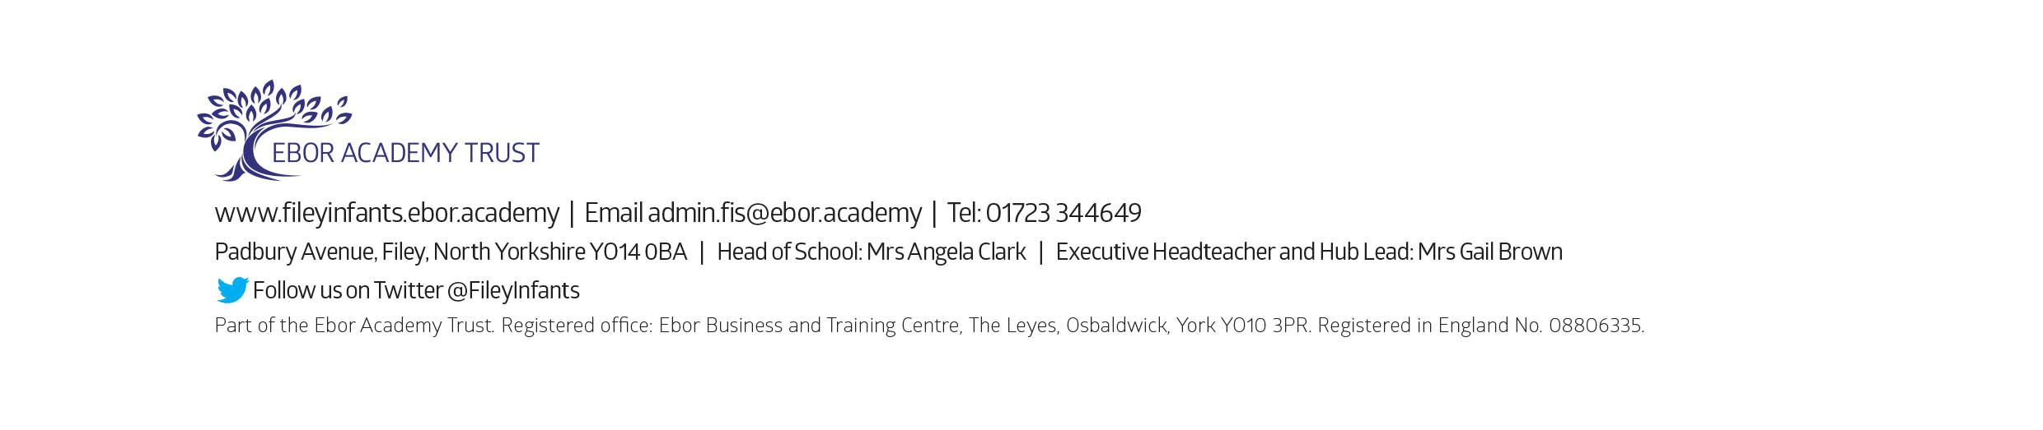
Tuesday 3rd September - School reopens for the start of the new academic year.

