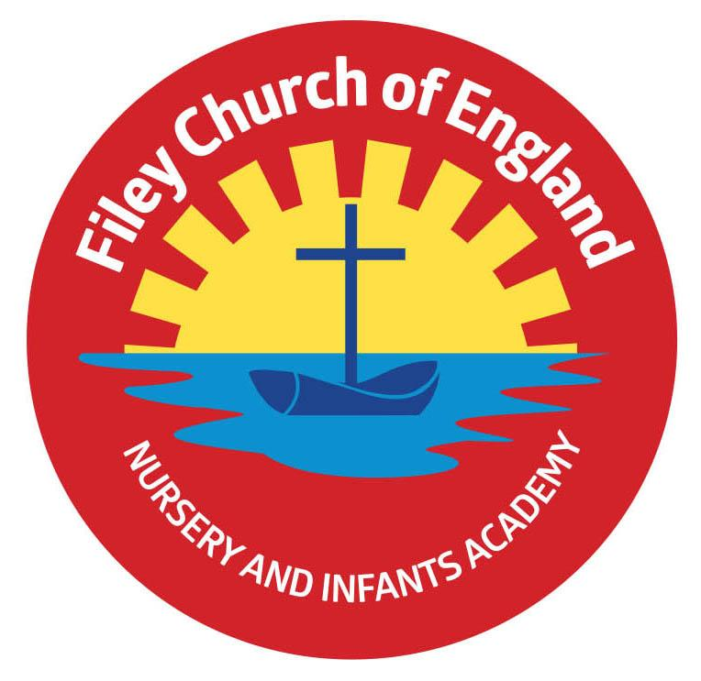
Dear Parents and carers,
We hope you had a lovely Easter break and are ready for the Summer Term. I am writing to give you some more information about what to expect during this half term.
Our Curriculum
As a school we provide an exciting and engaging curriculum for all our children. This half-term our theme is ‘Time to Grow.’ During this topic we will be learning about the life cycle of different plants and animals and how living things change as they grow. We will be enjoying and retelling a range of different stories, including Tadpoles Promise, The Odd egg and Oliver’s Vegetables. We are also going to be exploring the information book, The Amazing Life Cycle of Plants.
Children will continue to have weekly PE sessions. This term PE is on a Friday so please ensure your child has their PE kit in school on these days. This should include a white t-shirt, black or navy blue shorts, and trainers. Feel free to also include leggings/tracksuit bottoms and a warm jumper/hoody. Please ensure everything is clearly named. For ease, PE kits can be left in school for the half term.
If your child wears earrings, please remove or cover them before school as staff are not able to support them to do this. Please can all long hair be securely tied up to avoid any accidents.
As a school we are trying to do our bit for the planet and recycle and reuse wherever possible. In school we have a uniform cupboard full of pre-loved items. If you need any additional uniform or PE kit please phone the office or catch us on the door.
Phonics and Reading
Children will continue to have daily phonics and guided reading sessions. To help you support your child’s learning at home, we will continue to send home a small sheet each Friday detailing what we have covered.
In school guided reading books will be changed weekly. These books continue to be available to read the following week on our online reading platform, Collins eBooks.
Children will continue to bring home an additional book to read. This can be read and changed as regularly as they wish.
As a school we promote a love of reading and encourage you to enjoy books regularly at home.
Library
Children visit our Big Red Reading Bus twice a week. We will have a whole class story time on the bus, as well as allowing another opportunity for children to choose and borrow their own book. Mrs Kerr’s library session is on a Wednesday and Mrs Stubbs library session is on a Tuesday. Please remember to bring your library book on these days so your child can change it for a new book.
Weekly Newsletters
As always Mrs Clark will continue to write weekly newsletters to keep you up-to-date with all the exciting things happening in school. To reduce our paper use and do our part for the planet, these will be emailed out every Friday. Please contact the office if you are not receiving them. These newsletters also include important upcoming dates that you need to be aware of so please take the time to check them weekly.
If you have any questions please don’t hesitate to ask.
Kind regards,
Mrs Stubbs, Mrs Kerr, and the rest of the EYFS team

