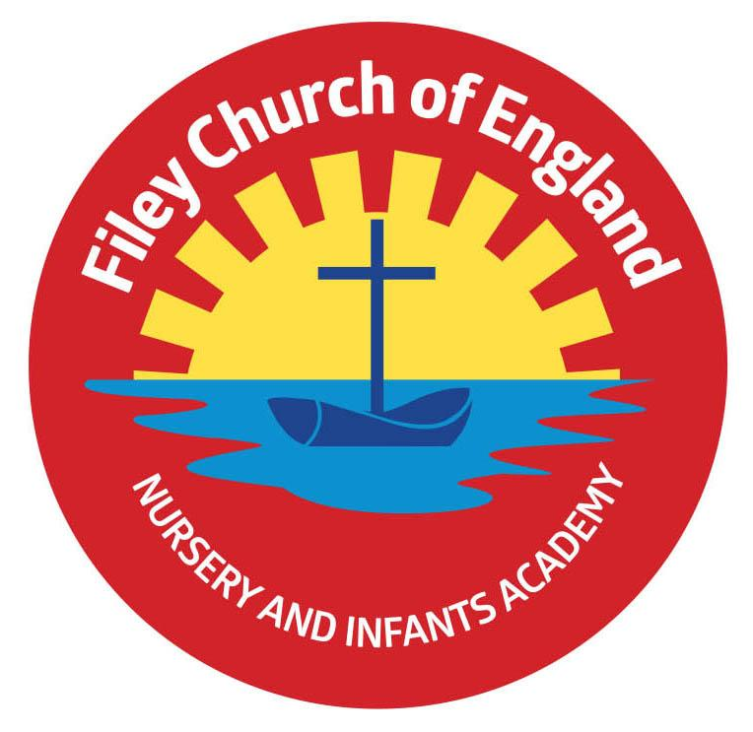
Friday 12th April 2024

Dear Parents and carers,
Welcome back, I hope you all had a fantastic Easter! I can’t believe we are entering the Summer term already! I am writing to let you know what we will be learning this half-term and all of the exciting things we have coming up.
Our Curriculum
As a school we work tirelessly to make sure our curriculum is up-to-date as well as exciting and engaging for all our children. This half-term our theme is Animal Kingdom! Our themes for the year and more information about our long term plan can be found on the school website ww.fileyinfants.ebor.academy under TEACHING & LEARNING – Curriculum.
This half-term, as our topic title suggests, we are going to be learning all about animals! Our focus in science will be identifying and classifying animals in lots of different ways. Children will learn to use key vocabulary including: mammals, birds, fish, reptiles, amphibians, herbivores, omnivores and carnivores. In Geography we will be revisiting our learning about the UK before learning all about Kenya and comparing these two amazing countries. In Art children will be exploring the work of Elisabeth Frink. They will have the chance to explore printing techniques designing and making their own printing block to create a piece of artwork based on patterns from the animal world. Children will also explore sculpting later in the term by designing and making a clay animal model experimenting with tools to create texture in the clay.
We will begin our literacy this half-term by reading and writing our own animal themed poems. Later children will be working to create an information page on their favourite animal to be part of our own class animal encyclopaedia. They will finish the term by having a go at writing news reports also based around our animal theme.
In Maths, we are moving on to working with numbers 1-20. We will be spending time building children’s knowledge and number fluency within these numbers including; splitting numbers into tens and ones, doubling and halving, and applying prior number facts to the teen numbers. Later in the term we will be moving on to learning about unitising including coin recognition and counting.
In Music, the children will be revisiting the importance of good singing posture and furthering their knowledge of key musical concepts such as melodies, rhythm and pulse. They will apply all of their learning later in the term when learning to sing and perform some pieces of traditional African music.
In Computing, children are going to begin exploring programming and algorithms through the use of our programmable floor robots called BeeBots.
In RE, our key question this term is: Who do Christians say made the world? Children will be exploring the Christian story of The Creation. They will learn to retell this story and build an understanding of why it is important to Christians and what it teaches Christians about God and how they should live in our beautiful world.
We will also continue to cover seasonal changes as we move through the school year.
Enterprise
We will be holding our second class enterprise of the year in the afternoon of Monday 20th May. More information to follow!
PE and Swimming
Children will have twice-weekly PE sessions. PE will be on a Monday afternoon and our PE lesson with Mr Ellis will be on a Thursday morning. Children must have the correct PE kit with them. This should include named; white t-shirt, black or navy shorts, and trainers for outside. Feel free to also include leggings/tracksuit bottoms and a warm jumper as we will be going outside for PE as much as possible as the weather improves. Children are welcome to leave this hanging on their peg all half-term to make life easier! On PE days please ensure that your child is properly prepared. If they wear earrings please remove them before school (staff are not able to support them with this). Please can all long hair be securely tied up to avoid any accidents.

Uniform
Do not forget, as a school we are trying to do our bit for the planet and recycle as much as possible. If you would like any uniform or some PE kit from our good quality second hand uniform cupboard, please phone the office or catch me at the door.
Phonics and Reading
We will continue to have daily phonics and guided reading sessions. This term we will be revisiting our prior learning to ensure that all children are confident and fluent within phase 5 of phonics and are ready for the upcoming Phonics Screening Check. To enable you to best support your child’s phonics at home, we will continue sending home a small sheet each Friday detailing what we have covered so you know what to practise with them. We will also be sending home new weekly phonics challenges which will include real and alien words to support children in building their confidence for the screener. These are optional bonus tasks for children but there will be reward incentives for the children who complete them over the weekend!
In school guided reading books will be changed regularly. We aim to change books every week but on some occasions this may be fortnightly. This book will be available to read the following week on our online reading platform, Collins eBooks (login details in reading records).
Children will also be able to bring home a physical book to read. This can be read and changed as regularly as they wish. In year 1, children are given the responsibility of changing this book themselves. Whilst we do remind them regularly, please let us know if it keeps getting missed!
As a school we recommend that children read at home every day, so please read as regularly as you are able to.
Library
During the week children will visit our Big Red Reading Bus, please support your child to remember to bring their library book to change every Wednesday.
Homework
The children will continue to receive weekly homework. We try to provide a range of engaging activities covering all different areas of the curriculum. Each week these can be found in children’s yellow homework books.
Homework will be given out each Friday. Please help your child to return their homework to school by the following Wednesday so we can mark and update their books. Although we encourage this to be completed every week, we understand that sometimes life is just a bit busy so please do not worry!
Weekly Newsletters
As always Mrs Clark will continue to write weekly newsletters to keep you up-to-date with all the exciting things happening in school. To reduce our paper use and do our part for the planet, these will be emailed out every Friday. Please contact the office if you are not receiving them. These newsletters also include important upcoming dates that you need to be aware of so please take the time to check them weekly.
Thank you in advance for all of your support. Please always remember that school is here to help if you need us.
Kind regards,
Miss C Withers
Miss Withers

