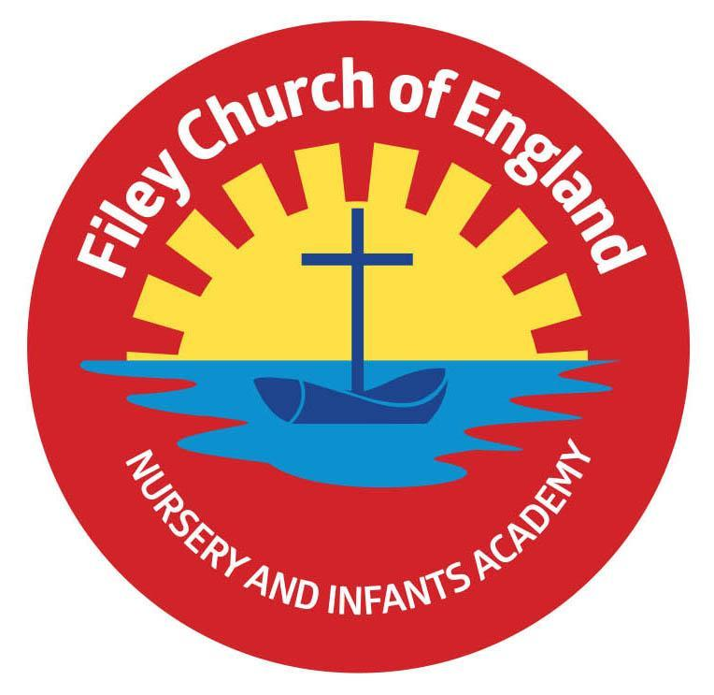
Friday 12th April 2024

Dear Parents and carers,
Welcome back, I hope you all had a fantastic Easter! I can’t believe we are entering the Summer term already! I am writing to let you know what we will be learning this half-term and all of the exciting things we have coming up.

Our Curriculum
As a school we work tirelessly to make sure our curriculum is up-to-date as well as exciting and engaging for all our children. This half-term our theme is Identity and Diversity. We will be answering the question- How have people changed the world? Our themes for the year and more information about our long term plan can be found on the school website ww.fileyinfants.ebor.academy under TEACHING & LEARNING – Curriculum.

This half term in Literacy children will be exploring writing newspapers and character descriptions. They will also write speeches inspired by Martin Luther King Jr’s ‘I have a dream’ speech thinking about the changes they want to see in the world. This will be further supported in our history lessons this half term where we will be learning about gender equality, racial equality and disability equality. We will be learing about some famous people who support this e.g. Emmeline Pankhurst, Nelson Mandela, Margaret Thatcher and Mae Jemison. In maths we will be learning about measurement and position and direction. In Science we will be observing and describing how seeds and bulbs grow into mature plants and finding out and describing how plants need water, light and suitable temperatures to grow and stay healthy. In Computing we will be using logical reasoning to predict the behaviour of simple programmes and revising our learning on e-safety. During our RE learning this half term we will be exploring the big question ‘What is the ‘good news’ that Christains believe Jesus brings?’. Here we will be learning about how Christians believe Jesus’ teachings make people think hard about how they live and show them the right way. Our PSHE learning will focus around ‘Celebrating Differences’. During this unit we will learn about what stereotypes are, how we can be a good friend and how we can get help if we think we are being bullied. During PE lessons we will be starting our unit on athletics. Children will be exploring running for distance and speed, different ways to jump and land with control and develop an overarm throwing technique. In music we will explore music by Stevie Wonder identifying the pulse, rhythm, tempo, dynamics and pitch in his music. In Art/ DT we will be exploring the artwork of Andy Warhol. Children will use printing methods to create their own artwork and design a bag. They will learn how to use simple running stitch to join fabrics and decorate textiles.

Enterprise
We will be holding our second class enterprise of the year.

More information to follow!

PE
Children will have twice-weekly PE sessions. PE will be on a Tuesday and Thursday. We are lucky to have our PE specialist Mr Ellis working with us again this half term. Children must have the correct PE kit with them. This should include named; white t-shirt, black or navy shorts, and trainers for outside. Feel free to also include leggings/tracksuit bottoms and a warm jumper as we will be going outside for PE as much as possible as the weather improves. Children are welcome to leave this hanging on their peg all half-term to make life easier!
On PE days please ensure that your child is properly prepared. If they wear earrings please remove them before school (staff are not able to support them with this). Please can all long hair be securely tied up to avoid any accidents.

Uniform
Do not forget, as a school we are trying to do our bit for the planet and recycle as much as possible. If you would like any uniform or some PE kit from our good quality second hand uniform cupboard, please phone the office or catch me at the door.

SPaG and Reading
In Year 2 children will have daily SPaG and guided reading sessions. In school, guided reading books are changed regularly. We aim to change books every week but on some occasions, this may be fortnightly. This book will be available to read the following week on our online reading platform, Collins eBooks. These are updated regularly so please support your children in accessing this.
Children will also bring home a physical book to read. This can be read and changed as regularly as they wish. In year 2, children are given the responsibility of changing this book themselves. Whilst we do remind them regularly, please let us know if it keeps getting missed! As a school we recommend that children read at home every day, so please read as regularly as you are able to. are able to.

Library
During the week children will visit our Big Red Reading Bus, please support your child to remember to bring their library book to change every Thursday.

Homework
The children will continue to receive weekly homework. We try to provide a range of engaging activities covering all different areas of the curriculum. Each week these can be found in children’s orange homework books.
Homework will be given out each Friday. Please help your child to return their homework to school by the following Thursday so we can mark and update their books. Although we encourage this to be completed every week, we understand that sometimes life is just a bit busy so please do not worry!

Weekly Newsletters
As always Mrs Clark will continue to write weekly newsletters to keep you up-to-date with all the exciting things happening in school. To reduce our paper use and do our part for the planet, these will be emailed out every Friday. Please contact the office if you are not receiving them. These newsletters also include important upcoming dates that you need to be aware of so please take the time to check them weekly.
Thank you in advance for all of your support. Please always remember that school is here to help if you need us.

Kind regards,
Miss J Williams
Miss Williams

