Friday 8th March 2024
Dear Parents/Carers
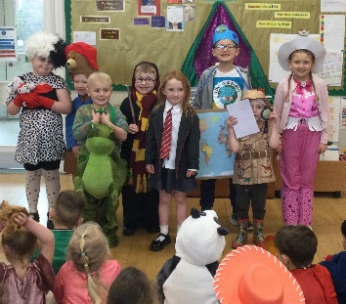
We have all had such a fun day in school today dressed up as favourite story characters and sharing books together. The winners of the World Book Day competition (judged by the school council) were: Nellie in Nursery, Darcie in Reception, Jasmine in Year 1 and Verity in Year 2, they all won a £10 National Book Token so they can choose their own lovely new book! Well done to everyone for taking part today, remember to use your World Book Day voucher. Next week our lunch menu is following week 2, please see attached to this email. This week Miss Williams’ class won the attendance award with 97%. Well done to them!

Christian Distinctiveness
On Tuesday this week Reverend Phil led Collective Worship for us in school. We explored Justice and how important it is to treat people fairly and with respect. Reverend Phil told us all about the family that started the Cadbury factory in 1831, the story of a father and two sons, and how their generosity inspired generations to come. They poured a ‘glass and a half’ into their Dairy Milk - and into their workers and communities, too. Cadbury believed that their staff and families should all be treated well, they were not only given jobs but also homes to live in and a school was built for their children to be educated. This very much aligns with our school vision to ‘Shine as lights in the world and love as Jesus loves us’ (Phillippians 2.15 & John 13.34). ‘Community, Compassion & Friendship’ are our core values, which are at the heart of everything we do.

Easter Eggstravaganzers!
From Monday, we will be selling Easter egg raffle tickets in classes for 50p each. These tickets will all go into a class draw, which will take place on Friday 22nd March with lots of winning prizes for each class. The money raised will go towards school funds so please try to support us if you can.
On Friday 22nd March, Mrs Wilson (chair of Governors) will be judging the Easter hat competition and the decorated egg competition for all children wanting to take part.
The following themes for decorated eggs have been chosen by the teachers:
Nursery and Reception – Animals (any kind of animal either alive or extinct!)
Year 1 – Traditional Tales (e.g. any characters from a favourite fairy tale)
Year 2 – Around the World (e.g. famous people, places or animals from anywhere around the world)

Children are invited to bring their hats and eggs into class on Friday morning. Children will wear their Easter hats for the school parade, starting at 2.30pm on Friday 22nd March. Gates will open at 2.20pm, parents/carers and family members are invited to sit in their child’s classroom and wait for the parade to begin!
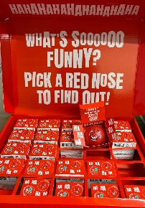
Comic Relief Day
As a school, we are keen to support a variety of charities and on Friday 15th March, it is Comic Relief Day. The theme is red, however as our uniform is red we thought children could wear anything that is red for the day and have funny hair too if they want! Staff will have collection buckets should you wish to make a small donation. We are selling red noses for £2 in the school office and still have plenty left!

Wrap Around Care (Seashells Club)
Just a reminder that we offer wrap around care in school for busy parents/carers. The before school session starts from 7.30am-8.40am and costs £4.50 including breakfast. After school runs from 3.05pm-6pm including a snack, this costs £7 until 5pm and £9 until 6pm. If you book both before and after school on the same day, it costs £12 for both. You can book these sessions through Parent Pay or just by phoning the school office.
Gymnastic Demonstrations
Children have been busy practising their vault and floor routines ready for the gymnastic demonstrations coming up very soon. This is a great opportunity for you to see what they have been learning in PE this term and for the children to demonstrate and share their hard work.
Nursery children that are NOT moving into Reception classes in September 2024 will not take part this time (they have another year in Nursery and will have the opportunity in spring 2025).
Please come along to the following sessions if you are able:
Thursday 14th March
9am – 9.45am Miss Ring’s class
10am – 10.45am Miss Haldenby’s class
11am – 11.45am Miss Wither’s class
1.15pm – 2pm Mr Jackson’s class
2.15pm – 3pm Miss Williams’ class
Thursday 21st March
10.30am – 11.15am Nursery (Just the older children that are due to start reception in September) Nursery children that do not normally attend on a Thursday morning are welcome to join us for this experience if they would like to 10.15am-11.15am.
1.15pm – 2pm Mrs Kerr/Mrs Monks’ class
2.15pm – 3pm Mrs Stubbs class

Nursery News
This week in nursery, we have been looking for bugs in the outdoor area and we have created an indoor habitat in the tuff spot. We have been looking for signs of spring in the outdoor area again and have had lots of stories about spring to help us remember what spring looks like and feels like. Today we enjoyed World Book Day and admired everyone in their dressing up outfits.
Reception News
The children have had a wonderful time dressing up as their favourite characters for World Book Day. They took part in lots of different activities and spoke with enthusiasm about their favourite stories. Throughout the week, the children have continued with the story 'Paper Dolls'. They have drawn and labelled a story map and then used these to re-tell the story. In maths, the children have been exploring the number nine. They have investigated different ways to make nine and enjoyed finding patterns within the number. In PE, the children have continued with their gymnastics skills and used the spring board to perform some imaginative jumps. They are very excited about sharing their skills with you during the 'Gymnastic Festival' in a few weeks.
Year One News
This week Year 1 have continued to enjoy exploring the Toys through time box from Scarborough Museum. Year 1 explored toys from the past, within living memory and the modern day. They continued to use their knowledge of toys from the past to write their own toy fact files. In Science, they investigated the properties of materials that different toys are made from. In Maths, they have explored inverse operations using addition and subtraction. In PE, they have been practising their gymnastics routines ready for their demonstration next Thursday. In RE the children enjoyed exploring activities relating to each of the days of Holy Week including taste testing, making palm leaves and creating Easter crosses using pastels.
Year Two News
This week year two have been learning about bees and how they make honey. They have written a set of instructions to help forgetful bees remember the process. In maths, they have learnt about fractions. In geography, they have learnt about the equator and have focused on the climates of countries around the world. In history, they have continued their learning about The Great Fire of London. The children have also been continuing to learn about Easter and have created Easter cards for the residents of Filey Fields.

Please remember to book a day and time for an appointment with your child’s class teacher if you have not already done so. These will be taking place in school on Monday, Tuesday and Wednesday next week. If you no longer have the letter to return please just phone the school office.
Thank you for your continued support, if you have any questions or concerns please just ask. We are here to help however we can.

Best Wishes
Mrs Angela Clark
Angela Clark
Headteacher

Diary Dates (Please keep these dates for your diary) more dates will be added as they arise!
March
Monday 11th March – Parent Meetings 3pm-5pm
Tuesday 12th March – Parent Meetings 3pm-5pm
Wednesday 13th March – Group of Y2 children visit Filey Fields Court
Wednesday 13th March – Parent Meetings 3pm-5pm
Thursday 14th March – Gymnastics Demonstrations for year 1 and 2 in the school hall
Thursday 14th March – First cookery club for group 4
Friday 15th March – Celebrate Red Nose Day!
Tuesday 19th March – Easter service at St John’s Church
Wednesday 20th March – Last swimming session for group 3
Thursday 21st March - Gymnastics Demonstrations for Reception and Nursery in the school hall
Friday 22nd March – Mrs Wilson (Chair of Governors) to judge the Easter hat and decorated egg competition
Friday 22nd March – Easter Hat Parade around school 2.30pm everyone welcome!
Friday 22nd March – School Closes for the end of term
April
Tuesday 9th April – School opens for the start of the summer term
Wednesday 10th April – First swimming session for Group 4
Thursday 11th April – After school PE club starts for Year 1
Monday 15th April – Open the Book Collective Worship
Tuesday 23rd April – School Book Fair arrives
Thursday 25th April – Last cookery club for group 4
Monday 29th April – Last day for the school Book Fair
Tuesday 30th April - Reverend Phil leads Collective Worship in school
May
Thursday 2nd May – First cookery club for group 5
Monday 6th May – BANK HOLIDAY
Tuesday 7th May – Class Photo Day
Wednesday 22nd May – Last swimming session for group 4
Thursday 23rd May – Last PE Club for year 1
Friday 24th May – School closes for half term
June
Tuesday 4th June – school opens
Wednesday 5th June – first swimming session for group 5
Thursday 6th June – Reception Outdoor Education Day (Filey Beach)
Thursday 6th June – first PE club for Nursery
Thursday 6th June – last cookery club for group 5
Thursday 13th June – Year 1 Outdoor Education Day (Glenn Gardens)
Thursday 13th June – first cookery club for group 6
Monday 17th June – Open the Book Collective Worship
Thursday 20th June – Year 2 Outdoor Education Day (Dalby Forest)
Friday 21st June – School reports go out to parents/carers
Thursday 27th June – School Open Evening 4pm – 6pm

July
Tuesday 2nd July – Year 2 transition day to the Junior School
Wednesday 3rd July – Year 2 transition day to the Junior School
Thursday 4th July – Whole School transition day
Monday 8th July – Reception Sports Day 1pm
Tuesday 9th July – Year 1 Sports Day 1pm
Wednesday 10th July – Year 2 Sports Day 1pm
Thursday 11th July – last PE club for Nursery
Thursday 11th July – last cookery club for group 6
Friday 12th July – School Summer Fayre 3pm-4.30pm
Monday 15th July – Nursery Sports Day 1pm
Wednesday 17th July – last swimming session for group 5
Thursday 18th July – Year 2 Party 5pm-6.30pm
Friday 19th July – 11am Year 2 Collective Worship (parents/carers invited)
Friday 19th July – 12pm – 1pm whole school family picnic (everyone welcome)
Friday 19th July – 3.05pm School closes

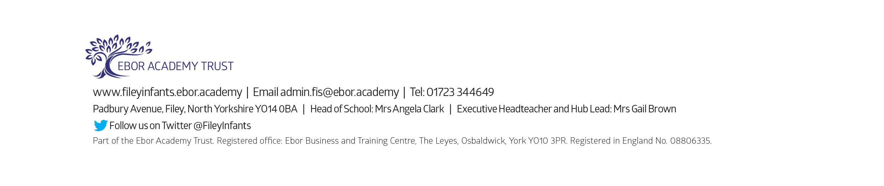
Tuesday 3rd September - School reopens for the start of the new academic year.

