Friday 23rd February 2024
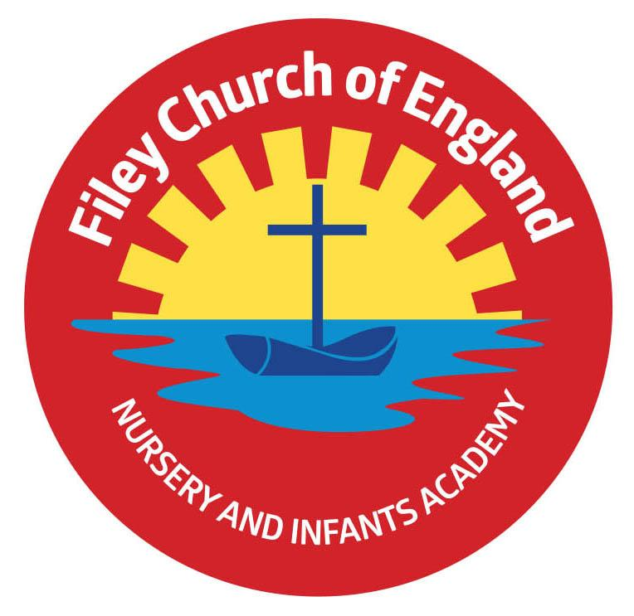
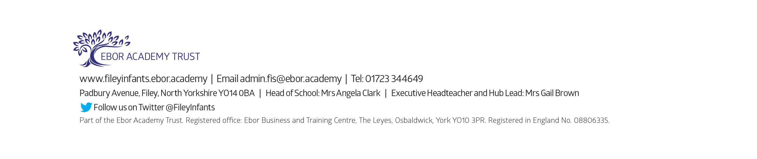
Dear Parents and carers,
Welcome back to the second half of the Spring Term! We are writing to let you know what we will be learning this half term and all of the exciting things we have coming up.
Our Curriculum
As a school, we provide an exciting and engaging curriculum for all our children. This half term our theme is Come Outside! Our themes for the year and our long-term plan can be found on the school website www.fileyinfants.ebor.academy Throughout this topic will be enjoying lots of exciting books including The paper Dolls, Superworm, Spinderella and The Tiny Seed.

PE
Children will have weekly PE sessions. This term we will have PE on a Thursday. Please ensure your child has their PE kit on these days. This should include a white t-shirt, black/blue shorts, and trainers. Please ensure everything is clearly named. For ease, PE kits can be left in school for the half term. If your child wears earrings, please remove them before school as staff are not able to support them to do this. Please can all long hair be securely
As a school, we are trying to do our bit for the planet and recycle and reuse wherever possible. In school, we have a uniform cupboard full of pre-loved items. If you need any additional uniform or PE kit please phone the office or catch us on the door.

Phonics and Reading
In Reception children have daily phonics and guided reading sessions. To help you support your child’s learning at home, we will be continuing to send home a small sheet each Friday detailing what we have covered.
In school, guided reading books will be changed weekly. This book will be available to read the following week on our online reading platform, Collins eBooks. Children will also bring home an additional book to read. This can be read and changed as regularly as they wish.
As a school we promote a love of reading and encourage you to enjoy books regularly at home.

Library
Children will visit our Big Red Reading Bus twice a week. We will have a whole class story time on the bus, as well as allowing another opportunity for children to choose and borrow their own book. Miss Kerr and Mrs Monks’ library session will be on a Wednesday and Mrs Stubbs’ library session will be on a Tuesday. Please remember to bring your library book on these days so that your child can exchange their old book for a new one.

Weekly Newsletters
As always, Mrs Clark will continue to write weekly newsletters to keep you up-to-date with all the exciting things happening in school. To reduce our paper use and do our part for the planet, these will be emailed out every Friday. Please contact the office if you are not receiving them. These newsletters also include important upcoming dates that you need to be aware of so please take the time to check them weekly.
If you have any questions please do not hesitate to ask.

Kind regards,
Mrs Stubbs, Mrs Kerr, Mrs Monks and the rest of the EYFS team.

