Friday 23rd February 2024
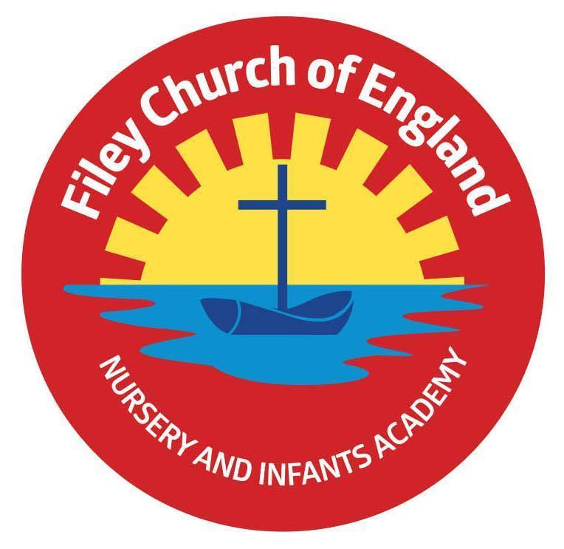
Dear Parents and Carers
Welcome back to the second half of the Spring Term! Firstly thank you all for your incredible support at our class enterprise! The children loved the experience and it was fantastic that so many of you were able to come along. I am writing to let you know what we will be learning this half term and all of the exciting things we have coming up.
Our Curriculum
As a school, we work tirelessly to make sure our curriculum is up-to-date as well as exciting and engaging for all our children. This half term our theme is The Great Fire of London. This topic will include a visit to Visit Filey fire station. During our topic we will also be answering the question Why is it important to look after our world?

Our Literacy focus will be writing Poetry linked to the seasons, setting descriptions and writing Instructions. We will do this through reading and sharing our class books ‘The Great fire of London’, ‘The Night Gardener’, ‘Story Orchestra’ and ‘The Book of Bees’. In maths, we begin our learning on shape, statistics and fractions. In Science, we will be learning about the suitability of materials, using our prior knowledge about the properties of materials.
In Computing, we will be learning about stop motion animation and will create our own, based on last terms DT project. In RE we will be revising our big question ‘Why does Easter matter to Christians? Which includes a focus on forgiveness. We will also be looking at Christianity around the world, linked to our geography topic. Our PSHE learning will focus on ‘Healthy me’ and the children will learn how to look after their bodies.
In PE we will be looking at ‘hands, feet, equipment’ which explores the key skills needed to play invasion games. In Geography, the children will use their prior knowledge of the 7 continents and 5 oceans to help expand their knowledge of the world. They will focus on the equator, northern hemisphere and the southern hemisphere.
In History, the focus will be The Great Fire of London and the children will learn facts about what happened; this will inform their literacy work too. In Music, children will be exploring music linked to the ‘Story Orchestra’. They will listen to the interrelated dimensions of music and discuss how the tempo changes in relation to the seasons. This will also be linked to their work on poetry.
PE
Children will have twice-weekly PE sessions. The days may change each half term (check the class window for changes). Our PE days will be Tuesday and Wednesday. On these days please ensure that your child is properly prepared. If they wear earrings please remove them before school (staff are not able to support them with this). Please can all long hair be securely tied up to avoid any accidents.
Children must have the correct PE kit with them. This should include named; white t-shirt, black or navy blue shorts, and trainers for outside. Children are welcome to leave this hanging on their peg all half term to make life easier!
Do not forget, as a school we are trying to do our bit for the planet and recycle as much as possible. If you would like some PE kit (or any uniform) from our good quality free second hand uniform cupboard, please phone the office or catch me on the door.

Phonics and Reading
Children have daily phonics/SPaG and guided reading sessions. In school, guided reading books are changed regularly. We aim to change books every week but on some occasions, this may be fortnightly. This book will be available to read the following week on our online reading platform, Collins eBooks. These are updated regularly so please support your children in accessing this.
Children also bring home a physical book to read. This can be read and changed as regularly as they wish. In year 2, children are given the responsibility of changing this book themselves. Whilst we do remind them regularly, please let us know if it keeps getting missed! As a school, we recommend that children read at home every day, so please read as regularly as you are able to.
Library
During the week, children will visit our Big Red Reading Bus twice. We will have a whole class story time on the bus, as well as allowing another opportunity for children to choose and borrow their own book. Please support your child to remember to bring their library book to change every Monday.

Homework
Children receive weekly homework and we try to provide a range of engaging activities covering all different areas of the curriculum. Each week these can be found in children’s orange homework books. Every half term year 2 children also have a set of key words to practise. These are words which all children of this age should be able to read and write by the end of the year. Please support your child to practise these words at home throughout the half term, some suggestions of how to do this can also be found in their homework books.
Homework will be given out each Friday. Please help your child to return their homework to school by the following Thursday so we can mark and update their books. Although we encourage this to be completed every week, we understand that sometimes life is just a bit busy so please do not worry! Each week your child will receive a set of spellings based on the spelling rules we have been learning that week. Children will complete a short spelling check every Friday.
Weekly Newsletters
As always, Mrs Clark will continue to write weekly newsletters to keep you up-to-date with all the exciting things happening in school. To reduce our paper use and do our part for the planet, these will be emailed out every Friday and uploaded onto the school website. Please contact the office if you are not receiving them. These newsletters also include important upcoming dates that you need to be aware of so please take the time to check them weekly. Thank you in advance for all of your support.

Kind regards
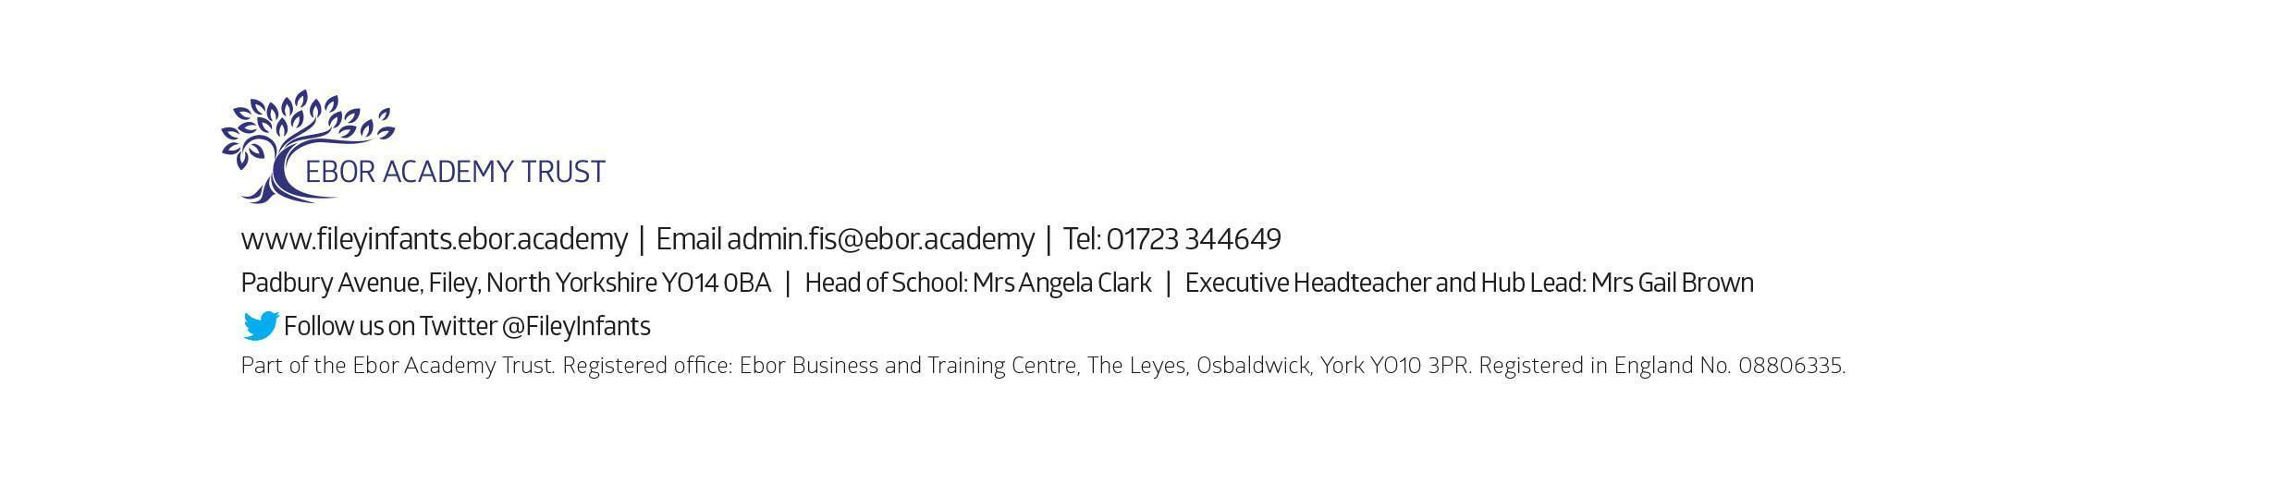
Miss Williams

