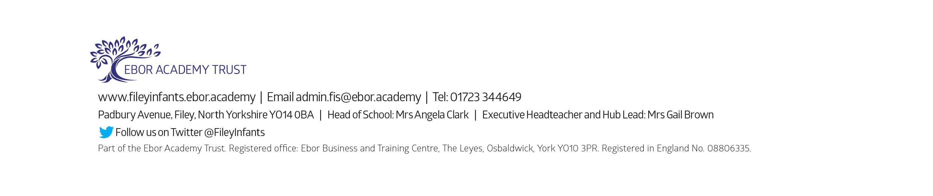
Friday 23rd February 2024

Dear Parents and Carers
Welcome back to the second half of the Spring Term! Firstly thank you all for your incredible support at our class enterprise! The children loved the experience and it was fantastic that so many of you were able to come along. I am writing to let you know what we will be learning this half term and all of the exciting things we have coming up.
Our Curriculum As a school we work tirelessly to make sure our curriculum is up-to-date as well as exciting and engaging for all our children. This half term our theme is Toy Box! Our themes for the year and more information about our long-term plan can be found on the school website: www.fileyinfants.ebor.academy under TEACHING & LEARNING - Curriculum
This half term our key question is “How have toys changed?” We will begin by exploring this question within our History lessons before the children have the opportunity to design and make their own toy cars in DT later in the term. During our Science lesson this term, we are continuing our learning about everyday materials considering some of the basic properties of materials. We will link this to our learning about toys by considering why toys are made of certain materials and why this has changed over time.
In Literacy we will be developing our inference and comprehension skills by exploring the book “How to find gold” by Viviane Schwarz. Children will also be creating their own toy fact files about a toy from the past. We will finish the term by learning about traditional tales and writing our own versions of the Gingerbread Man.
During maths, we are continuing our learning about additive structures within 10 and will be building children’s’ fluency of number facts (addition and subtraction) within 10.
In Music, the children will be exploring a number of key concepts within pieces of music including phrases, pitch and dynamics.
In RE children will continue considering the question: How and why do we celebrate special and sacred times? We will be learning about The Easter Story and how Christians celebrate this special time. Children will also recall last terms learning about Islamic celebrations and consider the similarities and differences between these and Easter celebrations.
We will also continue to cover seasonal changes as we move through the school year.
PE and Swimming
Children will have twice-weekly PE sessions. PE will be on Wednesday and Friday. Children must have the correct PE kit with them. This should include named; white t-shirt, black or navy shorts, and trainers for outside. Feel free to include leggings/tracksuit bottoms and a warm jumper while the weather is still cold. Children are welcome to leave this hanging on their peg all half term to make life easier!
Children who are in swimming group 4 will start their lessons after the Easter break on Wednesday 10th April until 22nd May. If you have any questions regarding swimming, please get in touch. Please note swimming counts as their second PE lesson of the week. Children must come prepared with their swimming kit, which should include a one piece swimming suit/shorts and a towel. Children are welcome to bring goggles but need to be able to put them on themselves. Armbands are not needed, as floats will be provided if required. Children may come to school with their swimming things on under their uniforms but please ensure they bring everything they need for after.
On swimming and PE days please ensure that your child is properly prepared. If they wear earrings please remove them before school (staff are not able to support them with this). Please can all long hair be securely tied up to avoid any accidents.
Uniform
Do not forget, as a school we are trying to do our bit for the planet and recycle as much as possible. If you would like any uniform or some PE kit from our good quality second hand uniform cupboard, please phone the office or catch me at the door.

Phonics and Reading
We will continue to have daily phonics and guided reading sessions. To enable you to best support your child’s phonics at home, we will continue sending home a small sheet each Friday detailing what we have covered so you know what to practise with them.
In school, guided reading books will be changed regularly. We aim to change books every week but on some occasions, this may be fortnightly. This book will be available to read the following week on our online reading platform, Collins eBooks (login details in reading records).
Children will also bring home a physical book to read. This can be read and changed as regularly as they wish. In year 1, children are given the responsibility of changing this book themselves. Whilst we do remind them regularly, please let us know if it keeps getting missed! As a school, we recommend that children read at home every day, so please read as regularly as you are able to.
Library
During the week, children will visit our Big Red Reading Bus twice. We will have a whole class story time on the bus, as well as allowing another opportunity for children to choose and borrow their own book. Please support your child to remember to bring their library book to change every Friday.

Homework
I have been so impressed with everyone's efforts with homework so far this year. The children will continue to receive weekly homework. We try to provide a range of engaging activities covering all different areas of the curriculum. Each week these can be found in children’s yellow homework books.
Homework will be given out each Friday. Please help your child to return their homework to school by the following Wednesday so we can mark and update their books. Although we encourage this to be completed every week, we understand that sometimes life is just a bit busy so please do not worry!

Weekly Newsletters
As always, Mrs Clark will continue to write weekly newsletters to keep you up-to-date with all the exciting things happening in school. To reduce our paper use and do our part for the planet, these will be emailed out every Friday. Please contact the office if you are not receiving them. These newsletters also include important upcoming dates that you need to be aware of so please take the time to check them weekly.
Thank you in advance for all of your support. Please always remember that school is here to help if needed.
Kind regards Miss Haldenby

