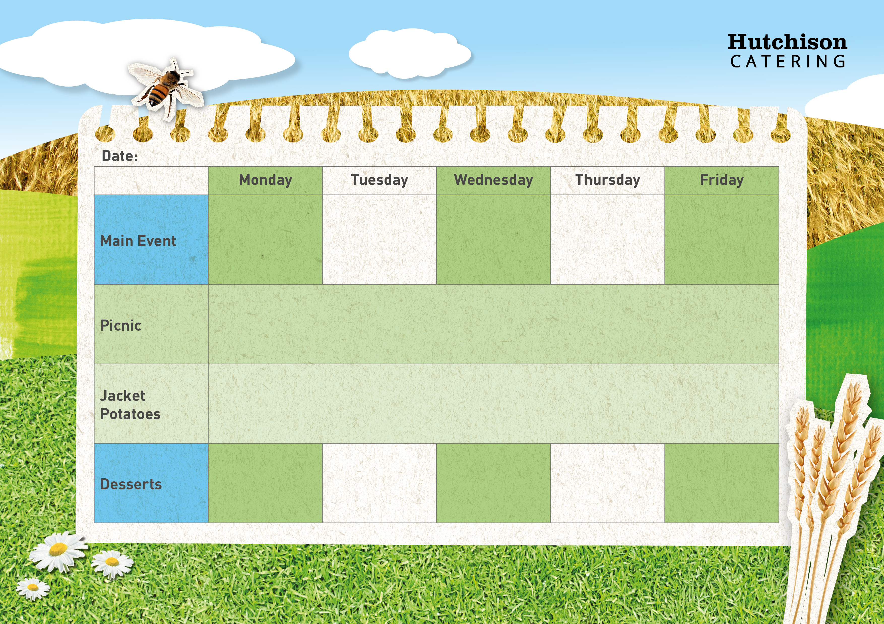

Chicken Tikka

With Rice &

Broccoli

Crispy Battered Fish with Potato Wedges & Baked Beans

Homemade Pasta Bolognaise with Peas

Roast Chicken with Yorkshire Pudding, Crispy Roast Potatoes, Carrots & Gravy



Orange Cake

**Spring Week 1 19th Feb, 4th March,18th March,1st April, 15th April, 29th April,13th May,27th May,10th June, 24th June, 8th July,**

Flapjack

Strawberry Whip

With Fruit

Margherita Pizza

With Herby Potatoes &

Sweetcorn

Banoffee Cake

**Available Daily:** Fresh Bread, Water, Fresh Fruit and Yoghurt

**Freshly Prepared Sandwich, Healthy Snack,**

**Dessert of the Day or Fresh Fruit**

**Crispy Baked Jacket Potato with a Choice of Fillings**

**Dessert of the Day or Fresh Fruit**

Ice Cream

With Fruit