Friday 12th January 2024
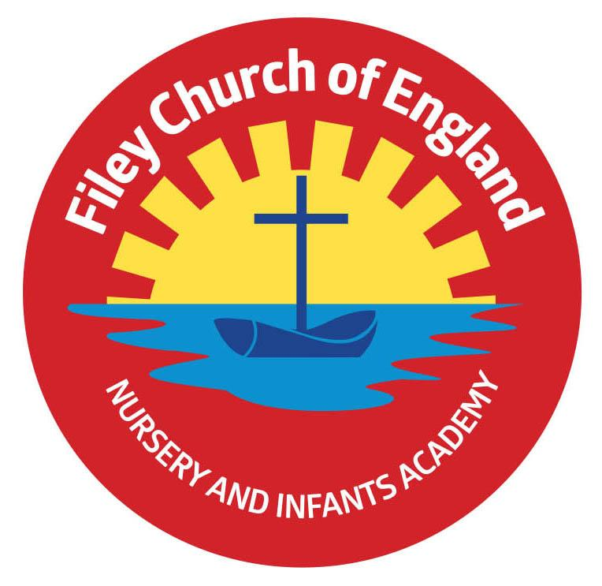
Dear Parents and Carers
Happy New Year! I hope you all had a wonderful Christmas holiday. It was lovely to welcome the children back into school this week. As we start the spring term, I am writing to let you know what we will be learning this half-term and all of the exciting things we have coming up.

Our Curriculum
As a school, we work tirelessly to make sure our curriculum is up-to-date as well as exciting and engaging for all our children. This half term our theme is Paddington! Our themes for the year and more information about our long-term plan can be found on the school website: www.fileyinfants.ebor.academy under TEACHING & LEARNING – Curriculum
This half-term in literacy we will be exploring two fantastic books about two very adventurous bears. The first is “Leaf” by Sandra Dieckmann and the second is, of course, “Paddington” by Michael Bond. Children will explore the characters of these books and will practise their comprehension and inference skills. They will work towards writing their own Paddington adventure story later in the half term.
During maths this term, we will continue our learning of numbers to 10 before beginning to explore additive structures within 10. In science this term, our topic is Everyday Materials. Children will be learning to identify and sort a variety of everyday materials. In geography, we will be learning about the four countries that make up the United Kingdom and in computing the children will be learning how to log on to and access learning on the school chrome books.
Our learning in art will involve looking at the work of artist Anni Albers and creating our own special weaving pieces of art. In Music, the children will be exploring the use of timbre in music, including in their own voice and using drums.
Through the spring term, in RE children will be considering the question: How and why do we celebrate special and sacred times? They will begin by considering times that are special to them before learning about times that are special to religions. This half term we will be learning about Ramadan and Eid ul Fitr, two special celebrations for Muslims.
We will also continue to cover seasonal changes as we move through the school year.

Enterprise
Our first class enterprise of the year will be on the afternoon of Tuesday 6th February. More details to follow closer to the date.

PE
Children will have twice-weekly PE sessions. This half term is our opportunity to have our PE lessons with Mr Ellis. This half term our PE days will be Wednesday and Thursday. On these days please ensure that your child is properly prepared. If they wear earrings please remove them before school (staff are not able to support them with this). Please can all long hair be securely tied up to avoid any accidents.
Children must have the correct PE kit with them. This should include named; white t-shirt, black or navy shorts, and trainers for outside. Feel free to also include leggings/tracksuit bottoms and a warm jumper in cold weather. Children are welcome to leave this hanging on their peg all half term to make life easier!

Uniform
Do not forget, as a school we are trying to do our bit for the planet and recycle as much as possible. If you would like any uniform or some PE kit from our good quality second hand uniform cupboard, please phone the office or catch me at the door.

Phonics and Reading
We will continue to have daily phonics and guided reading sessions. To enable you to best support your child’s phonics at home, we will continue sending home a small sheet each Friday detailing what we have covered so you know what to practise with them.
In school, guided reading books will be changed regularly. We aim to change books every week but on some occasions, this may be fortnightly. This book will be available to read the following week on our online reading platform, Collins eBooks (login details in reading records).
Children will also be able to bring home a physical book to read. This can be read and changed as regularly as they wish. In year 1, children are given the responsibility of changing this book themselves. Whilst we do remind them regularly, please let us know if it keeps getting missed! As a school, we recommend that children read at home every day, so please read as regularly as you are able to.

Library
During the week, children will visit our Big Red Reading Bus twice. We will have a whole class story time on the bus, as well as allowing another opportunity for children to choose and borrow their own book. Please support your child to remember to bring their library book to change every Friday.

Homework
I have been so impressed with everyone's efforts with homework so far this year. The children will continue to receive weekly homework. We try to provide a range of engaging activities covering all different areas of the curriculum. Each week these can be found in children’s yellow homework books.
Homework will be given out each Friday. Please help your child to return their homework to school by the following Wednesday so we can mark and update their books. Although we encourage this to be completed every week, we understand that sometimes life is just a bit busy so please do not worry!

Weekly Newsletters
As always, Mrs Clark will continue to write weekly newsletters to keep you up-to-date with all the exciting things happening in school. To reduce our paper use and do our part for the planet, these will be emailed out every Friday. Please contact the office if you are not receiving them. These newsletters also include important upcoming dates that you need to be aware of so please take the time to check them weekly.

Thank you in advance for all of your support. Please always remember that school is here to help if you need us.

Kind regards,
Miss L Haldenby
Miss Haldenby
