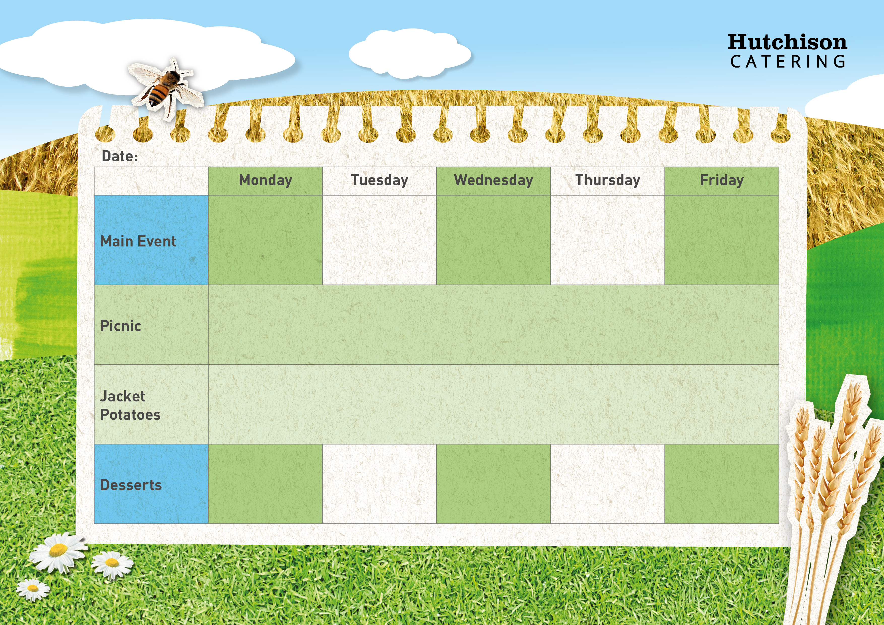

Oven Baked Fish Fingers with Chips & Baked Beans

Meatballs in a Homemade Tomato Sauce with Pasta with Sweetcorn

Roast Turkey with Yorkshire Pudding, Crispy Roast Potatoes, Carrots & Gravy



Chicken Goujon Wrap with Herby Diced

Potatoes & Salad

“Meat Free Mondays”

Margherita Pizza with Potato Wedges & Peas

**Autumn Week 2**

Fruity Flapjack

Chocolate & Vanilla Marble Cake

Strawberry whip with Fruit

Fruit Sponge

**Available Daily:** Fresh Bread, Water, Fresh Fruit and Yoghurt

**Freshly Prepared Sandwich, Healthy Snack,**

**Dessert of the Day or Fresh Fruit**

**Crispy Baked Jacket Potato with a Choice of Fillings**

**Dessert of the Day or Fresh Fruit**

Ice cream Cups