Friday 8th December 2023
Dear Parents/Carers
We are very much looking forward to our Christmas Fayre after school today from 3.10pm until 4.30pm; please join us if you can. This week Mrs Kerr & Mrs Monks class won the attendance award with 98% very well done to them! Next week the school lunch menu will be following ‘week 2’ please see the menu attached to this email.

Christian Distinctiveness
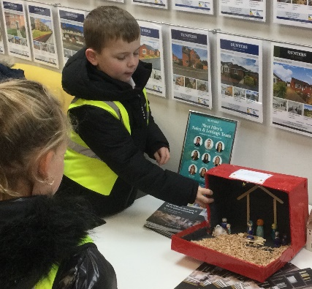
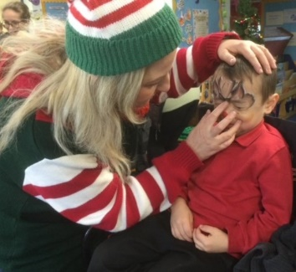
This week a group of our Year 2 children delivered Nativity Boxes in the local community. Each class made a selection of Nativity Boxes to share around Filey. Look out for them as you are out and about! On Wednesday our Reception children enjoyed a Christmas breakfast with family and friends, they had a story session, took part in Christmas activities and had their faces painted. This was provided through the National Literacy Trust who also gave every child a lovely free book to take home. A big thank you to everyone who joined us for this special event. ‘Community, Compassion & Friendship’ are our core values, which are at the heart of everything we do.

Christmas Production Tickets
Christmas productions are next week and you should have already asked your child’s class teacher for tickets! Teachers will be checking the wish lists and giving out any extra tickets that remain. Please remember to bring your tickets with you to the performances.
Tuesday 12th at 2pm – Nursery and Reception performance ‘The Greatest Story Ever Told’
Wednesday 13th at 9.30am - Nursery and Reception performance ‘The Greatest Story Ever Told’
Wednesday 13th at 2pm – Year 1 performance ‘Twinkly Nativity’
Thursday 14th at 9.30am - Year 1 performance ‘Twinkly Nativity’
Thursday 14th at 1.30pm – Year 2 performance ‘Hey Ewe’
Friday 15th at 9.30am - Year 2 performance ‘Hey Ewe’

Jack and The Beanstalk and Thor’s Great Big Adventure
On Friday 15th December, we will be taking all Nursery and Reception children to The Stephen Joseph Theatre to enjoy Thor’s Great Big Adventure! We will be leaving school at 12.45pm and should be back at school for 3pm (there is a possibility that we may arrive back 5/10 minutes late depending on traffic etc.) If your Nursery child does not attend Nursery on this day they are still invited to this exciting event. Please let Miss Hiley know if your child will be joining us.

On Tuesday 19th December, we will be taking all year 1 and 2 children to Scarborough Spa to enjoy the pantomime Jack and The Beanstalk. Coaches will be leaving school prompt at 9.10am on this morning so please ensure your child arrives at school on time.
All tickets and coaches have been paid for by fundraising events in school e.g. Schools Fayres & Sponsored Walk etc. Thank you for your wonderful support!

Christmas Jumper Day
We invite children and staff to wear a Christmas jumper on Thursday 21st December for our Christmas Lunch. This is of course optional and we do not request any donations to charities on this occasion. We appreciate Christmas is expensive enough for everyone! We do make a school donation of £50 to The Salvation Army when their brass band visits us on Wednesday 13th December.

Family Learning & Family Reading Clubs
Both these family clubs have now finished for this term. Thank you to all the Family Learning adults for organising the lovely parties that the children enjoyed this week. Family Learning will restart straight away after the Christmas holiday on Tuesday 9th January 2024. Family Reading clubs will start again the week beginning 15th January 2024.

PE Club and Year 2 Choir
The last session for these clubs will be on Thursday 14th December. There will be no school clubs taking place in the last week of term.

Cookery Club with Mrs Newlove
Group 1 cookery club had their last session on Thursday 7th December. Group 2 will have their first session on Thursday 14th December but then no more until Thursday 11th January (this is a change to the original letter).

Nursery News
This week Nursery have enjoyed many Christmas activities. The children have played Christmas games and made paper chains. They have also been on the stage practising for their Chrsitmas productions next week. Please can Nursery children come to school wearing their Christmas jumpers on Tuesday and Wednesday next week? Thank you.
Reception News
This week, the Reception children had a visit from Santa's Elves. The Elves had prepared the children a tasty breakfast and brought books and crafts for the children to enjoy. The children could choose to have their face painted and they looked very festive. We all joined in with the Christmas songs and the children listened carefully to the Christmas stories. It was a fantastic start to our Christmas celebrations.
Year One News
This week year 1 have been busy getting ready for their nativity. In literacy, they have been writing The Christmas Story. In maths, they have been looking at numbers 6 to 10 and investigating how they are made of 5 and a bit. During science this week we completed an investigation using their sense of hearing to discover the best way to hear the bell ringing at playtime. In RE we thought about what Christians believe God is like and listened to some special hymns. In computing this week children thought about how different pieces of information technology help us in the wider world. During DT they have made their own Christmas tree decorations using gluing techniques. These will be brought home at the end of term.
Year Two News
This week we have been reading the story ‘The Christmas Truce’ in literacy. We have been looking at number patterns in maths and colour mixing in art. In RE, we have been thinking about gifts that Christian’s give at Christmas time. In science, the children have been looking at the suitability of materials to build an air raid shelter. This has been linked to our world wars history topic.

Thank you for your continued support. If you have any concerns or questions please just ask, we are here to help in any way we can. Keep the diary dates below for future reference, more dates are added weekly as they arise.

Best Wishes
Mrs Angela Clark
Angela Clark
Headteacher

Diary Dates – Please keep these dates safe for your information

December
Friday 8th December – Flu Vaccinations catch up session
Friday 8th December – Christmas Fayre 3pm-4.30pm
Monday 11th December – Open the Book Collective Worship
Monday 11th December – Year 2 children visit Filey Junior School to watch their Christmas Production
Tuesday 12th December – Year 3 children visit us to watch the year 2 Christmas Production
Tuesday 12th December – 2pm Nursery & Reception Christmas Production for parents/carers
Wednesday 13th December – 9.30am Nursery & Reception Christmas Production for parents/carers
Wednesday 13th December – The Salvation Army Band join us for Christmas Carols
Wednesday 13th December – 2pm Year 1 Christmas Production
Thursday 14th December – 9.30am Year 1 Christmas Production
Thursday 14th December – 1.30pm Year 2 Christmas Production
Thursday 14th December – Year 2 cookery club group 2 starts
Friday 15th December – 9.30am Year 2 Christmas Production
Friday 15th December – Nursery & Reception children visit The Stephen Joseph Theatre
Monday 18th December – Year 1 and 2 Christmas Party
Tuesday 19th December – Year 1 and 2 visit The Spa Theatre
Wednesday 20th December – A group of Reception children visit Filey Fields to sing Christmas songs
Wednesday 20th December – Nursery & Reception Christmas Party
Thursday 21st December – Christmas Lunch
Friday 22nd December – Travelling Theatre Company visit our school
Friday 22nd December – School Closes

January
Tuesday 9th January – School Opens
Thursday 11th January – After school PE club starts for Y1
Thursday 11th January – After school Cookery Club for group 2
Monday 15th January – ‘Wonder Time’ lunchtime club starts for year 1
Wednesday 17th January – Last swimming session for Group 2
Wednesday 24th January – First swimming session for Group 3
Friday 9th February – School Closes for half term
Monday 19th February – School opens

