Friday 15th December 2023

Dear Parents/Carers
Thank you to everyone who came to our Christmas Fayre or bought their children’s Christmas design items, we raised a wonderful £1030 towards school funds. Today our Nursery and Reception children had a great time at The Stephen Joseph Theatre, paid for through our fundraising events. This week Mrs Stubbs class won the attendance award with 98% very well done to them! Next week the school lunch menu will be following ‘week 3’ please see the menu attached to this email.
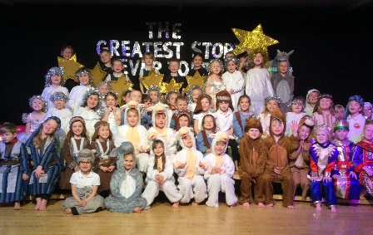
Christian Distinctiveness
This week we have enjoyed Christmas performances from each year group. Remember recordings of these will be up loaded onto our school website next week and can be found under: FAITH – Community Links
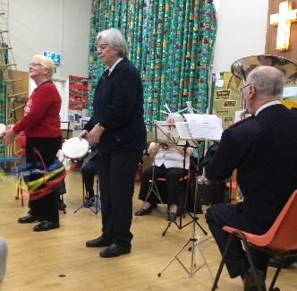
On Wednesday we were blessed with a visit from The Salvation Army brass band. They played us a selection of Christmas Carols and we joined in with singing and some percussion instruments. We made a small donation of £50 from school to the Salvation Army to say thank you for their visit and wished them all a very happy Christmas. Next Wednesday we look forward to a Christingle Service at St John’s Church. We received a thank you card today from The Royal British Legion saying thank you for the wonderful £260.27 we raised selling poppies and other Remembrance Day merchandise. ‘Community, Compassion & Friendship’ are our core values, which are at the heart of everything we do.

Jack and The Beanstalk
On Tuesday 19th December, we will be taking all year 1 and 2 children to Scarborough Spa to enjoy the pantomime Jack and The Beanstalk. Coaches will be leaving school prompt at 9.10am on this morning so please ensure your child arrives at school on time.
All tickets and coaches have been paid for by fundraising events in school e.g. Schools Fayres & Sponsored Walk etc. Thank you for your wonderful support!

Christmas Parties
Next week we will be enjoying our Christmas Parties. We kindly ask that Nursery & Reception bring gifts of buns/biscuits to share for the parties and year 1 & 2 bring gifts of crisps. Please could all donations arrive for Monday morning.
Year 1 and Year 2 children are invited to come to school on Monday 18th in their party clothes ready for the afternoon.
Nursery & Reception are invited to come to school on Wednesday 20th in their party clothes ready for the afternoon. Any Nursery children that do not normally attend on a Wednesday afternoon are invited to join us for the party. Please drop your child off at the Nursery gate at 12.45pm and collect at 3pm.

Christmas Lunch & Christmas Jumper Day
We invite children and staff to wear a Christmas jumper on Thursday 21st December for our Christmas Lunch. This is of course optional and we do not request any donations to charities on this occasion. There will be no jacket potatoes or sandwich options on this day just the traditional Christmas dinner.

Cookery Club with Mrs Newlove
Group 1 cookery club had their last session on Thursday 7th December. Group 2 had their first session on Thursday 14th December but then no more until Thursday 11th January (this is a change to the original letter).
Nursery News
This week in nursery we have really enjoyed being in our Christmas Nativity production. We liked the Salvation Army Brass Band and had fun making Christmas trees. We also made a Christmas wreath for our nursery door. Mr Ellis brought his dog Murphy to school and the children had fun looking after him.
Reception News
This week, the Reception children have amazed us with their fantastic Nativity performances. They sang confidently, danced beautifully and spoke loudly. They were able to get changed independently into their costumes and were so sensible before, during and after the performances. We then finished our busy week with a well-earned treat to Stephen Joseph Theatre to watch a performance of Thor’s Great Big Adventure! Well done Reception!
Year One News
In year one this week we have all been very excited to perform our Nativity play- 'The Twinkly Nativity' and we put on a wonderful performance for all of our grownups. In literacy, we have started to look at our new story 'Flood' and made some predictions about what might happen in the story. We have been looking at odd and even numbers in maths. In science this week, we were excited to do an investigation to find out more about our sense of smell.
Year Two News
This week Y2 have been writing letters based on our class story 'The Christmas Truce'. In Art, we have been making our Christmas crafts, which include a tree decoration, Christmas card and a class calendar. In RE, we have been continuing learning about why Christmas matters to Christians and we have enjoyed a visit to the junior school to watch the Year 3 Nativity. Finally, we really enjoyed performing our Year 2 Nativity to the rest of the school and sharing it with our families.

Thank you for your continued support. If you have any concerns or questions please just ask, we are here to help in any way we can.
Best Wishes
Mrs Angela Clark
Angela Clark
Headteacher
Diary Dates – Please keep these dates safe for your information
December
Monday 18th December – Year 1 and 2 Christmas Party 1pm
Tuesday 19th December – Year 1 and 2 visit The Spa Theatre
Wednesday 20th December – A group of Reception children visit Filey Fields to sing Christmas songs
Wednesday 20th December – Nursery & Reception Christmas Party 1pm
Thursday 21st December – Christmas Lunch
Friday 22nd December – Travelling Theatre Company visit our school – School Closes 3.05pm
January
Tuesday 9th January – School Opens
Thursday 11th January – After school PE club starts for Y1
Thursday 11th January – After school Cookery Club for group 2
Monday 15th January – ‘Wonder Time’ lunchtime club starts for year 1
Wednesday 17th January – Last swimming session for Group 2
Wednesday 24th January – First swimming session for Group 3
Friday 9th February – School Closes for half term

