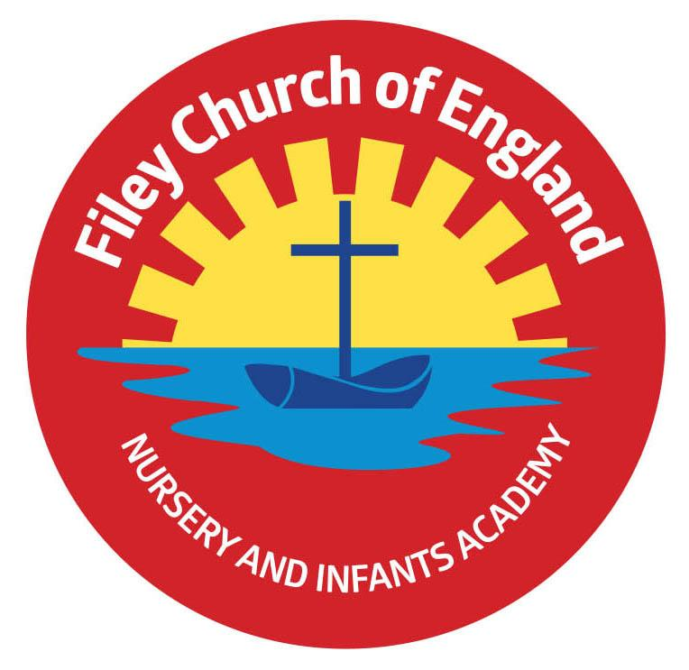
Friday 24th November 2023

Dear Parents/Carers
Another wonderful week in school with so many great things happening. This week Miss Ring’s class won the attendance award with 96.6% very well done to them! Next week the school lunch menu will be following ‘week 3’ please see the menu attached to this email.

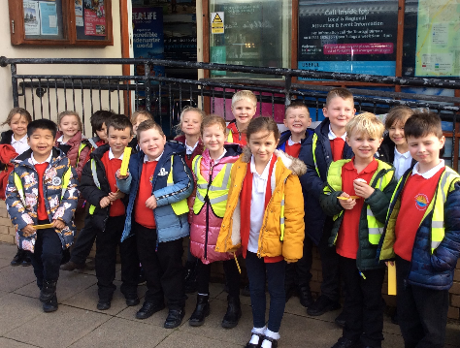
Christian Distinctiveness
Well done to Miss Ring’s and Miss Haldenby’s classes for their super poetry assemblies this week. Their poems and singing were all fabulous. If you missed these classes leading Collective Worship, a recording can be found on our school website under: TEACHING AND LEARNING – Classes – teachers name, these will not be avaiable to view until early next week. On Thursday a group of year two children performed a collection of hymns at Filey Evron Centre. This was enjoyed by many elderly Filey residents and continues to promote the importance we place on intergenerational work for our children and community. ‘Community, Compassion & Friendship’ are our core values, which are at the heart of everything we do.

Non-Uniform Day
Friday 1st December will be a non-uniform day in school and we ask all pupils if they can to ‘Bring a Bottle’ for our Christmas Fayre Tombola. We welcome bottles of shampoo, bubble bath, wine, sauce, spirits, wine, soft drinks etc. (unopened bottles only please). Please give any bottles of alcohol to members of staff or to the school office. Thank you for your support.

Christmas Fayre – Friday 8th December 3.10pm-4.30pm
We are in the process of planning a very special Christmas Fayre again this year with lots of wonderful prizes and stalls.
The fayre will take place in the school hall and Reception / Nursery classes. Stalls and activities will be as follows:
- Santa’s Grotto will be in the Nursery classroom.
- The bottle tombola, raffle stall, cakes, hotdogs and refreshments will be in the school hall.
- Christmas decorations, reindeer food bags, face painting and many other festive games and activities will take place in both the Reception classrooms.

Christmas Fayre Raffle Tickets
We have some amazing prizes this year for our Christmas raffle. Prizes include a super Christmas Hamper worth £50, two children’s scooters, a pamper hamper, children’s board games, toys and much, much more. Tickets cost £1 each and the prizes will be drawn at 4.20pm during the Christmas Fayre. Please complete the raffle ticket sheet and return to school in an envelope with the correct money if you would like to buy tickets in advance of the Fayre.

‘Healthy Selfie’
In school, we often talk about healthy living and the importance of exercise. From next week, we will be creating a ‘Healthy Selfie’ display in the school hall and would like you to send us your pictures. All you need to do is send a photo of your child doing something active or something that promotes a healthy/ active lifestyle to the following email address. The photo can then be printed and added to the hall display, if you want to add a description to what they have done, you can. The email address for ‘Healthy Selfie’ photos is healthyselfiefiley@gmail.com

Christmas Production Tickets
Tickets for your child’s Christmas Production will be available from Friday 8th December. You will need to collect them from your child’s class teacher. We issue two tickets to each family initially. If you would like more tickets please ask your child’s teacher and they will add your request to a wish list (we will try but these are not guaranteed and can only be given out once all children have their two ticket allocation). If parents are separated we can give two tickets to each parent if required. Please understand we have to do this because of the size of our hall and to ensure that we meet health and safety standards. A recording of each performance will be uploaded onto the school website so you are able to share it with extended family and friends.

Nursery News
This week in nursery we have been thinking about the nativity story and learning some traditional carols to sing in our Christmas production. We have also been very creative, making cards and decorations for our families for Christmas.
Reception News
This week Reception children have been using and creating story maps to retell the story of Goldilocks. They went on a shape hunt in the outside area and used mathematical vocabulary to describe 2D shapes. In phonics, they have been using their blending skills to read sentences and we have been very impressed with their letter formation.
Year One News
This week Miss Ring's and Miss Haldenby's Classes have worked really hard on their poetry assemblies. In phonics this week year 1 were introduced to split digraphs. They have been writing Autumn poetry in Literacy and exploring 3D shapes in maths. In science they started to learn about the five senses and which part of the body they are associated with. Next week (weather depending!) they will be using their senses on a local Autumn walk. During RE lessons they learnt about the importance of prayer for Christians and had a go at writing their own prayers. In DT, they used joining and cutting skills to create some amazing junk model skeletons (see Twitter for some photos). For history this week they were considering their personal histories and what significant things have happened within their lives.
Year Two News
In Literacy this week, we have been using the story ‘White Night Farm’ as inspiration for writing a diary. We have considered the characters thoughts and feelings at different times in the story and how we can use these in our writing. In maths, we have been finding the difference between two numbers. In Art, children have explored the artwork of Gustav Klimt and used a viewfinder to sketch a section of his work. In Computing, children have been introduced to ‘Kiddle’, which is a child friendly search engine, and have completed research about World War 1. In science, we conducted an experiment testing out the properties of different materials including how we can manipulate the shape of them. In RE we have learnt about how Christians prepare for Christmas and the purpose of advent. We got creative and made our class contribution to the whole school advent calendar. In music, we have been listening to different instruments and discussing rhythm. We have considered and discussed the musical dimensions and how it makes us feel. Finally, we have begun preparations for our Christmas Nativity play!

Thank you for your continued support remember we now have a massive 478 followers on Twitter (now called X) so please follow the posts and save the wonderful photos shared via this platform. If you have any concerns or questions please just ask, we are here to help in any way we can. Keep the diary dates below for future reference, more dates are added weekly as they arise.
Best Wishes
Mrs Angela Clark
Angela Clark
Headteacher
Diary Dates – Please keep these dates safe for your information

November
Friday 24th November – Miss Haldenby’s poetry assembly
Monday 27th November – Mr Jackson’s class visit Filey Library

December
Friday 1st December – Non-uniform day and bring a bottle for the Christmas Fayre bottle tombola
Friday 1st December – Miss Williams’ class visit Filey Library
Wednesday 6th December - Reception children’s Christmas breakfast and story session
Friday 8th December – Flu Vaccinations catch up session
Friday 8th December – Christmas Fayre 3pm-4.30pm
Monday 11th December – Open the Book Collective Worship
Monday 11th December – Year 2 children visit Filey Junior School to watch their Christmas Production
Tuesday 12th December – Year 3 children visit us to watch the year 2 Christmas Production
Tuesday 12th December – 2pm Nursery & Reception Christmas Production for parents/carers
Wednesday 13th December – 9.30am Nursery & Reception Christmas Production for parents/carers
Wednesday 13th December – The Salvation Army Band join us for Christmas Carols
Wednesday 13th December – 2pm Year 1 Christmas Production
Thursday 14th December – 9.30am Year 1 Christmas Production
Thursday 14th December – 1.30pm Year 2 Christmas Production
Thursday 14th December – Year 2 cookery club group 2 starts
Friday 15th December – 9.30am Year 2 Christmas Production
Friday 15th December – Nursery & Reception children visit The Stephen Joseph Theatre
Monday 18th December – Year 1 and 2 Christmas Party
Tuesday 19th December – Year 1 and 2 visit The Spa Theatre
Wednesday 20th December – A group of Reception children visit Filey Fields to sing Christmas songs
Wednesday 20th December – Nursery & Reception Christmas Party
Thursday 21st December – Christmas Lunch
Friday 22nd December – Travelling Theatre Company visit our school
Friday 22nd December – School Closes

January
Tuesday 9th January – School Opens

