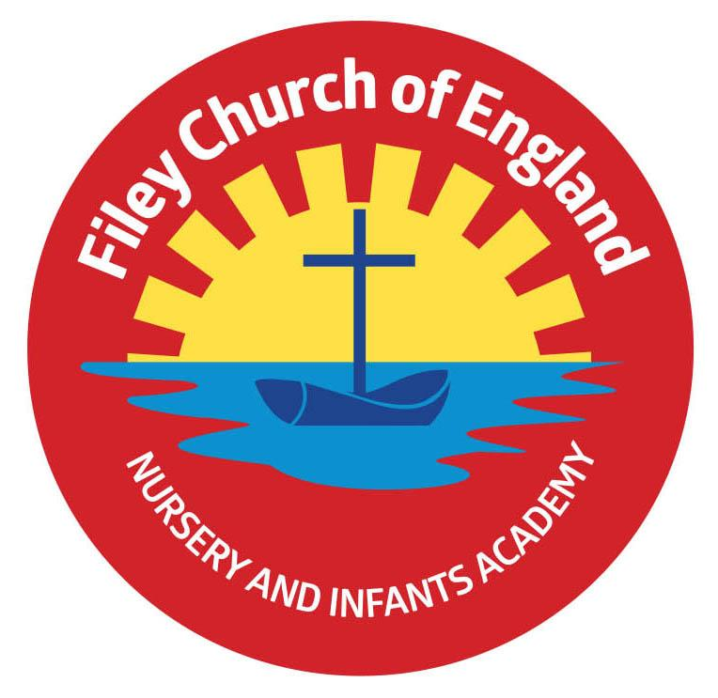
Friday 17th November 2023

Dear Parents/Carers
What a wonderfully spotty day we had in school today! Thank you everyone who made a donation to BBC Children in Need, we raised a ‘Spotacular £155.96. This week Miss Haldenby’s class won the attendance award with 97% very well done to them! Next week the school lunch menu will be following ‘week 2’ please see the menu attached to this email.

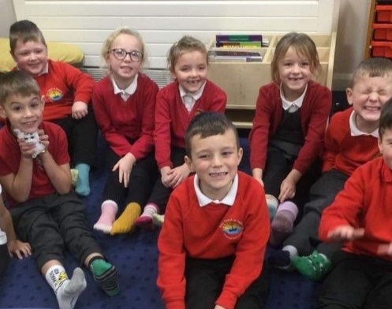
Christian Distinctiveness
On Monday children and staff wore odd socks in support of National Bullying Awareness Day. We wore odd socks to celebrate our uniqueness and together we discussed how everyone is different but all very special.
This week we also enjoyed an ‘Open the Book’ Collective Worship with our friends from St John’s Church, the story was ‘Groaning Jonah’ (also known as Jonah and the Whale) and was thoroughly enjoyed by us all. Some of our year two children joined in with the acting and did a great job. Well done to Miss Withers’ class for their super poetry assembly yesterday, their poems and singing were wonderful. ‘Community, Compassion & Friendship’ are our core values, which are at the heart of everything we do.

Non-Uniform Day
Friday 1st December will be a non-uniform day in school and we ask all pupils if they can to ‘Bring a Bottle’ for our Christmas Fair Tombola. We welcome bottles of shampoo, bubble bath, wine, sauce, spirits, soft drinks etc. (unopened bottles only please). Please give any bottles of alcohol to members of staff or to the school office. Thank you for your support.

Police Report
North Yorkshire Police are aware of several reports of an unknown male described as Asian, mid to late 30’s and of slim build, following children and adults, in both the Scarborough and Filey areas. As a school, we have already had PCSO Hayes visit all our classes to talk about stranger danger and staying safe when out and about. The local police ask that people continue to be vigilant, and report anything suspicious to the police via 101.

The National Sleep Helpline
If your child is having difficulties sleeping in their own bed or you are finding bedtimes difficult the national sleep helpline can help. You can call someone for advice on 03303 530541 Mon,Tues & Thurs 7pm-9pm and Mon, Wed 9am-11am.

Morning Drop Off
It is always busy in a morning around school during drop off times. Please allow yourself enough time so that you are not rushing or becoming impatient. It is most important that everyone is safe and of course respectful of each other. Please do not drive or park in a way that is either dangerous or inconsiderate. Thank you for your support regarding this matter, if you do notice dangerous behaviour please inform the school office and we will alert our local police/road traffic officers.

Nursery News
This week in nursery, we have been busy making tiger masks. We made these as the author Terenia Edwards came into school to read her book The Lonely Tiger to the children. We have also been practicing our Nativity songs for the school production. The children have also been thinking about Children in need and why we raise money for such a worthy charity.

Reception News
This week, the Reception children have been introduced to Goldilocks and the Three Bears. They have enjoyed creating props and puppets to use when re-telling the story and we were very impressed with their acting skills. We have taken part in different activities linked to Anti Bullying week and we have been discussing how important it is to celebrate our differences. In maths, we have continued our work using the part - part whole model and have been investigating ways of splitting the numbers into the terrible twos. In RE, the children have started to find out why Christmas is an important time for Christians and they have been learning about the Nativity story.

Year One News
In Year 1 this week, we have been continuing our learning about the Funnybones story in literacy. We have retold the story and written diary entries as Big Skeleton. In P.E., we have made our own Funnybones dance using a prop for Big Skeleton's top hat! In R.E., we have been thinking of different ways that Christians show their love to God. We have started to learn about Autumn in science. In PSHE, we have been continuing our learning about being healthy and thought about healthy choices that we can make. In history, we have talked about important events in our lives and we have made simple timelines to order events in our lives. Miss Withers' class enjoyed performing their poetry assembly for everyone; this will be uploaded onto the school website under: TEACHING & LEARNING – Classes – Miss Withers.

Year Two News
This week Year 2 have fully immersed themselves in their World Wars topic. We started by learning about WW1 and the history that came with this war. The children plotted key dates on a timeline, showing their understanding of chronology. We then used this knowledge to write a fact file in Literacy all about WW1. This covered why the war started, the trenches, the home front and Armistice Day. This has followed on nicely from our learning last week and from Remembrance Day. Year 2 have also been using their chrome books during computing, to research WW1 facts online. We remind ourselves of E safety to keep ourselves safe online. In Art, we looked at sketching and used mixed media to create a poppy inspired battlefield.

Thank you for your continued support remember we now have a massive 473 followers on Twitter (now called X) so please follow the posts and save the wonderful photos shared via this platform. If you have any concerns or questions please just ask, we are here to help in any way we can. Keep the diary dates below for future reference, more dates are added as they arise.

Best Wishes
Mrs Angela Clark
Angela Clark
Headteacher

Diary Dates – Please keep these dates safe for your information

November
Friday 17th November – Children in Need ‘Spotacular’ Day
Thursday 23rd November – Miss Ring’s poetry assembly
Thursday 23rd November – Group of Y2 children sing at Filey Evron Centre
Friday 24th November – Miss Haldenby’s poetry assembly
Monday 27th November – Mr Jackson’s class visit Filey Library

December
Friday 1st December – Non-uniform day and bring a bottle for the Christmas Fayre bottle tombola
Friday 1st December – Miss Williams’ class visit Filey Library
Wednesday 6th December - Reception children’s Christmas breakfast and story session
Friday 8th December – Flu Vaccinations catch up session
Friday 8th December – Christmas Fayre 3pm-4.30pm
Monday 11th December – Open the Book Collective Worship
Monday 11th December – Year 2 children visit Filey Junior School to watch their Christmas Production
Tuesday 12th December – Year 3 children visit us to watch the year 2 Christmas Production
Tuesday 12th December – 2pm Nursery & Reception Christmas Production for parents/carers
Wednesday 13th December – 9.30am Nursery & Reception Christmas Production for parents/carers
Wednesday 13th December – 2pm Year 1 Christmas Production
Thursday 14th December – 9.30am Year 1 Christmas Production
Thursday 14th December – 1.30pm Year 2 Christmas Production
Thursday 14th December – Year 2 cookery club group 2 starts
Friday 15th December – 9.30am Year 2 Christmas Production
Friday 15th December – Nursery & Reception children visit The Stephen Joseph Theatre
Monday 18th December – Year 1 and 2 Christmas Party
Tuesday 19th December – Year 1 and 2 visit The Spa Theatre
Wednesday 20th December – A group of Reception children visit Filey Fields to sing Christmas songs
Wednesday 20th December – Nursery & Reception Christmas Party
Thursday 21st December – Christmas Lunch
Friday 22nd December – Travelling Theatre Company visit our school
Friday 22nd December – School Closes

January
Tuesday 9th January – School Opens

