Friday 10th November 2023

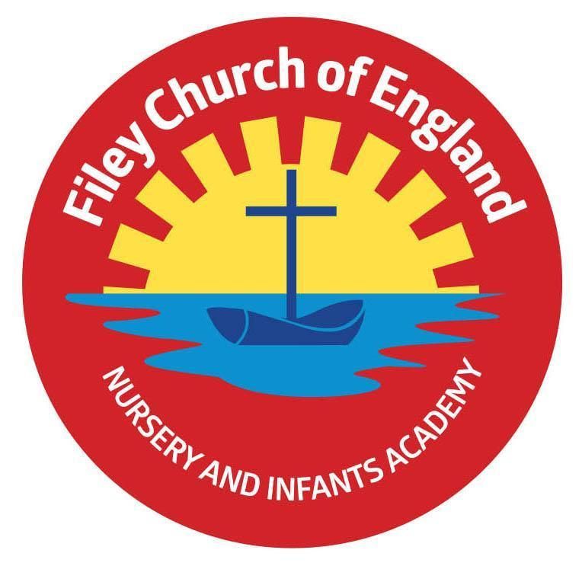
Dear Parents and carers,
What a fantastic first half term of Year 2 we have had! All of the children have settled in so well and are already making me so very proud to be their year 2 teacher. As we start our second half of the autumn term, I am writing to let you know what we will be learning and all of the exciting things that we have planned in the lead up to Christmas.
Our Curriculum
As a school, we work tirelessly to make sure our curriculum is up-to-date as well as exciting and engaging for all our children. This half term our theme is World Wars. During this topic, we will be learning about why it is important to remember the past. In Literacy, we will be exploring three different genres of writing (poem, letter and diary) which will be inspired by our core texts. In maths, we will continue our learning on addition and subtraction. In Science, we will be learning about everyday materials and how they can be manipulated by squashing, bending, twisting and stretching. We will also learn about reversible and irreversible change. In computing, we will learn about digital literacy including adding text and images to a document.
In RE we are extending our learning on Understanding Christianity considering the question ‘Why does Christmas matter to Christians?’ Our PSHE learning will focus on relationships. Children will learn about different types of families, how to feel safe and how they can resolve conflict with a peer. This half term in PE we will begin our unit of work around dance which links to our learning of rhythm in music. As this is a history-based topic, we will be learning all about life during WW1 and WW2 for example life as a soldier and life on the home front. In Art, we will explore colour mixing to create artwork inspired by Gustav Klimt Field of Poppies 1907.
Poetry Assembly and Christmas Productions
We have a number of special events this term. Our year 2 Christmas production is scheduled for 2pm on Thursday 14th December and 9.30am on Friday 15th December. More details about this will be released closer to the time. We have numerous other special events in the run up to Christmas as well, the dates for all of these can be found on the weekly newsletter.
PE
Children will have twice-weekly PE sessions. The days may change each half term (check the class window for changes). If your child is attending swimming lessons then this will count as their second PE lesson. Our PE days will be Tuesday and Wednesday. On these days please ensure that your child is properly prepared. If they wear earrings please remove them before school (staff are not able to support them with this). Please can all long hair be securely tied up to avoid any accidents.
Children must have the correct PE kit with them. This should include named; white t-shirt, black or navy blue shorts, and trainers for outside. Feel free to also include leggings/tracksuit bottoms and a warm jumper, as the weather gets colder. Children are welcome to leave this hanging on their peg all half term to make life easier!
Do not forget, as a school we are trying to do our bit for the planet and recycle as much as possible. If you would like some PE kit (or any uniform) from our good quality free second hand uniform cupboard, please phone the office or catch me on the door.
Phonics and Reading
In Year 2 children will have daily phonics/SPaG and guided reading sessions. In school, guided reading books are changed regularly. We aim to change books every week but on some occasions, this may be fortnightly. This book will be available to read the following week on our online reading platform, Collins eBooks. Login details for this are in your child’s reading record book.
Children also bring home a physical book to read and this can be read and changed as regularly as they wish. In year 2, children are given the responsibility of changing this book themselves. Whilst we do remind them regularly, please let us know if it keeps getting missed! As a school, we recommend that children read at home every day, so please read as regularly as you are able to.
Library
During the week, children will visit our Big Red Reading Bus twice. We will have a whole class story time on the bus, as well as allowing another opportunity for children to choose and borrow their own book. Please support your child to remember to bring their library book to change every Monday.
Homework
Throughout the year, children will receive weekly homework. We try to provide a range of engaging activities covering all different areas of the curriculum. Each week these can be found in children’s orange homework books. Every half term year 2 children also have a set of key words to practise. These are words which all children of this age should be able to read and write by the end of the year. Please support your child to practise these words at home throughout the half term, some suggestions of how to do this can also be found in their homework books. Homework will be given out each Friday. Please help your child to return their homework to school by the following Thursday so we can mark and update their books. Although we encourage this to be completed every week, we understand that sometimes life is just a bit busy so please do not worry!
Weekly Newsletters
As always, Mrs Clark will continue to write weekly newsletters to keep you up-to-date with all the exciting things happening in school. To reduce our paper use and do our part for the planet, these will be emailed out every Friday and uploaded onto the school website. Please contact the office if you are not receiving them. These newsletters also include important upcoming dates that you need to be aware of so please take the time to check them weekly.
Thank you in advance for all of your support. Please remember that we are here to help if you need us.
Kind regards
Mr Jackson
