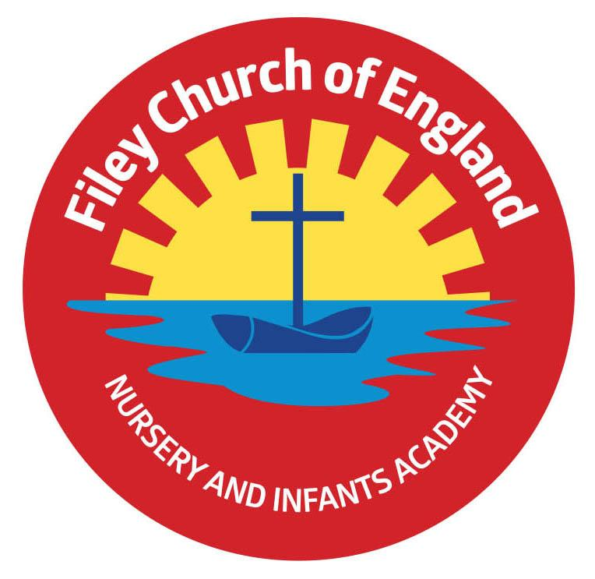
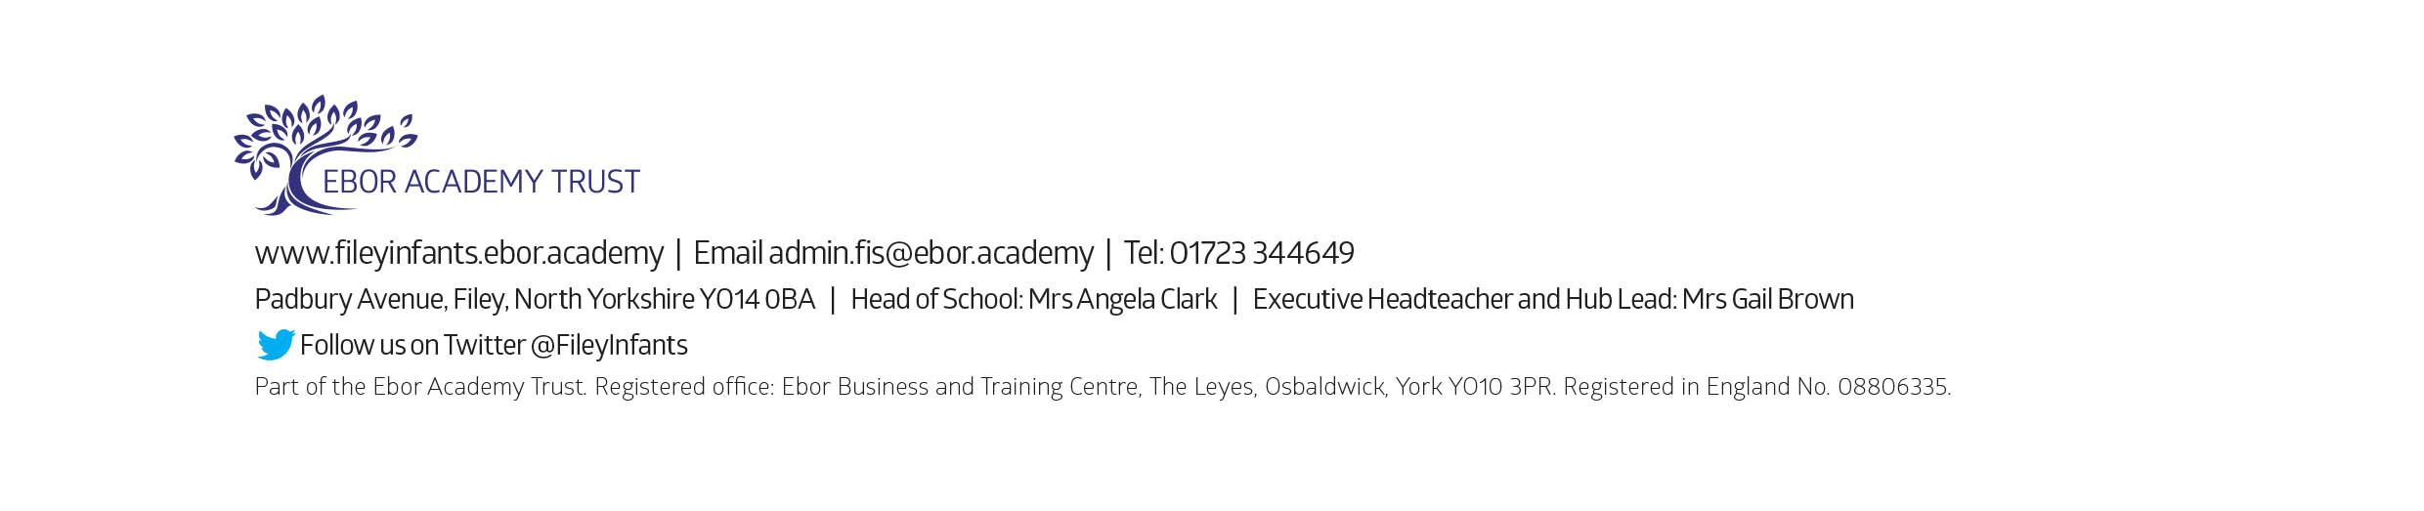
Friday 10th November 2023

Dear Parents and carers,
What a fantastic first half term of Year 1 we have had! All of the children have settled in well and are already making me so proud. As we start our second half of the Autumn term, I am writing to let you know what we will be learning about and all of the exciting things we have in the lead up to Christmas.

Our Curriculum
As a school, we deliver a curriculum that is up-to-date, exciting and engaging for all. This half term our theme is Funny Bones! Our themes for the year and more information about our long-term plan can be found on the school website.
This half-term, in Science and PSHE, we will be learning about our amazing bodies and how to keep them healthy and safe. This will include naming the parts of the body, making healthy choices, medicine safety, road safety and much more. In DT children will have the opportunity to make their own healthy body before later applying their cutting and joining skills to create a Christmas decoration.
In History, the children will be thinking about their own histories. They will be exploring what has happened in their lives so far and will work towards creating their personal timelines.
In computing this term, we will be learning about technology. We will explore the difference between technology and information technology and will consider the many uses and benefits of information technology in today's modern world.
In RE children will be considering the questions: What do Christians believe God is like? As we get closer to Christmas, they will also cover the Christmas Story and will have the opportunity to make Christmas cards, decorations and calendars.
We will also be covering the seasonal changes we are currently experiencing as we move further into autumn and then into winter.

Poetry Assembly and Christmas Productions
We have a number of special events this term, starting with our class poetry assembly, which will be on Thursday 16th November at 9am in the school hall. Our Year 1 Christmas production is scheduled for 2pm on Wednesday 13th December and 9.30am on Thursday 14th December. More details about this will be released closer to the time. We have numerous other special events in the run up to Christmas. The dates for all of these can be found in the weekly newsletter.

PE
Children have twice-weekly PE sessions. The days may change each half term (check the class window for changes). This half term our PE days will be Monday and Tuesday. On these days please ensure that your child is properly prepared. If they wear earrings please remove them before school (staff are not able to support them with this). Please can all long hair be securely tied up to avoid any accidents.
Children must have the correct PE kit with them. This should include named; white t-shirt, black or navy shorts, and trainers for outside. Feel free to also include leggings/tracksuit bottoms and a warm jumper as the weather gets colder. Children are welcome to leave this hanging on their peg all half term to make life easier!
Uniform
Do not forget, as a school we are trying to do our bit for the planet and recycle as much as possible. If you would like any uniform or PE kit from our good quality second hand uniform cupboard, please phone the office or catch me at the door.

Phonics and Reading
We will continue to have daily phonics and guided reading sessions. To enable you to best support your child’s phonics at home, we will continue sending home a small sheet each Friday detailing what we have covered so you know what to practise with them.
In school, guided reading books will be changed regularly. We aim to change books every week but on some occasions, this may be fortnightly. This book will be available to read the following week on our online reading platform, Collins eBooks (login details in reading records).
Children will also be able to bring home a physical book to read. This can be read and changed as regularly as they wish. In Year 1, children are given the responsibility of changing this book themselves. Whilst we do remind them regularly, please let us know if it keeps getting missed!
As a school, we recommend that children read at home every day, so please read as regularly as you are able to.

Library
During the week, children will visit our Big Red Reading Bus. We will have a whole class story time on the bus, as well as allowing time for the children to choose and borrow their own book. Please support your child to remember to bring their library book to change every Wednesday.

Homework
Thank you to everyone who has supported their child to complete their homework so far this year. I have been very impressed with the time and effort put into these tasks. The children will continue to receive weekly homework. We try to provide a range of engaging activities covering all different areas of the curriculum. Each week these can be found in children’s yellow homework books.
Homework will be given out each Friday. Please help your child to return their homework to school by the following Wednesday so we can mark and update their books. Although we encourage this to be completed every week, we understand that sometimes life is just a bit busy so please do not worry!

Weekly Newsletters
As always, Mrs Clark will continue to write weekly newsletters to keep you up-to-date with all the exciting things happening in school. To reduce our paper use and do our part for the planet, these will be emailed out every Friday. Please contact the office if you are not receiving them. These newsletters also include important upcoming dates that you need to be aware of so please take the time to check them weekly.

Thank you in advance for all of your support. Please always remember that school is here to help if you need us.
Kind regards,
Miss Withers

