Safeguarding Newsletter October 2023

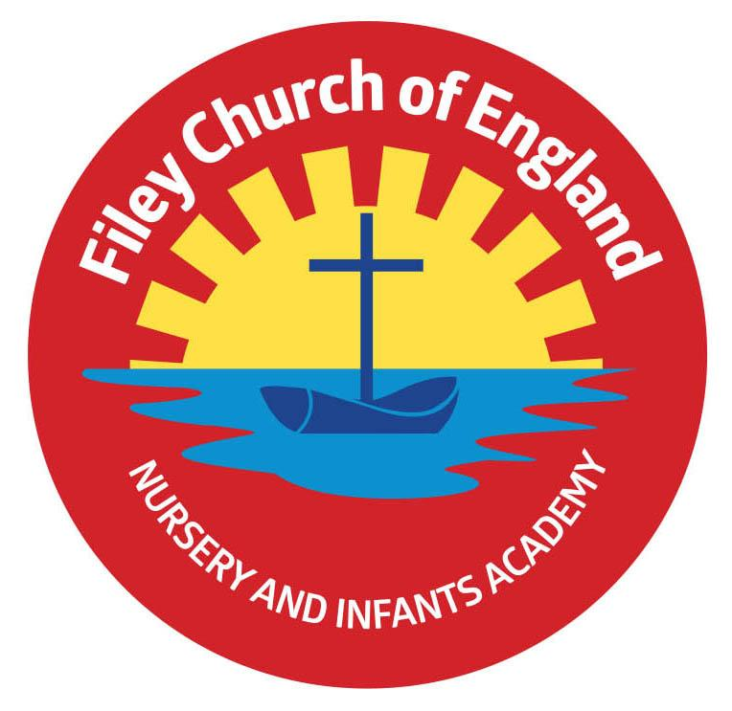
Community, Compassion & Friendship

“Shine as lights in the world and love as Jesus loves us”
(Philippians 2:15, John 13:34)

Safeguarding at Filey CE Nursery & Infants Academy

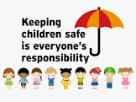
WHO TO CONTACT IF YOU HAVE A CONCERN ABOUT A CHILD

If you are worried about a child's safety please do not hesitate to contact any of the Designated Safeguarding Team.
The following members of staff are Designated Safeguarding Leads for Filey CE Nursery & Infants Academy:
Mrs Angela Clark (DSL)
Mrs Hannah Stubbs (DDSL)

They can be contacted via the school office, or by telephone on 01723 344649. If your concern is urgent and out of school hours, please contact:

North Yorkshire Safeguarding Children Partnership: 01609 780780
**************************************
For a copy of our school’s Child Protection and Safeguarding 2021 Policy, please visit the ‘Safeguarding’ page on our website.

Dear Parents and Carers,

At Filey Church of England Nursery & Infants Academy, safeguarding and promoting the welfare of children is everyone’s responsibility and our top priority. Anyone who comes into contact with children and their families has a role to play.

This newsletter will focus on the effective Safeguarding Culture that we have in place at our school.
Thank you,
Mrs Angela Clark
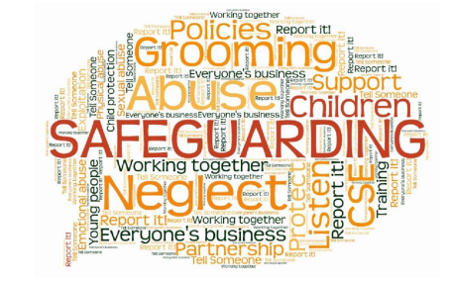
Our Safeguarding Governor

The safeguarding Governor at Filey CE Nursery & Infants Academy is Mrs Christine Wilson.

The safeguarding governor’s responsibilities include:

- Behaviour and recruitment of both staff and volunteers, ensuring the school is following safe recruitment procedures.

- Reviewing all activity and policy relating to the physical and emotional well-being of all children.

- Seeking improvement to ensure the school follows best practice in creating a productive and safe environment for all.

Mrs Christine Wilson can be contacted via the school office:

admin.fis@ebor.academy

Safeguarding children is a phrase most people will have heard of but may find it difficult to define. The Working together to Safeguard Children 2018 guidance by HM Government provides an explanation. Safeguarding and promoting the welfare of children is defined as:  - protecting children from maltreatment  - preventing impairment of children's health or development  - ensuring that children grow up in circumstances consistent with the provision of safe and effective care  - taking action to enable all children to have the best outcomes.  Safeguarding is everyone’s job and everyone’s responsibility.  Our designated safeguarding team and staff work hard to make sure that our school has a safe and happy environment in which all children can learn and flourish in order to be the best that they can be. The DSL & DDSL make sure that all safeguarding policies and procedures are up to date and are communicated clearly so that everyone understands what is expected of them.  Our curriculum and our safeguarding curriculum is regularly reviewed to keep pace with the changing risks and the needs of our pupils. Leaders at all levels are not afraid to tackle difficult issues in order to maintain a high quality, safe learning environment.  Early Help Offer  There will be times when you and your family need support or when you are not sure how to make things better  Providing early help to our children and families at Filey CE Nursery & Infants Academy means we are more effective in promoting support as soon as we can.  Early Help means providing support as soon as a problem emerges, at any point in a child’s life, beginning with our Nursery. We endeavour to create a school ethos that promotes trust between all adults and children so that all children know who they are able to talk to if they have any concerns or worries. All Early Help is offered in partnership with parents and carers. | Safeguarding Curriculum  We believe that one of the best ways to safeguard children is through equipping them with the knowledge and skills for how they can keep themselves safe.  Safeguarding themes weave through our curriculum and the extra-curricular opportunities we offer in school.  Some examples include:  PSHE (personal social and health education)  We use Jigsaw- the mindful approach to PSHE. Jigsaw PSHE perfectly connects the pieces of Personal, Social and Health Education, emotional literacy, social skills and spiritual development into a weekly programme for all of our classes. It provides pupils with the knowledge, understanding, attitudes, values and skills they need in order to reach their potential as individuals and within the community.  Lunchtime clubs including:  Nurture Support, Mindfulness, Yoga, Games Club, ‘Wonder Time’, Art & Crafts.  Online safety discussions in computing lessons Links with the NSPCC (Daily worships, Awareness Days etc.)  Pastoral Support Worker: Miss Julie Roen  At Filey Infants we aim to support the whole family as part of our community. We value parent contributions and do our best to help families both at school and at home.  Miss Roen is available at various times throughout the week to spend time with children and/or their families. She can help with many things including: coping with bereavement, behaviour & friendship issues, social skills, child welfare, routines at home, relationship issues, attendance, developing self-confidence and much more.  If you would like some time to talk with Julie Roen, please just ask at the school office or call us on 01723 344649

