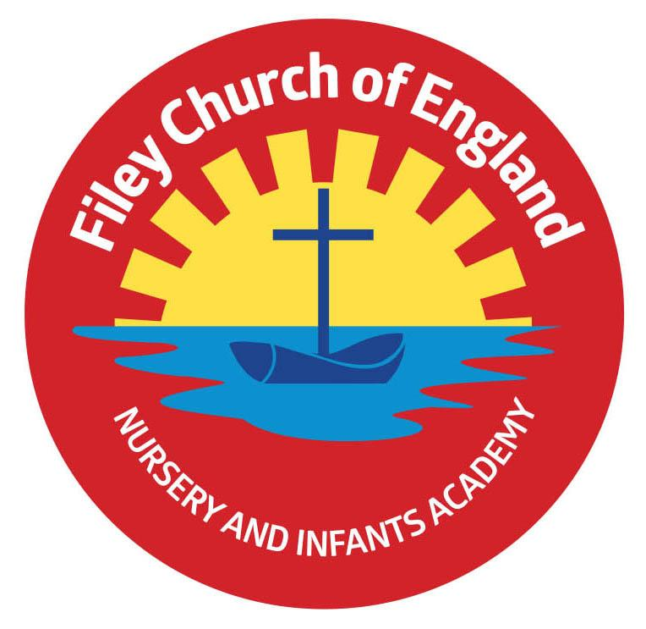
Friday 27th October 2023

Dear Parents/Carers
We come to the end of a very busy half term with all classes enjoying many exciting activities in school. From time to time and often before a school holiday we gratefully receive food bags from our friends at St John’s Church. If you would like to go on our list to receive one of these fabulous bags, please let us know in the school office. This week Miss Ring’s class won the attendance award with 99% very well done to them!

Christian Distinctiveness
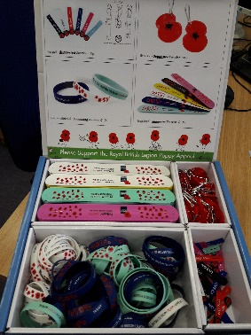
Remembrance Day:
When we return after the half term holiday poppies and other remembrance items (see picture) will we available to buy in school. All money raised goes to The Royal British Legion. Our year 2 children will also be visiting Filey Memorial Gardens on Friday 10th November to plant their hand made poppies as a mark of respect. On Wednesday 8th November, a group of year 2 children will visit Filey Fields again to join our elderly friends in singing songs and sharing some of their handmade poppies. ‘Community, Compassion & Friendship’ are our core values, which are at the heart of everything we do.

Head Lice
We have had a number of cases of head lice in school this half term. A head lice comb is best for catching head lice so we have provided every child in school with a FREE head lice comb. Please use the half term holiday as an opportunity to ensure your child is lice free ready for the start of the next half term. Because head lice are passed on through hair-to-hair contact, could I also remind parents that pupils with long hair should have their hair tied back with a bobble or clip. If you require any further information, please check out the NHS website:
https://www.nhs.uk/conditions/head-lice-and-nits/ Together we can lose the lice!

Stay & Play Sessions
North Yorkshire council are offering some FREE stay and play sessions for children during the half term holiday. The Communication and Interaction team work with children in the Scarborough, Whitby, Ryedale area and are hosting these sessions for children up to 11 yrs old. They would love you to join them! NO NEED TO BOOK!
If you would like more information, please see the flyer attached to this email.

Safeguarding Newsletter
At Filey CE Nursery & Infants Academy, safeguarding and promoting the welfare of children is everyone’s responsibility and our top priority. Anyone who comes into contact with children and their families has a role to play. I have attached a safeguarding newsletter to this email with all the information needed in case you have a concern or are worried about a child/family. This information can also be found on our school website under SAFEGUARDING – Useful Links
My Happy Mind
We have introduced a program to all year groups at school called myHappymind. myHappymind is all based around helping children to understand how their brain works and to support them in developing positive skills and habits to be their very best selves!
To further embed this learning and ensure that you are able to engage in these topics with your child, myHappymind has developed a set of resources for parents. These resources can be accessed online on your computer, or through an app on your phone. To access these materials just go to https://myhappymind.org/parent-resources and enter your name, email, and authentication code. Your authentication code is 144274
If you would like more information, please see the letter attached to this email.

Online Safety Poster
Your child will be bringing home an online safety poster with them today. Checking on your child’s screen time, considering the benefits and the downsides of screen time are important factors in ensuring your child stays healthy and happy. Please take time to share the information provided as a family and read the 10 top tips for parents/carers. A copy of the poster can also be found on our website under: KEY INFO – Safeguarding – Useful Links

Christmas Creations
Just a reminder that your child’s unique drawing can be professionally printed onto a range of items in time for Christmas presents. This is also an opportunity for school to raise some money towards school funds. Your child brought home with them last week their design and order form for anyone wanting to place an order. Order forms must be returned to school by Monday 6th November 3pm – unfortunately, late forms cannot be processed.

Nursery News
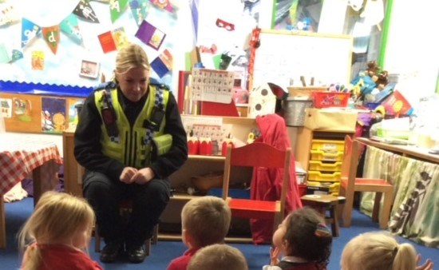
This week in nursery, they have been using pastels to draw still life pumpkins for their art books. They have been talking about fire safety and bonfire night (they also had a practise fire drill and lockdown drill as they were discussing being safe). PCSO Natalie came to talk to them about being safe too! Children made firework pictures using paints. Children have also been practising taking turns by playing board games and of course getting ready for their Nursery Enterprise!

Reception News
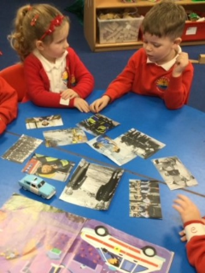
This week in maths, Reception children have been investigating how one can create every number. The children created their own number lines using numberblock one and labelled their pictures. They had a visit from PCSO Natalie and she spoke to them about ways that they can keep safe. They have also been comparing pictures of uniforms past and present and found out that they did not have lots of equipment to keep them safe in the olden days. The children listened carefully and asked interesting questions. Children have also been practising their 'happy breathing' and learning how to calm themselves down.

Year One News
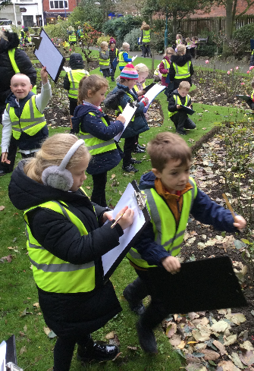
In Year 1 this week, children enjoyed a walk through Filey to the Memorial Gardens. They looked at the trees and plants, sketched them and had a go at identifying them. They spotted deciduous and evergreen trees. In music, children enjoyed singing sea shanty songs. During literacy lessons, everyone enjoyed sharing the story ‘Tree- Seasons Come, Seasons Go,’ and finding out how trees change through the seasons. Children wrote questions for the owl from the story who lives in the same tree all year round! They also wrote sentences about what the owl sees in each season. In maths, they have been exploring the number words from zero to five and learned about ordinal numbers. During PE, they put their throwing and catching skills to the test by having a go at a "Head, shoulders, knees and toes" challenge!

Year Two News
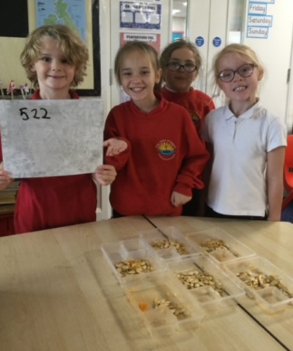
This week Year 2 have been learning about adding three addends in maths and ended the week with a challenge where they had to work in teams to complete the question. In Literacy, they have written letters to Pandora in the first person, pretending they were her friend the bird, who left her behind. Children have also been working hard to finish their DT project. They have used clay to mould their boats and carefully measured material to create a mast and sail. They then evaluated their finished boats. The children have also enjoyed carving a pumpkin. They had to estimate how many seeds were inside and then use their knowledge of counting in 2s, 5s and 10s to find out the answer! Great Fun! After school choir will start for year 2 children after half term, first session Tuesday 7th November. All year 2 children are invited, you will need to collect your child from the office at 3.45pm.

Thank you for your continued support and I hope everyone has a lovely half term break. Remember we now have a massive 472 followers on Twitter (now called X) so please follow the posts and save the wonderful photos shared via this platform. If you have any concerns or questions please just ask, we are here to help in any way we can. Keep the diary dates below for future reference.

Best Wishes
Mrs Angela Clark
Angela Clark
Headteacher

Diary Dates – Please keep these dates safe for your information
November
Monday 6th November – School reopens
Tuesday 7th November – Year 2 choir starts after school till 3.45pm
Wednesday 8th November – Last swimming session for group 1
Wednesday 8th November – A group of year 2 children sing at Filey Fields
Thursday 9th November – First after school PE club starts for Y1
Friday 10th November – Year 2 visit Filey Memorial Gardens to plant their homemade poppies.
Monday 13th November – Open the Book Collective Worship
Wednesday 15th November – First swimming session for group 2
Thursday 16th November – Miss Withers’ poetry assembly
Friday 17th November – Children in Need ‘Spottacular’ Day
Thursday 23rd November – Miss Ring’s poetry assembly
Friday 24th November – Miss Haldenby’s poetry assembly
December
Friday 8th December – Christmas Fayre
Monday 11th December – Open the Book Collective Worship
Monday 11th December – Year 2 children visit Filey Junior School to watch their Christmas Production
Tuesday 12th December – Year 3 children visit us to watch the year 2 Christmas Production
Tuesday 12th December – 2pm Nursery & Reception Christmas Production for parents/carers
Wednesday 13th December – 9.30am Nursery & Reception Christmas Production for parents/carers
Wednesday 13th December – 2pm Year 1 Christmas Production
Thursday 14th December – 9.30am Year 1 Christmas Production
Thursday 14th December – 1.30pm Year 2 Christmas Production
Friday 15th December – 9.30am Year 2 Christmas Production
Friday 15th December – Nursery & Reception children visit The Stephen Joseph Theatre
Monday 18th December – Year 1 and 2 Christmas Party
Tuesday 19th December – Year 1 and 2 visit The Spa Theatre
Wednesday 20th December – Nursery & Reception Christmas Party
Thursday 21st December – Christmas Lunch
Friday 22nd December – Travelling Theatre Company visit our school
Friday 22nd December – School Closes

