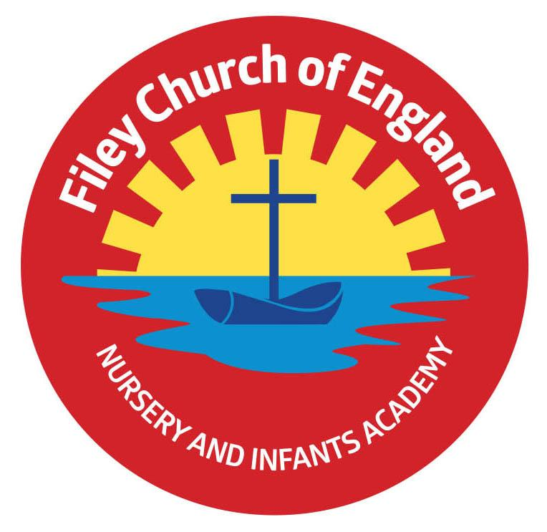
Filey CE Nursery & Infants Academy

Our School Vision Statement

Our school is a Church of England School rooted in “Community, Compassion and Friendship” We deliver a creative curriculum which promotes moral, spiritual, mental and physical development. Our curriculum is interesting and encourages each child to do their best, to love learning & to appreciate each other. Our school is part of the community of Filey and we develop every child’s appreciation of our community heritage and the world in which we live.
We endeavour to uphold Christian teaching to:
“Shine as lights in the world and love as Jesus loves us”
(Philippians 2:15, John13.34)

- The school Governors are committed to children, parents and staff and aim to promote and support high standards throughout the school. They will seek to achieve this by appointing highly motivated staff and providing quality resources which ensure sound foundations, fulfil each child’s needs and help develop well balanced, well-educated young people.
- We aim to deliver a curriculum that will promote moral, spiritual, mental and physical development. A curriculum that is interesting, fun and encourages each child to do their best promoting basic skills.
- We value the partnership between home and school and aim to develop this through good communications, encouraging parents and carers to take part in school activities and to help their children at home. Our school is part of the community of Filey and we encourage activities and initiatives that develop the child’s appreciation and understanding of their immediate environment and the world in which they live.
- We promote and embed British Values implicitly through every aspect of the Curriculum reflecting the school culture of ‘Community, Compassion and Friendship’
- The Christian character and values of the school foster the spiritual, moral, social and cultural development of all learners. An understanding of Christianity as a multicultural world faith supports understanding and respect for diversity and difference. We promote a policy of equal opportunities and believe it is important to show fairness to all.
- The shared aim of all involved in the life of our school is the continued development of Filey C.E. Nursery and Infants Academy as a successful and welcoming part of the Church and community which supports children and their families.

