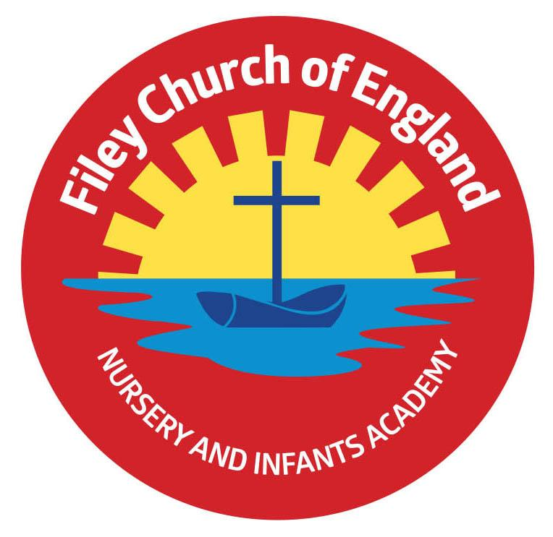
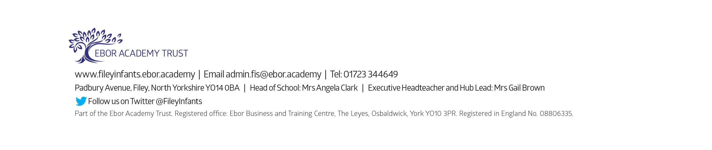
Friday 8th September 2023
Dear Parents and carers,
Welcome to Reception! We have had a fantastic start to the year and are very much enjoying getting to know each other. We are writing to you to welcome you as a Reception parent and to give you some more information about what to expect in Reception.
Our Curriculum As a school we provide an exciting and engaging curriculum for all our children. This half term our theme is Amazing Me! Our themes for the year and our long-term plan can be found on the school website.
PE This half term we will have PE on a Wednesday. For the first half term, we will only be taking off our shoes and socks so a PE kit will not be necessary. If your child wears earrings, please remove them before school as staff are not able to support with this. Please can all long hair be securely tied up to avoid any accidents. After half term, we will start changing into full PE kits. This should include a white t-shirt, black or navy blue shorts, and trainers for outside. Please ensure everything is clearly named. For ease, PE kits can be left in school on children’s pegs for the half term. As a school, we are trying to do our bit for the planet and recycle and reuse wherever possible. In school, we have a uniform cupboard full of pre-loved free items. If you need any additional uniform or PE kit, please phone the office or catch us on the door.
Phonics and Reading In Reception, children have daily phonics and guided reading sessions. To help you support your child’s learning at home, we will be sending home a small sheet each Friday detailing what we have covered. In school, guided reading books will be changed weekly. This book will be available to read the following week on our online reading platform, Collins eBooks. Once your child receives a reading record it will contain login details for this. As the year progresses, children will also bring home an additional book to read. This can be read and changed as regularly as they wish. As a school we promote a love of reading and encourage you to enjoy books regularly at home.
Library Children will visit our Big Red Reading Bus twice a week. We will have a whole class story time on the bus, as well as allowing another opportunity for children to choose and borrow a book to take home. Mrs Monks and Mrs Kerr’s library session will be Wednesday and Mrs Stubbs library session will be on a Tuesday. Please remember to bring your library book back on these days so they can be changed for another book.
Weekly Newsletters As always, Mrs Clark will continue to write weekly newsletters to keep you up-to-date with all the exciting things happening in school. To reduce our paper use and do our best for the planet, these will be emailed out every Friday and uploaded onto the school website. Please contact the office if you are not receiving them. These newsletters also include important upcoming dates that you need to be aware of so please take the time to check them weekly.
If you have any questions please do not hesitate to ask and remember we are here to help if needed.
Kind regards,
Mrs Stubbs, Mrs Kerr, Mrs Monks and the rest of the EYFS team

