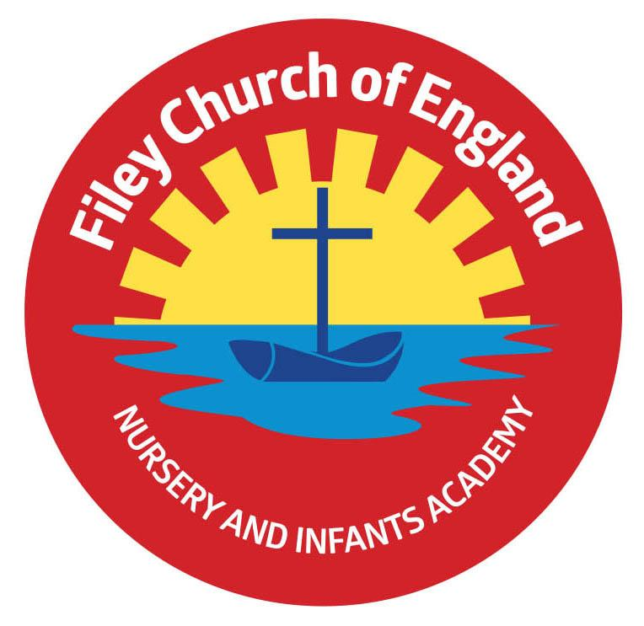
Friday 29th September 2023

Dear Parents/Carers
Another wonderful week in school with so many things happening. We received a GOLD AWARD from Filey in Bloom best-kept school gardens and enjoyed a wonderful Harvest Festival! Remember to follow us on Twitter to see what each class has been doing. This week Miss Haldenby’s class won the attendance award with 100% well done to them!

Christian Distinctiveness
Today we celebrated our school Harvest Festival with beautiful singing from all year groups. Thank you to everyone who helped to make our Harvest table so spectacular. Our children took some of this food to St John’s Church this morning and this afternoon some year 2 children delivered fresh fruit and vegetable gifts to our elderly neighbours.

Parent Meetings
Your child should have brought home a form ready for you to sign up for an appointment to talk with your child’s class teacher on either Monday 9th, Tuesday 10th or Wednesday 11th October between 3pm-5pm. Once you have returned your form, your child’s class teacher will give you a time to attend. Please come to the main office for your appointment, Nursery and Reception parents will need to wait in the school hall and year 1 and year 2 parents wait outside their child’s classroom.

Flu Vaccinations
These will take place in school on Friday 13th October 2023. If you would like your child to be included, please sign up following this link: https://yny.schoolvaccination.uk/flu/2023/northyorkshire

Head Lice
Unfortunately, head lice can be an ongoing problem for young children and we have had a few cases in school this week. You do not need to buy special treatments unless you want to and you certainly do not need to keep your child off school. You do however need to use the wet combing method quickly and thoroughly. Please see below:
WET COMBING is just as effective as medicated lotions and shampoos if done thoroughly.

You will need a special fine-toothed comb (detection comb) these can be purchased online or from local pharmacies. Follow these instruction:
- wash hair with ordinary shampoo
- apply lots of conditioner (any conditioner will do)
- comb the whole head of hair, from the roots to the ends

It usually takes about 10 minutes to comb short hair, and 20 to 30 minutes for long or curly hair. Do wet combing on days 1, 5, 9 and 13 to catch any newly hatched head lice. Check again that everyone's hair is free of lice on day 17.

Thank you for your continued support. Remember we are here to help however we can, if you have any concerns or questions please just ask. Please see the diary dates below.

Best Wishes
Mrs Angela Clark
Angela Clark
Headteacher

Diary Dates – (for this half term) Please keep these dates safe for your information

October
Monday 2nd October – Summer Reading Challenge Certificates are presented by Filey Library
Wednesday 4th October – Some Y2 children visit Filey Fields to sing Harvest songs for the residents
Monday 9th October – Parents Evening – 3pm-5pm
Tuesday 10th October – Reverend Phil leads Collective Worship
Tuesday 10th October – Parents Evening – 3pm-5pm
Tuesday 10th October – Y1&2 Cross Country Running Competition 4pm at Scarborough Rugby Club
Wednesday 11th October – Parents Evening – 3pm-5pm
Friday 13th October – Miss William’s class poetry assembly in the school hall 9am
Friday 13th October – Flu Vaccinations in school
Monday 16th October – Open the Book Collective Worship
Friday 20th October – Mr Jackson’s class poetry assembly in the school hall 9am
Friday 27th October – Nursery Enterprise 2.30pm
Friday 27th October – School closes for half term

November
Monday 6th November – School reopens

