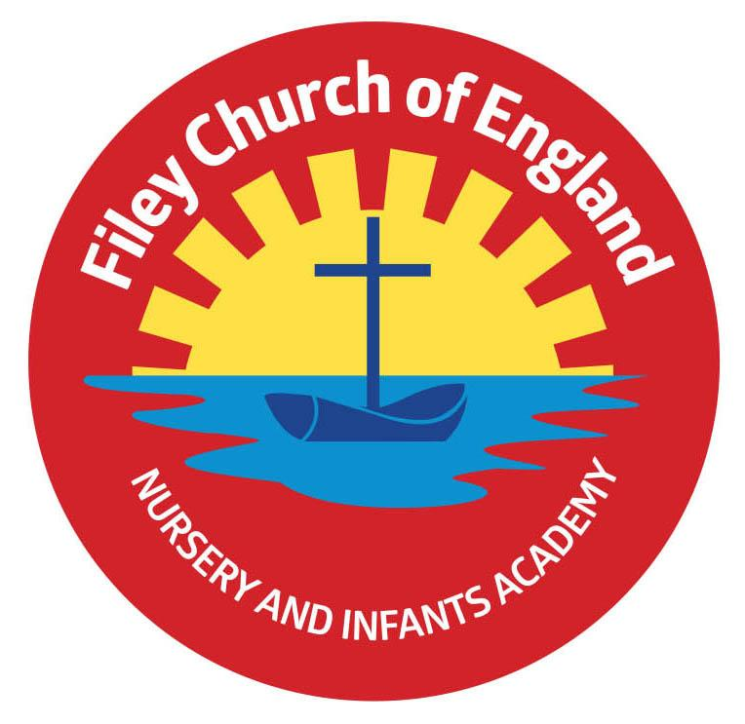
Friday 22nd September 2023

Dear Parents/Carers
This afternoon we enjoyed a wonderful sponsored walk, thank you to everyone who joined us. A big, big thank you to all those who managed to collect sponsors and help raise some money towards school funds. This week Miss Ring class won the attendance award with 98% well done to them!

Free Food Table
Apologies to anyone who has picked up an out of date item from the free food table. We will ensure all items are checked carefully from now on. We will be offering the free food table on Monday 25th September; there is always a good selection of tins, packets, cereal, pasta, tea, coffee, toiletries and nappies so please bring a bag and take what you like, we always send a text message indicating when the table is ready.

Harvest Festival
We will be holding our Harvest Festival in the school hall at 9am on Friday 29th September. Parents/Carers are welcome to join us for this special time but we ask that no more than two people attend per family. Nursery children do not take part in Harvest Festival, although a recording of their Harvest song will be uploaded onto our website for you to enjoy. We welcome your Harvest gifts of fruit, vegetables, tins or packets on Thursday 28th September.

Parent Meetings
You will have the opportunity to sign up for an appointment to talk with your child’s class teacher on either Monday 9th, Tuesday 10th or Wednesday 11th October between 3pm-5pm. Your child will bring home a letter next week so you can select a convenient day and approximate timeslot. Your child’s class teacher will then let you know an exact time for you to attend. Please come to the main office for your appointment, Nursery and Reception parents will need to wait in the school hall and year 1 and year 2 parents wait outside their child’s classroom.

School Photos
All children in school yesterday had their photo taken. Your child should have brought home a copy of their photo and the information needed to order them if wanted.

Flu Vaccinations
These will take place in school on Friday 13th October 2023. If you would like your child to be included, please sign up following this link: https://yny.schoolvaccination.uk/flu/2023/northyorkshire

Speech Sound Development Workshop
The NHS Children’s Therapy Team are offering free workshops for parents and professionals. The workshops give a brief overview of how speech sounds are made/develop and offer advice and strategies to consider when working with children with speech sound difficulties. If you would like more information, please see the leaflet attached to this email.

Thank you for your continued support. Remember we are here to help however we can, if you have any concerns or questions please just ask. Please see the diary dates below.

Best Wishes
Mrs Angela Clark
Angela Clark
Headteacher
Diary Dates – (for this half term) Please keep these dates safe for your information

September
Friday 22nd September – School Sponsored Walk 1pm – all family members welcome (no dogs)
Friday 29th September – School Harvest Festival 9am in the school hall

October
Monday 9th October – Parents Evening – 3pm-5pm
Tuesday 10th October – Parents Evening – 3pm-5pm
Tuesday 10th October – Y1&2 Cross Country Running Competition 4pm at Scarborough Rugby Club
Wednesday 11th October – Parents Evening – 3pm-5pm
Friday 13th October – Miss William’s class poetry assembly in the school hall 9am
Friday 13th October – Flu Vaccinations in school
Friday 20th October – Mr Jackson’s class poetry assembly in the school hall 9am
Friday 27th October – School closes for half term

November
Monday 6th November – School reopens

