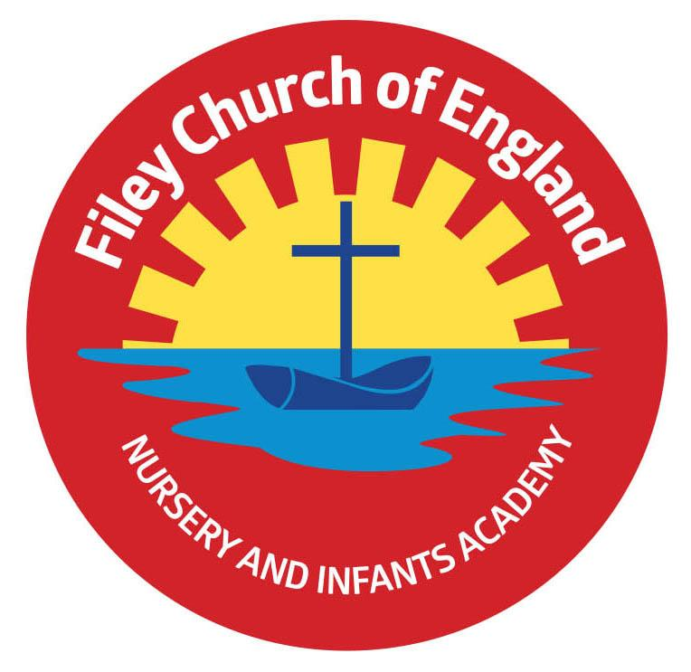
Friday 15th September 2023

Dear Parents/Carers
Another great week in school with all children now settled and enjoying their classes.
This week Mrs Monks/Mrs Kerr and Miss Haldenby’s class won the attendance award with 99%. Well done to them!

Free Breakfast
Please remember to let the class teacher know if your child would like a free breakfast in the classrooms at 8.40am each morning. This includes a choice of cereal with milk and a drink of water.

School Sponsored Walk – Friday 22nd September 1pm
Each year we hold a whole school sponsored walk to raise money for school funds and enjoy the exercise, fresh Filey air and an ice cream! We invite all family members to walk with us but please request no dogs. Nursery children do a little walk around our school grounds at some point during the day and still enjoy an ice cream. Your child was given a sponsor form yesterday for those who are able to help.

Free Food Table & Uniform Cupboard
Most Friday’s we have a table full of free food for all our families to enjoy. There is always a great selection of tins, packets, pasta, cereal, toiletries, nappies, tea and coffee. Please come along with a shopping bag and take what you like. We will always send a text out first letting you know it is available on that day. Our good quality free second hand uniform cupboard is overflowing! You can phone the office with your requests or ask your child’s class teacher at the end of the day.

Harvest Festival
We will be holding our Harvest Festival in the school hall at 9am on Friday 29th September. Parents/Carers are welcome to join us for this special time but we ask that no more than two people attend per family. Nursery children do not take part in Harvest Festival, although a recording of their Harvest song will be uploaded onto our website for you to enjoy. We welcome your Harvest gifts of fruit, vegetables, tins or packets on Thursday 28th September.

School Photos
Thursday 21st September will be our school photograph day. If you would like to bring siblings that do not attend our school to have a group photo you can do this between 8.20am and 9am. All children will have their photograph taken individually and with any siblings that they have in our school. If your child is in Nursery and you would like them to have their photograph taken, please bring them to the office at 10am. ONLY if they do not normally attend Nursery on a Thursday morning.

Communication & Interaction Drop-In Sessions
NYCC are offering drop-in sessions for any parents wanting advice regarding their child’s communication skills. Two of these sessions are in Filey, if you would like more information please see the flyer attached to this email.

We are very much looking forward to working with all children and families this new school year and thank you for your continued support. Remember we are here to help however we can, if you have any concerns or questions please just ask. Please see the diary dates below.
Best Wishes
Mrs Angela Clark
Angela Clark
Headteacher
Diary Dates – (for this half term) Please keep these dates safe for your information

September
Tuesday 19th September – Cross Country Running Competition 4pm at Scarborough Rugby Club Thursday 21st September – School Photographs am
Friday 22nd September – School Sponsored Walk 1pm – all family members welcome (no dogs)
Friday 29th September – School Harvest Festival 9am in the school hall

October
Monday 9th October – Parents Evening – 3pm-5pm
Tuesday 10th October – Parents Evening – 3pm-5pm
Tuesday 10th October - Cross Country Running Competition 4pm at Scarborough Rugby Club
Wednesday 11th October – Parents Evening – 3pm-5pm
Friday 13th October – Miss William’s class poetry assembly in the school hall 9am
Friday 20th October – Mr Jackson’s class poetry assembly in the school hall 9am
Friday 27th October – School closes for half term

November
Monday 6th November – School reopens

