Friday 8th September 2023

Miss Williams’s Class Welcome Letter – Year 2’s
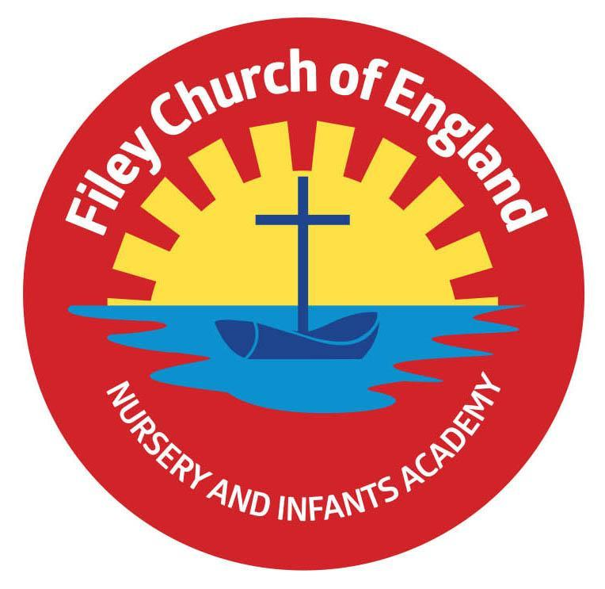
Dear Parents and carers,
Welcome to Miss Williams’s class! We have had a fantastic start to the year and are very much enjoying getting to know each other. I am writing to you to welcome you as a year 2 parent and to give you some more information about what to expect in year 2.
Our Curriculum
As a school, we work tirelessly to make sure our curriculum is up-to-date as well as exciting and engaging for all our children. This half term our theme is Our Heritage by the Sea! During this topic we will be learning about our local community in History and Geography, explore living things and their habitats in science, and use clay to make our very own boat in D.T. Our themes for the year and more information about our long-term plan can be found on the school website.
PE
Children will have twice-weekly PE sessions. The days may change each half term (check the class window for changes). If your child is attending swimming lessons then this will count as their second PE lesson. This half term it is our chance to work with Mr Ellis (specialist PE teacher) so our PE days will be Wednesday and Thursday. On these days please ensure that your child is properly prepared. If they wear earrings please remove them before school (staff are not able to support them with this). Please can all long hair be securely tied up to avoid any accidents.
Children must have the correct PE kit with them. This should include named; white t-shirt, black or navy blue shorts, and trainers for outside. Feel free to also include leggings/tracksuit bottoms and a warm jumper as the weather gets colder. Children are welcome to leave this hanging on their peg all half term to make life easier!
Do not forget, as a school we are trying to do our bit for the planet and recycle as much as possible. If you would like some PE kit (or any uniform) from our good quality free second hand uniform cupboard, please phone the office or catch me on the door.
Phonics and Reading
In Year 2 children will have daily phonics/SPaG and guided reading sessions.
In school, guided reading books are changed regularly. We aim to change books every week but on some occasions, this may be fortnightly. This book will be available to read the following week on our online reading platform, Collins eBooks. Please keep an eye out in your child’s reading record book, as we will be sticking login details for this very soon.
Children will also be able to bring home a physical book to read. This can be read and changed as regularly as they wish. In year 2, children are given the responsibility of changing this book themselves. Whilst we do remind them regularly, please let us know if it keeps getting missed!
As a school we recommend that children read at home every day, so please read as regularly as you are able to.
Library
During the week, children will visit our Big Red Reading Bus twice. We will have a whole class story time on the bus, as well as allowing another opportunity for children to choose and borrow their own book. Please support your child to remember to bring their library book to change every Monday.
Homework
Throughout the year, children will receive weekly homework. We try to provide a range of engaging activities covering all different areas of the curriculum. Each week these can be found in children’s orange homework books.
Every half term year 2 children also have a set of key words to practise. These are words which all children of this age should be able to read and write by the end of the year. Please support your child to practise these words at home throughout the half term, some suggestions of how to do this can also be found in their homework books.
Homework will be given out each Friday. Please help your child to return their homework to school by the following Thursday so we can mark and update their books. Although we encourage this to be completed every week, we understand that sometimes life is just a bit busy so please do not worry!
Weekly Newsletters
As always, Mrs Clark will continue to write weekly newsletters to keep you up-to-date with all the exciting things happening in school. To reduce our paper use and do our part for the planet, these will be emailed out every Friday and uploaded onto the school website. Please contact the office if you are not receiving them. These newsletters also include important upcoming dates that you need to be aware of so please take the time to check them weekly.
Thank you in advance for all of your support. Please remember that we are here to help if you need us.
Kind regards
Miss Williams
