Friday 8th September 2023

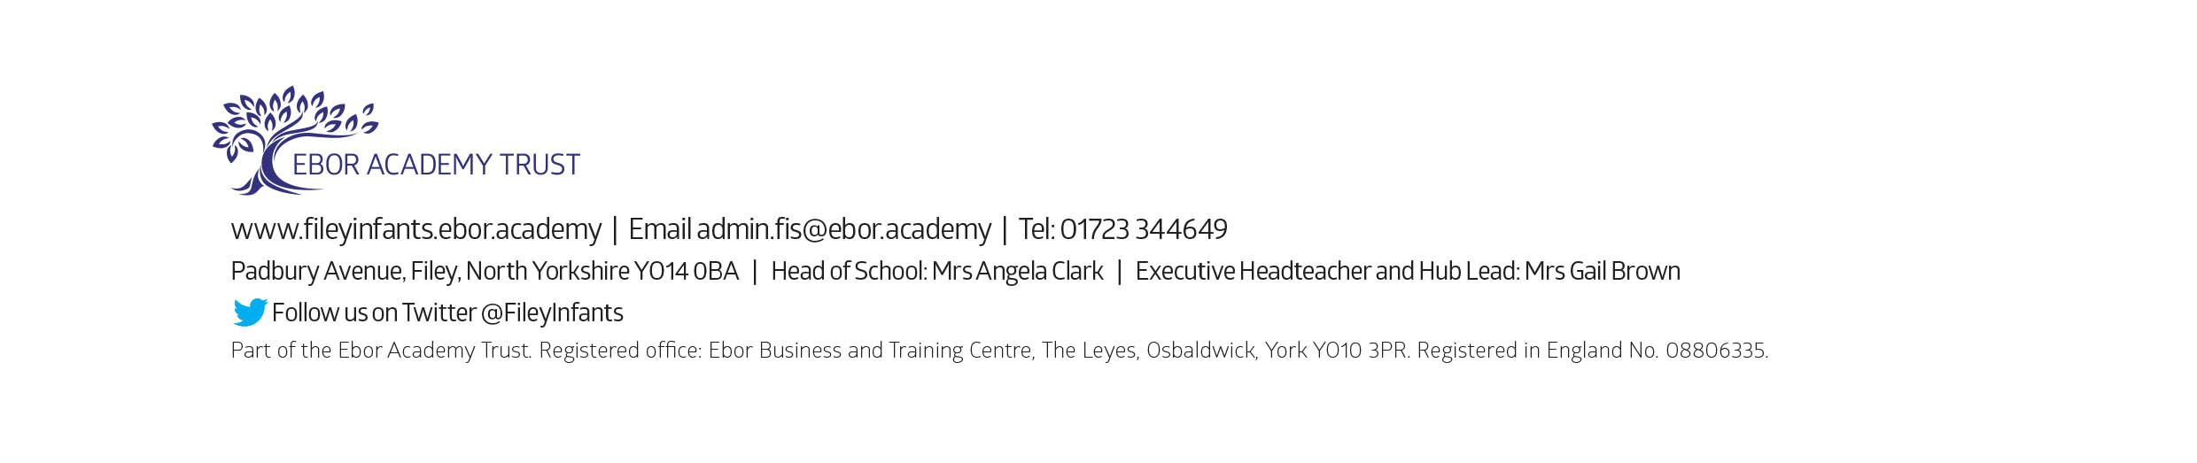
Dear Parents and carers,
Welcome to Miss Ring’s class! We have had a fantastic start to the year and are very much enjoying getting to know each other. I am writing to you to welcome you as a Year 1 parent and to give you some more information about what to expect in year 1.
Our Curriculum
As a school, we work tirelessly to make sure our curriculum is up-to-date as well as exciting and engaging for all our children. This half term our theme is Fantastic Filey! Our themes for the year and more information about our long-term plan can be found on the school website.
PE
Children will have twice-weekly PE sessions. The days may change each half term (check the class window for changes). This half term is our chance to work with Mr Ellis (specialist PE teacher) so our PE days will be Monday and Thursday. On these days please ensure that your child is properly prepared. If they wear earrings please remove them before school (staff are not able to support them with this). Please can long hair be securely tied up to avoid any accidents.
Children must have the correct PE kit with them. This should include named; white t-shirt, black or navy shorts, and trainers for outside. Feel free to include leggings/tracksuit bottoms and a warm jumper, as the weather gets colder. Children are welcome to leave this hanging on their peg all half term to make life easier!
Uniform
Do not forget, as a school we are trying to do our bit for the planet and recycle as much as possible. If you would like any uniform or some PE kit from our good quality free second hand uniform cupboard, please phone the office or catch me at the door.
Phonics and Reading
In Year 1 children will have daily phonics and guided reading sessions. To enable you to best support your child’s phonics at home, we will be sending home a small sheet each Friday detailing what we have covered so you know what to practise with them.
In school, guided reading books will be changed regularly. We aim to change books every week but on some occasions, this may be fortnightly. This book will be available to read the following week on our online reading platform, Collins eBooks. Please keep an eye out in your child’s reading record, as we will be sticking in login details for this very soon.
Children will also be able to bring home a physical book to read. This can be read and changed as regularly as they wish. In year 1, children are given the responsibility of changing this book themselves. Whilst we do remind them regularly, please let us know if it keeps getting missed!
As a school, we recommend that children read at home every day, so please read as regularly as you are able to.
Library
During the week, children will visit our Big Red Reading Bus twice. We will have a whole class story time on the bus, as well as allowing another opportunity for children to choose and borrow their own book. Please support your child to remember to bring their library book to change every Thursday.
Homework
Throughout the year, children will receive weekly homework. We try to provide a range of engaging activities covering all different areas of the curriculum. Each week these can be found in children’s yellow homework books.
Homework will be given out each Friday. Please help your child to return their homework to school by the following Wednesday so we can mark and update their books. Although we encourage this to be completed every week, we understand that sometimes life is just a bit busy so please do not worry!
Weekly Newsletters
As always, Mrs Clark will continue to write weekly newsletters to keep you up-to-date with all the exciting things happening in school. To reduce our paper use and do our part for the planet, these will be emailed out every Friday. Please contact the office if you are not receiving them. These newsletters also include important upcoming dates that you need to be aware of so please take the time to check them weekly.
Thank you in advance for all of your support. Please always remember that we are here to help if you need us.
Kind regards,
Miss Ring

