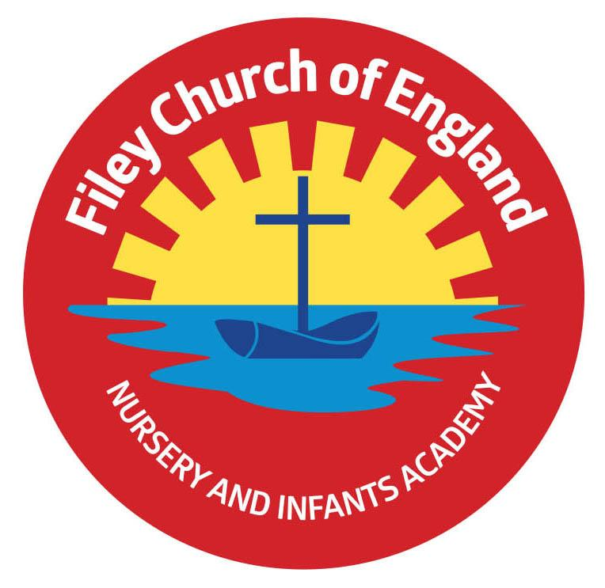
Friday 7th July 2023

Dear Parents/Carers
Another wonderful week in school! Reception had a super time at the beach on Thursday, enjoying many team-building activities. A big thank you to the Coastguards for their time with the children and the lovely teddy bears and gift bags. Our Nursery children held a super Enterprise event this afternoon, thank you to everyone who managed to join them and the tremendous support given. Please remember to follow us on Twitter so you do not miss all the wonderful pictures of our children learning and having fun. Miss Williams’ class won the attendance award this week with 100%, well done to them.

The Glasshouse at Charlottes
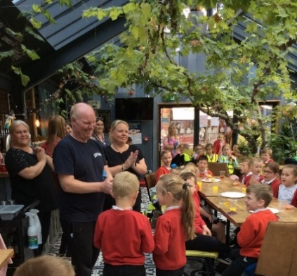
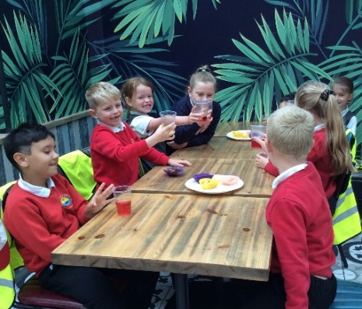
Mr Jackson’s, Miss Williams’ and Mrs Mackay’s classes all enjoyed cake and juice at The Glasshouse in Filey this week. A HUGE thankyou to the staff and owners of
The Glasshouse for agreeing to our visit out of opening hours and then for giving the children their money back to spend on something else in school. A very kind, Filey community gesture that is very much appreciated. We will use the money to buy extra special party bags and prizes for the leavers’ party on Thursday 20th July 5pm- 6.30pm. The tickets will only cost £2 this year, to cover the cost of hotdogs, ice cream and juice.

Summer Fair
This year our Summer Fair will take place after school on Friday 14th July from 3pm-4.30pm. There will be a variety of stalls including tombola, raffle, cakes, hot dogs, face painting, games and competitions. Thank you for everyone who brought a bottle to school today for the bottle tombola.
The Fayre will take place at the back of school on the field area, weather permitting. If the weather is wet or extremely windy, the Fayre will take place inside the school building. A text message will go out to parents/carers on the day if plans do need to change.

We have some great raffle prizes again with the star prize being a Summer food and drink hamper worth over £50 other prizes include local shop vouchers, theatre vouchers, games, toys, chocolates and pamper sets. Your child will bring home a raffle ticket sheet should you wish to buy some tickets in advance of the Fayre. Any donations of cakes/buns/biscuits will be gratefully received on the morning of Friday 14th July.

Diversity Role Models
We are fortunate to be taking part in a new anti-bullying project called ‘Embracing Difference – Ending Bullying’, which has been funded by the Department for Education. We are working with a charity called Diversity Role Models, who will be delivering staff training and support us to tackle and prevent prejudice-based bullying.
An important part of this project is to understand the views and experiences of our parents/carers. This is a chance for you to share your views and help create a positive and impactful change at our school. Please take 5 minutes to complete the survey by following this link:
Click here to access the Parent/Carer Survey. Your responses will help to shape the training and create a tailored school action plan. Please complete the survey by 14th July 2023. Thank you in advance for your support.
Family Learning, Reading Club, Choir, Cookery Club and PE Club
All these activities will take place next week (10th-14th) but these will be the last sessions before we break up for the summer holidays. Just to clarify there will be no extracurricular activities in the last week of term.

Meet Fern!
This is Fern a guide dog puppy. Some of the enterprise money that children have raised this year has gone towards sponsoring a guide dog. Every six minutes one more person in the UK loses their sight. Our sponsorship will help raise and train even more puppies to become life-changing guide dogs. We will receive regular ‘Pupdates’ with photos and news of how Fern is progressing. Guidedogs.org.uk rely on donations to continue their amazing work. Our sponsorship will help to provide independence and freedom for people who are blind or partially sighted. Well done and thank you to everyone who has contributed to an Enterprise event at some point this year. Each class also decides how to spend the rest of their money on something for them to enjoy. Year two children enjoyed a treat at The Glasshouse in Filey. Reception and Nursery children are looking forward to a visit from Whitby Falconers to experience reptiles and birds of prey first hand. Miss Ring’s and Miss Haldenby’s classes are hoping to organise a cinema experience with ice-cream and other treats!

Driving and Parking Around School
Unfortunately, a small number of parents/carers have been driving at speed on the roads leading to our school. Can all drivers please be mindful of young children walking or cycling to and from school. Young children do occasionally step into the road or fall from their bicycle therefore I urge drivers to keep this in mind when driving.

Sadly, people are also parking cars in unsafe places and some are mounting the pavements. All schools have yellow zig lines in front of them for a clear reason, SAFETY! Our children are small and very precious! They cannot see around parked cars easily so the front of our school must be kept clear during school run times. Parking on restricted areas or mounting the pavement is a traffic offence. Yellow zig-zag lines outside schools indicate the length of road where stopping or waiting is strictly prohibited. Our school also has an upright sign indicating a mandatory prohibition of stopping anywhere in the bus area as well as cones and our new children signs as an extra reminder. Please help us to keep our children safe, drive slowly, and park responsibly.

Pupil Voice Questionnaires
Children in years 1 and 2 have completed a questionnaire recently regarding their experiences in school. If you would like to see the data and the comments children made please see the attachment to this email. Your child will also be bringing home a school questionnaire for parents/carers to complete. If you have the time to complete and return this questionnaire, we will be extremely grateful. Your thoughts and suggestions are very much appreciated and help to shape the future of our school. Please return by Friday 14th July 2023.

Stephen Joseph Theatre Auditions
If your child is interested in drama workshops, theatre making, storytelling, acting techniques or backstage skills, auditions will take place on Wednesday 30th August. If you would like more information, please see the leaflet attached to this email.
Thank you for your continued support, we are here to help our children and families in any way that we can. If you have any questions or concerns please do not hesitate to get in touch.
Best Wishes
Angela Clark
Mrs Angela Clark
Headteacher
Diary Dates
July
Friday 7th July – Nursery Enterprise 2.15pm
Monday 10th July – Open the Book Collective Worship
Friday 14th July – School Summer Fayre 3pm – 4.30pm
Monday 17th July – Year 2 Sports Day 1pm
Tuesday 18th July – Year 1 Sports Day 1pm
Tuesday 18th July – Whitby Falconers visit Nursery and Reception
Wednesday 19th July – Reception Sports Day 1pm
Thursday 20th July – Nursery Sports Day 1pm
Thursday 20th July – Year 2 Leavers Disco 5pm-6.30pm
Friday 21st July – Year 2 Leavers Collective Worship 11am
Friday 21st July – Family Picnic – everyone invited 12pm – School Closes at the usual time of 3.05pm

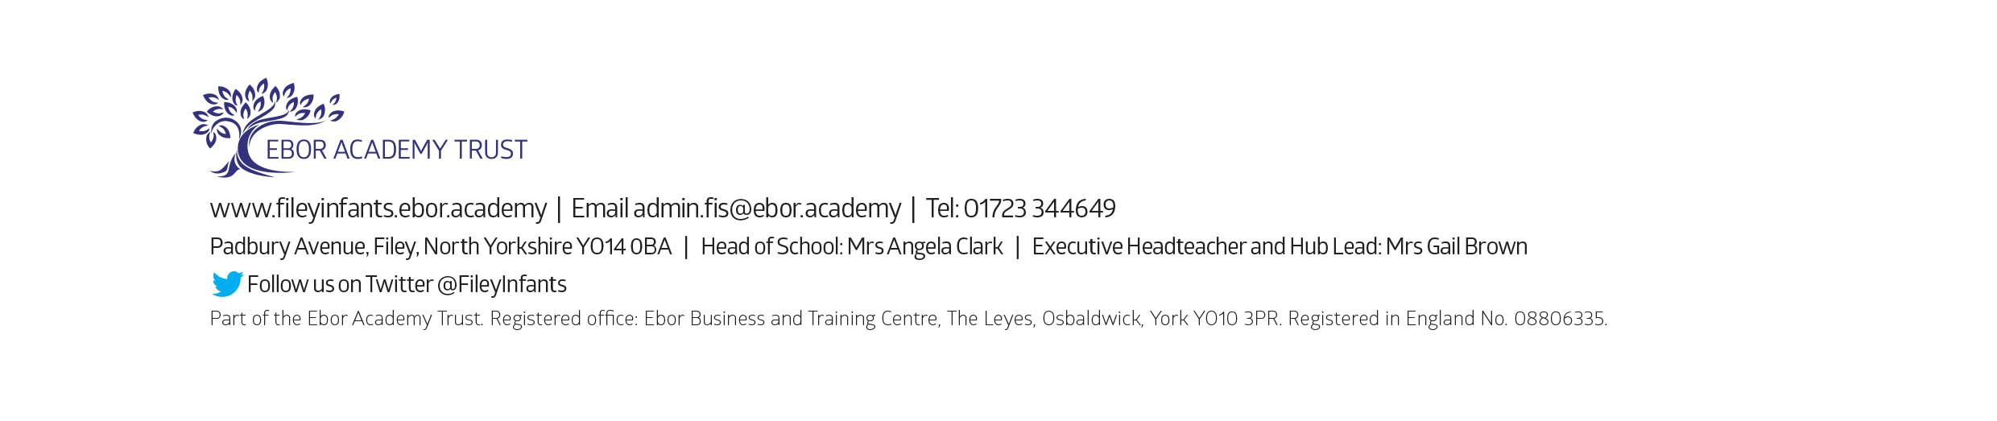
Tuesday 5th September – School opens for the start of the academic year 2023/2024

