Friday 14th July 2023

Dear Parents/Carers
Another very exciting week in school! Thank you to everyone who supported us at our summer fayre today. Unfortunately, the weather was against us but we still managed to have a great time and raise a wonderful amount of money towards school funds.
Please remember to follow us on Twitter so you do not miss all the wonderful pictures of our children learning and having fun. Miss Williams’ class won the attendance award this week with 95%, well done to them.

Sports Days
Next week each year group will take part in their sports days. These will take place on the track at the back of school and are as follows:
Monday – Year 2
Tuesday – Year 1
Wednesday – Reception
Thursday - Nursery
The back school gate will open at 1pm with races due to start at 1.10pm. Unfortunately, if the weather is wet and we have to cancel, a text message will go out as soon as possible. Children would still enjoy team games in the school hall but unfortunately without spectators.

Year 1 Cinema Experience – Monday 17th July
We are very excited to announce that Miss Ring and Miss Haldenby’s classes will travel on the train to Scarborough and visit The Stephen Joseph Theatre to enjoy a cinema experience. This is what the children have chosen to do with their Enterprise money and we are delighted that we have been able to make this happen before we close for the end of this academic year. We will need to leave prompt at 9am on this morning in order to catch the train. Please ensure your child is at school by 8.50am so we are able to register them and prepare to leave. Please also ensure that you have returned the consent slip and ordered a FREE school packed lunch if required.

RNLI Visit
On Wednesday 19th July we have a visit planned from the RNLI. They will be talking to the children about staying safe at the beach over the summer holidays.

Year 2 Party
Remember to get your ticket for just £2 for the year two celebration party taking place on Thursday 20th July. This will take place in the school hall from 5pm to 6.30pm, please come to the main reception at the front of school.

Year 2 Leavers Celebration Worship
All parents/carers of year 2 children are invited to attend their celebration leavers worship time on Friday 21st July at 11am in the school hall. Please come to the main reception area at the front of school. Please do not take photographs at this event; a recording will be made available on our school website.

Family Picnic
All families are welcome to join us for a whole school picnic on Friday 21st July at 12pm. The back and side gates will open at 11.50am, each teacher will bring their class outside and then you will be able to collect them. You are welcome to take your child home early after the family picnic if you wish although school will remain open until the usual finish time of 3.05pm.

Thank you for your continued support, we are here to help our children and families in any way that we can. If you have any questions or concerns please do not hesitate to get in touch.

Best Wishes
Angela Clark
Mrs Angela Clark
Headteacher

Diary Dates
July
Monday 17th July – Miss Ring and Miss Haldenby’s class cinema experience
Monday 17th July – Year 2 Sports Day 1pm
Tuesday 18th July – Year 1 Sports Day 1pm
Tuesday 18th July – Whitby Falconers visit Nursery and Reception
Wednesday 19th July – RNLI visit school
Wednesday 19th July – Reception Sports Day 1pm
Thursday 20th July – Nursery Sports Day 1pm
Thursday 20th July – Year 2 Leavers Disco 5pm-6.30pm
Friday 21st July – Year 2 Leavers Collective Worship 11am
Friday 21st July – Family Picnic – everyone invited 12pm – School Closes at the usual time of 3.05pm

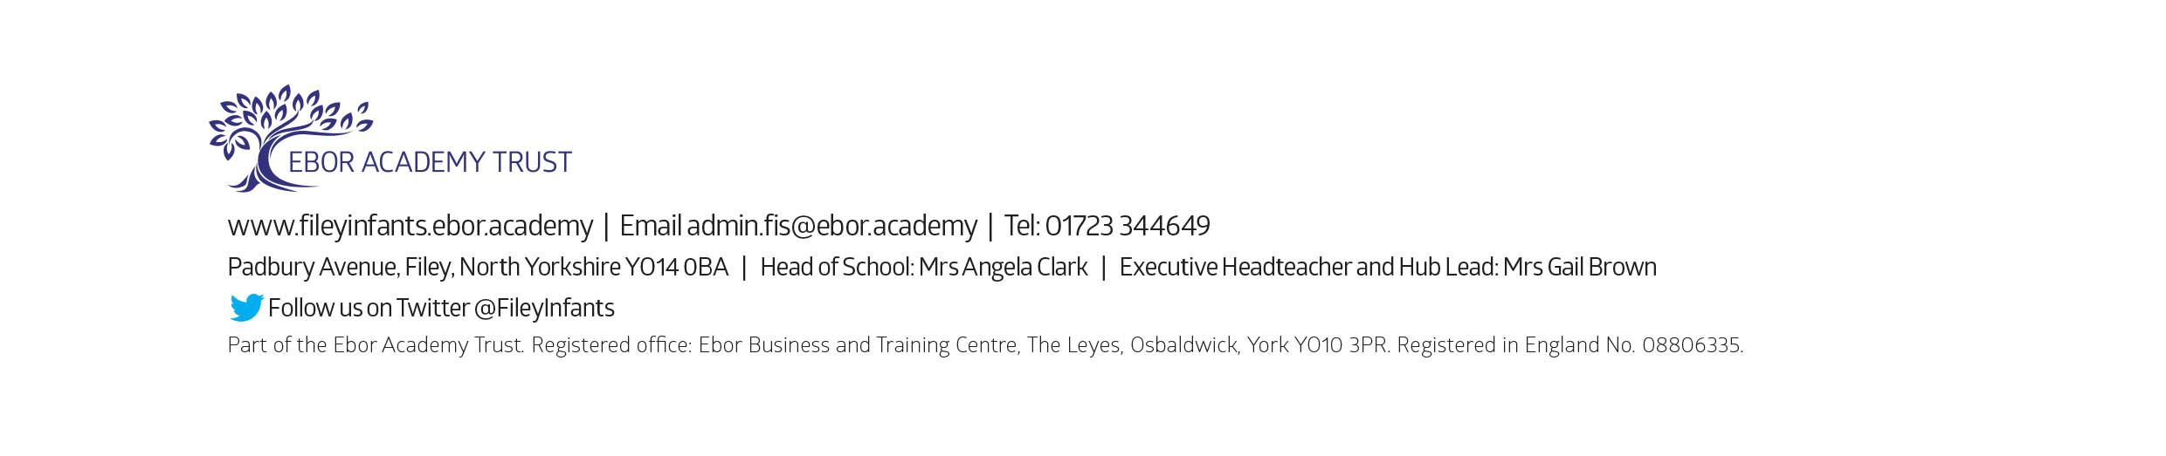
Tuesday 5th September – School opens for the start of the academic year 2023/2024

